Metal 3D Printer

Sichao Jiang: Budget Lieson, Website Design
Erik Leon: Equipment Guides Lead, Partition Design Lead
Riley Shepard: Team Lead, Project Manager, CAD Lead, Testing Manager, Fundraising Organizer

Fall 2025-Spring 2026



Project Sponsor: Mechanical Engineering Department: Dr. Ciocanel and the Idea Lab
Faculty Advisor: Dr. Constantine “Conel” Ciocanel
Sponsor Mentor: Mike Downey- Honeywell, Justin Sokel- W.L. Gore
Instructor: David Willy

DISCLAIMER
This report was prepared by students as part of a university course requirement. While considerable effort has been put into the project, it is not the work of licensed engineers and has not undergone the extensive verification that is common in the profession. The information, data, conclusions, and content of this report should not be relied on or utilized without thorough, independent testing and verification. University faculty members may have been associated with this project as advisors, sponsors, or course instructors, but as such they are not responsible for the accuracy of results or conclusions.

EXECUTIVE SUMMARY
The purpose of this project is to complete the final commissioning and validation of a DMLS (direct metal laser sintering) 3D printer donated by Honeywell for use in NAU’s IDEA Lab. The team will complete the commissioning tasks that the previous capstone team did not complete including the creation of quick-start, operational, and safety guides for the printer’s operation. The project relies on the team’s ability to provide all information for operation so that references are available after the completion of the project. Knowledge and operational processes can be passed to the manager of the Idea Lab to use for jobs within the university. This includes the use of equipment for peripheral tasks utilizing a material sieve for reclaiming powder and wet separator for cleaning. The team will be selecting suitable materials for work within the lab and validating the printer’s function by completing a series of tensile tests comparing printed specimens with traditionally manufactured specimens of the same material. The team is expected to print 3-4 different materials and complete a “full characterization” of the material properties.
The team will complete individual design projects that use topology optimization to demonstrate the capabilities of metal additive manufacturing. The design projects are defined by the ability to showcase the additively manufactured and topologically optimized part in a final assembly. The selected assemblies should have an engineering application and provide a clear view of the swapped component. The topology optimizations are likely to be completed using nTop software, and the generated geometries will be analyzed before printing.

The team has also been tasked with designing and building a partition to contain all metal additive
manufacturing materials and equipment. This includes determining the layout of the partition and
designing the structure using the 80/20 native builder. This will allow the team to streamline the ordering
process by compiling all parts in the assembly into a parts order for 80/20. The filters and fans will be
selected to align with necessary safety requirements and be capable of inducing a negative pressure to
prevent metal powder from leaving the space. After receiving all materials, the team will assemble and
install the partition into the Ideal Lab and validate its ability to keep hazardous materials contained.

This report includes the team’s work to date in completing the printer commissioning, individual design projects, and Idea Lab partition. The customer and engineering requirements are listed with explanation to outline the requirements of the partition and each team member’s individual design. Using these requirements, a house of quality was created for each section, relating the engineering and customer requirements. The benchmarking was completed for each members’ project, looking at work completed in topology optimization to reference as state-of-the-art methods. These benchmarks will be used to compare with the topology optimizations completed by the team. A literature review was completed to gather resources that will help inform the team throughout the project. These sources include textbooks, standards, journal publications, websites, tutorials, and operation manuals. Each team member completed mathematical modeling and engineering analyses for their individual design projects to understand the loads associated with the component and complete finite element analyses to later parameterize the topology optimizations. A function decomposition was completed for the printer, and concept generations, evaluations, and selections were completed for all design projects and the room partition. The criteria and justification are provided to understand the final decision. The report also includes the printer commissioning completed thus far to document completion of commissioning related tasks.

Table of Contents
DISCLAIMER 1
[1] Table of Contents 3
1
[2] BACKGROUND 1
Project Description 1
Deliverables 2
Success Metrics 4
[3] REQUIREMENTS 5
Customer Requirements (CRs) 5
Printer Commissioning 5
RC Excavator Arm Customer Requirements 5
Steering Knuckle Customer Requirements 5
Hip Exoskeleton Abduction Bracket Customer Requirements 6
Engineering Requirements (ERs) 7
Safe Room Engineering Requirements 7
RC Excavator Arm Engineering Requirements 7
RC Car Steering Knuckle Engineering Requirements 8
Hip Exoskeleton Abduction Bracket Engineering Requirements 9
House of Quality (HoQ) 10
Excavator Arm House of Quality 10
Steering Knuckle House of Quality 11
Hip Bracket House of Quality 12
[4] Research Within Your Design Space 13
Benchmarking 13
RC Excavator Arm Topology Optimization Benchmarking 13
Steering Knuckle Topology Optimization Benchmarking 14
Hip Exoskeleton Bracket Topology Optimization Benchmarking 15
Literature Review 17
Lit. Review- Erik 17
Lit. Review- Sichao 18
Lit. Review- Riley 19
Mathematical Modeling 22
Excavator Arm Force and FEA 22
Steering Knuckle Static Safety Factor 23
Bracket Force Analysis and FEA- Riley 25
[5] Design Concepts 29
Functional Decomposition 29
Black Box Model 29
Functional Decomposition Flowchart 30
Concept Generation 31
Partition 31
Erik 32
Sichao 33
Riley 35
Selection Criteria 38
Partition 38
Erik 38
Sichao 39
Riley 39
Concept Selection 40
Partition 40
Erik 41
Sichao 42
Riley 43
[6] Schedule and Budget 44
Schedule 44
Budget 49
Bill of Materials 50
[7] Design Standards 51
Design Standards Research 51
Design Standards Used 51
Erik- Excavator Arm 51
Sichao- Steering Knuckle 51
Riley- Hip Abduction Bracket 52
[8] Design Validation and Initial Prototyping 52
Failure Modes and Effects Analysis 52
Initial Prototyping 53
Erik 53
Sichao 54
Riley 55
Other Engineering Calculations 56
Erik 56
Sichao 57
Riley 62
Service Requests 68
Future Testing Potential 75
Erik 75
Sichao 76
Riley 76
[9] Final Hardware 77
Final Physical Design 77
Excavator Arm 77
Steering Knuckle 79
Hip Abduction Bracket 83
Service Requests 86
[10] Final Testing 92
Top Level Testing Summary Tables 92
Erik 92
Sichao 93
Riley 94
Tensile Testing 95
Detailed Testing Plan 95
Erik 95
Sicaho 98
Riley 103
Tensile Testing 108
[11] Future Work 110
[12] CONCLUSIONS 110
[13] Commissioning Report 111
Printer Operation and Safety Guides 111
Initial Printed Parts- Diagnostics and Results 111
Idea Lab Printer Partition 113
Additional Printed Parts 114
[14] REFERENCES 115
[59] APPENDICES 118
Appendix A: Bill of Materials 118
Appendix B: Hip Abduction Bracket Force, Shear, and Moment Matlab Script for Initial Calculations 118
Appendix C: RC Excavator Torque and Moment Calculations 119

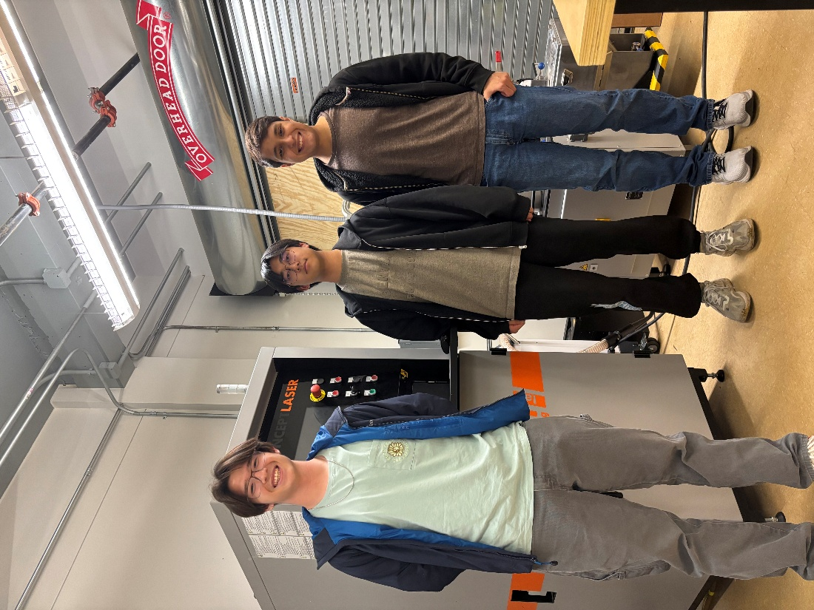
Figure 1: Team Photo (Printer in IDEA Lab)

BACKGROUND
This project’s background is separated into three parts: project description, deliverables, and metrics for success. The purpose of this section is to provide a list of goals the team must meet to ensure the project is successful in everything it sets out to accomplish.

Project Description
At its conception, this project was divided into three parts: commissioning, designing, and servicing.
NAU received the MLab Cusing R last year as a donation from Honeywell, but the printer itself was not in perfect condition. Last year’s capstone team worked to commission the printer, and over the summer someone from the University of Arizona came to fix the printer’s bed-leveling issue. This year, our team was tasked with finding the password for the powder-sieving unit, as well as producing QuickStart guides so that future students and Idea Lab managers can use the printer with ease. As the project developed, our sponsor, Dr. Ciocanel, asked us to also design a safe room using the website 80/20. This safe room needs to be completely sealed off to the rest of the Idea Lab, as well as have fan filters and an induced negative pressure to minimize the spread of metal powder dust.
The second portion of this project is designing and printing our own parts. Once the printer and its complimentary machines are in working order, each team member is to choose a component and perform a topology optimization on it. Afterward, the printer will be used to manufacture the optimized part and ideally replace the original object in its assembly.
Once the team is comfortable with the topology optimization and printing process, the final objective in the project is to service other capstone teams. This will be done by having each team member be given information by another team (e.g. part file, load case, part purpose, etc.) and reiterating the design portion of the project using this new part.
The budget for the project is not set in stone and has undergone a lot of change throughout the project thus far. Originally the projected budget was around $1000, covering expenses for safety equipment and materials for printing. After the addition of the safe room to the commissioning project, the estimated budget is approximately $6300. The team’s fundraising will be done through GoFundMe, as well as covering expenses for the individual design projects and any traveling done throughout the course of the project (i.e. trips to Honeywell in Phoenix for annealing). The team’s current budget and bill of materials are included in Appendix A.
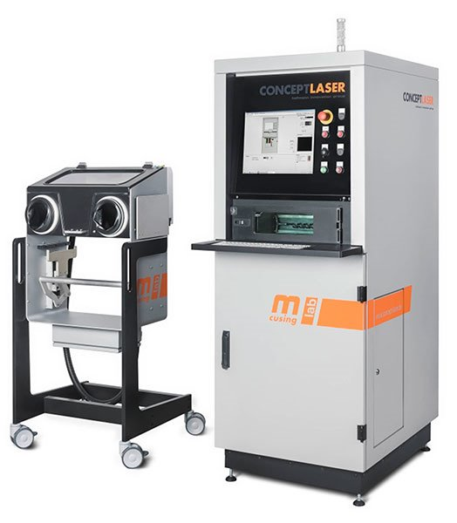
Figure 2: Mlab Cusing R and Glovebox

Deliverables
Several deliverables are expected for the course, the team’s sponsor, and the project as a whole:
Course:
Team Charter: This document outlines the expectations of the team in terms of deliverables and tasks to complete throughout the capstone project. The document includes the roles of each team member and their individual responsibilities to ensure the success of the project. The team made a list of rules and procedures for resolving potential conflicts. Each team member signed the document to acknowledge and abide by the expectations expressed in the charter.
Presentations: Two presentations are included in the first semester of the Capstone project.
Website: The website will function as a point of access for anyone to read about our capstone journey. It will have all of the significant documents, photos from the project, and any relevant information pertaining to the printer and project as a whole.
Prototypes: There are two prototypes required for the course this semester. The first prototype batch will be a meshed sphere to demonstrate the printer’s ability to print complex shapes as well as a sample specimen of the dog bones being printed for tensile testing. The second prototype batch has yet to be determined.
Final Report: The final report will be a document describing the project process throughout the entirety of the semester. It will include all final designs, prototypes, and any commissioning completed by then.
Bill of Materials: A bill of materials will be produced, encompassing any and everything bought for the completion of the project. It will include product names, suppliers, amounts, and costs.

Sponsor:
QuickStart Guide: A comprehensive guide to using the metal printer, powder sieve unit, and the wet separator. Includes safety information, step-by-step instructions on operation, and solutions for troubleshooting any malfunctions.
Tensile Tests: Using a variety of materials, the team is to print dog bones and tensile test them. The results will be reviewed along with existing data to determine the properties of the additively manufactured parts compared to parts made using subtractive manufacturing.
Safe Room: Due to the dangers posed by the metal powders, a safe room will be constructed around the machines that deal with the powder in any way. Filter fans will be used to induce negative pressure and minimize the spread of metal powder dust to the rest of the IdeaLab.

Project:
Topology Optimized Designs: Each team member will design a topology optimized part, print it, and replace the original part with the newly printed one.
Topology Optimized Service: Each team member will topologically optimize a part from a different capstone team, print it, and provide a fatigue analysis of the produced part.

Success Metrics
For the project to be a success, the team must have the metal printer, sieve unit, and wet separator operational. This includes the machines being functional but also teaching the current IdeaLab manager how to operate them when the team is no longer around. The team will also fully construct a safe room before the academic year is over. Regarding the design and service portions of the project, these will be deemed a success if the manufactured parts can replace the original in their assembly and still function. Moreso with the service, it will be a success as long as the team being service is satisfied with the optimized part they are provided with.

REQUIREMENTS
This section includes the requirements for the team’s main commissioning efforts and each member’s individual design projects. The requirements are separated into both customer and engineering requirements to encompass the needs of the project to determine potential design paths. The customer and engineering requirements are compiled into a house of quality and scored to determine the design methodology early on into the design process.

Customer Requirements (CRs)

Printer Commissioning
For commissioning overall, the customer requirements were rather simple: have the printer, wet separator, and sieve unit operational, and build a suitable safe room to protect other students in the IdeaLab.
The requirement for the printer is for it to be able to print in a variety of materials, and for the resulting parts to have similar properties to parts of the same material produced through subtractive manufacturing.
With the wet separator and sieve unit, the requirement is to have them both fully operational without need for outside instruction from the team.
The safe room is expected to contain all the metal printing adjacent machines, as well as induce and maintain a negative pressure within the enclosure.

RC Excavator Arm Customer Requirements
To establish the customer requirements for the RC excavator arm, the use case of the part was heavily considered. The intention of optimizing the arm is to produce a part that can replace the original in the assembly. As such, the following requirements were created:
Safe for Use: The part must be safe for anyone to touch or use. There should be minimal sharp edges and absolutely no risk of the part breaking while being used.
Lightweight: The initial part is made of plastic, and the entire assembly only operates if the weight of the arm does not tip over the cab. Therefore, the resulting part after topology optimization must be as light if not lighter than the original.
Durable: The proposed use of the RC excavator is to take to schools to demonstrate NAU’s additive manufacturing capabilities. With travel in mind, the stick needs to be able to survive traveling and any sort of accident that may occur.
Functionality: Since the printed part will be replacing the original in its assembly, functionality must be ensured and maintained. The RC excavator should function as well with the new part as it did with the original.

Steering Knuckle Customer Requirements
The customer requirements for the RC car steering knuckle are defined based on the performance expectations of competitive RC racing, compatibility with existing chassis systems, and durability during high-stress steering maneuvers. These requirements reflect the needs of end users, including hobbyists, competitive racers, and testing engineers. Each requirement focuses on ensuring reliable, lightweight, and precise steering performance.
The first customer requirement is high structural strength and durability. The steering knuckle must withstand repeated steering loads and impacts during racing without cracking or significant deformation. Users expect the part to last for the entire racing season without frequent replacements. This aligns with the demand for reduced maintenance and increased reliability.
The second customer requirement is lightweight construction. Racers prefer lighter components to improve acceleration, cornering, and handling response. A lightweight steering knuckle reduces unstrung mass, allowing for more responsive suspension performance and faster lap times.
The third customer requirement is high-dimensional accuracy and tight tolerance fit. Since the steering knuckle connects critical components—such as the control arm, hub carrier, and wheel axle—it must align precisely to ensure stable steering geometry. Any misalignment can cause steering wobbles, uneven tire wear, or unpredictable vehicle behavior.
The fourth customer requirement is compatibility with existing chassis and upgrade parts. The design must match the standard mounting points of the Slash 2WD platform so that users can easily install the new part without major modifications.
The fifth customer requirement is cost-effectiveness and manufacturability. Customers expect the upgraded steering knuckle to be affordable compared to CNC-machined or imported racing components. Additive manufacturing allows for lower tooling cost and faster lead time, enabling the team to offer the product at a competitive price.
The final customer requirement is aesthetic quality and branding potential. RC enthusiasts often value the visual appeal of upgraded parts. A clean surface finish and optional engraved branding increase the perceived value and desirability of the product.

Hip Exoskeleton Abduction Bracket Customer Requirements
The following customer requirements were collected to ensure that the topologically optimized designs meet the needs of the device. The requirements were gathered based on the current design and manufacturing method of the bracket and the capabilities offered by additive manufacturing. There are 5 key requirements: lightweight, durable, cost of manufacturing, and stable in use.
The customer's need for a lightweight design is motivated by the advantages of a lighter-weight system. A common requirement for wearable robotics is the need for lightweight systems. This reduced the additional cost of transportation inflicted on the user needing to carry the weight of the device. The current bracket design is thick and square milled aluminum, offering great potential for weight reduction. The current bracket weighs roughly 50 grams for the two separate parts, with a goal of providing a final mass lower than the current assembly.
The durability of the additively manufactured bracket is imperative for safe use. The device is rigorously tested with many loading cycles and control strategies. This requires the new bracket to be at a minimum as durable as the current design. The current design has not been tested until failure, but analyses will be completed to compare the structural integrity of the current and new designs. Durability in this context is safe and reliable operation under standard and increased loading states for a minimum of a million cycles.
The cost of manufacturing is considered based on the potential time and monetary savings by utilizing additive manufacturing. The current design requires a shop to manufacture the part using subtractive manufacturing. This takes a minimum of two weeks and costs about $1000 for a pair of brackets. The costs will be compared based on the cost of metal powder and time to build and post process the part. The goal of the project is to reduce both the cost of manufacturing and lead time to provide mechanical parts faster and at a cost reduction.
The stable in use requirement ensures that the new design will not fail under exoskeleton use. The load cases were determined based on the motor’s maximum loads and part geometries. Stability under use is defined as the ability for the part to function effectively under maximum stress conditions. This is an important requirement for the functionality of the hip exoskeleton to provide the user with safe and reliable operation. The distinction between this section and durability lies in the requirement of incorporating fatigue analysis on the new design where this requirement is incorporated as parameters in the topology optimization.

Engineering Requirements (ERs)

Safe Room Engineering Requirements
For the safe room, the measurable requirements were cost, an induced negative pressure, and the ease of construction.
Using the clean room capstone team’s design for reference, they came up with a cost of $3300 for a room of about 100sqft at 8ft tall. The safe room for this project is closer to 150sqft, and keeping consistent with the prior team our cost should be approximately $5000.
The purpose of the safe room is to keep metal powder dust and trace inside without exposing the rest of the Idea Lab to it. To ensure this is the case, negative pressure must be kept within the room, especially during machine operation.
With how big this project has become, the team is becoming increasingly pressed for time. As such, the ease of construction of a safe room is also heavily considered. This will be measured by total piece count as well as whether or not overly complicated geometries exist within the design.

RC Excavator Arm Engineering Requirements
Having established the customer requirements, the following engineering requirements were made to meet them: suitable fit, weight, maximum load, smooth finish, and range of motion.
- Suitable Fit: With the goal of replacing the original part in the assembly, the produced optimized part should fit exactly where the original was without issue. This includes connecting to the boom as well as to the bucket and all associated pins and screws.
- Weight: Since a plastic part is being replaced by a metal one, it is important to maintain the same weight if not reduce it. The goal is to have the printed part be the same weight as the plastic one or have a weight reduction of 10-20%.
- Maximum Load: Using an estimation of the excavator bucket being full of sand and the arm being fully extended, a maximum torque of 6.137x10^-4 Nm and a moment (based at cab) of ~0.002kgm/s were found. The optimized excavator stick should be able to handle and contribute to these loads without any sort of deformation.
- Smooth Finish: The RC excavator being optimized is made from polypropylene, which has a surface roughness of 6.3μm. Ideally the printed part will have the same surface finish, but otherwise not having dangerously sharp edges and corners will be acceptable.
- Range of Motion: As the optimization is attempting to improve the initial part, one way of doing so is to increase the range of motion. This entails making the stick longer in the optimized print by 10%, or at the very least not reducing the size of it.

RC Car Steering Knuckle Engineering Requirements
This section presents engineering requirements that directly reflect customer needs, specifying measurable goals to ensure the final design is both functional and effective. The engineering requirements for the RC car steering knuckle must meet the performance targets of durability, lightweight construction, and precise dimensional tolerances, while also being cost-effective and manufacturable. The following engineering requirements are based on the known design parameters and loading conditions of the Slash 2WD platform:
- Weight reduction of at least 20% compared to the stock aluminum steering knuckle
- A lifetime of a minimum of 25,000 steering cycles without structural failure
- Manufacturing cost below $80 per unit
- Lead time less than 2 weeks per batch
- Structural stability under lateral steering load of 80 N and vertical bump load of 120 N
The engineering requirement of weight reduction is established to improve the dynamic response of the suspension system. Reducing unsprung mass by 20% significantly improves cornering performance and vehicle agility. Based on the materials available for additive manufacturing, the weight reduction is constrained by the density and minimum wall thickness of the printed part. This requirement ensures that the new steering knuckle provides a performance advantage over both OEM plastic and CNC aluminum components.
The component lifetime requirement ensures that the steering knuckle remains structurally sound throughout the operational life of the RC vehicle. The component must withstand repeated steering loads from high-speed cornering and jumps without developing cracks or permanent deformation. The minimum cycle life of 500,000 steering cycles simulates long-term racing use and aligns with customer expectations for durability and reduced maintenance.
Manufacturing cost and lead time are also critical requirements. Using additive manufacturing provides advantages over conventional machining by reducing material waste and eliminating the need for expensive tooling. The total cost of the additively manufactured steering knuckle includes material, machine operation, and minimal post-processing. Producing the part locally significantly shortens lead time compared to outsourced machining and provides flexibility for rapid design iteration.
Finally, the induced lateral and vertical loads on the steering knuckle are used to define the boundary conditions for finite element analysis. Based on the wheel geometry and steering lever arm, the lateral load during cornering is expected to reach 80 N, while the vertical impact load during jumps can reach 120 N. These forces, combined with an appropriate safety factor, will be used to verify that the final design meets strength and stiffness requirements.

Hip Exoskeleton Abduction Bracket Engineering Requirements
The engineering requirements outlined in this section relate to meeting the requirements outlined by the customer. These requirements have associated measurable metrics which need to be met to have an effective design. The engineering requirements for the hip exoskeleton connect the needs of the device with comparable values to allow for safety factors to be provided based on the design. The following engineering requirements were defined based on the known parameters of the current design and loading conditions: weight reduction of 15% lifetime of a minimum of a million cycles, manufacturing cost below $1000 for a pair, lead time less than 2 weeks, and stable under the calculated axial load and bending moment induced my motor rotation.
The engineering requirement of a 15% weight reduction is established based on the size of the model and potential for weight reduction of the design. Based on the materials the team can print in, the weight reduction is constrained by the increased material density and focus of high cycle operation. The thickness of generated members needs to accommodate the loading pattern and number of cycles, making lightweighting challenging. The goal of 15% weight reduction ensures that the new design is an improvement upon the conventionally manufactured design.
The component lifetime requirement is important to ensure that the part will be functional throughout the life of the device/design iteration. The hip exoskeletons undergo extended testing and use in data collections, which requires that the new design holds up under long use. The parts designed for these devices are expected to be used for the lifetime of the device or until a new device design is developed.
The manufacturing costs and lead times are areas where additive manufacturing offers advantages over conventional manufacturing techniques like milling. The cost of an additively manufactured part includes the cost of materials, machine operation, and post processing. This can reduce the time it takes to make a finished part improving the ability to create complex and challenging to manufacture geometries. The ability for the team to print metal parts at NAU reduces the time it takes to get the parts on the end user, reducing lead times and eliminating the need for outsourcing manufacturing to companies that operate in another country, requiring time for shipping.
The induced axial load and bending moments caused by the device were calculated to determine the loading paths and parameters for finite element analysis. The motor will only provide a maximum of 10Nm when in use. Based on the radial distance to the bracket, the applied forces are comparatively low. The current design has been tested using nylon 3D printing but was not rigid enough to function for any longer than a short period of time walking. The axial load and bending moment were found to be 0.72N and 0.0031Nm respectively.

House of Quality (HoQ)

Excavator Arm House of Quality
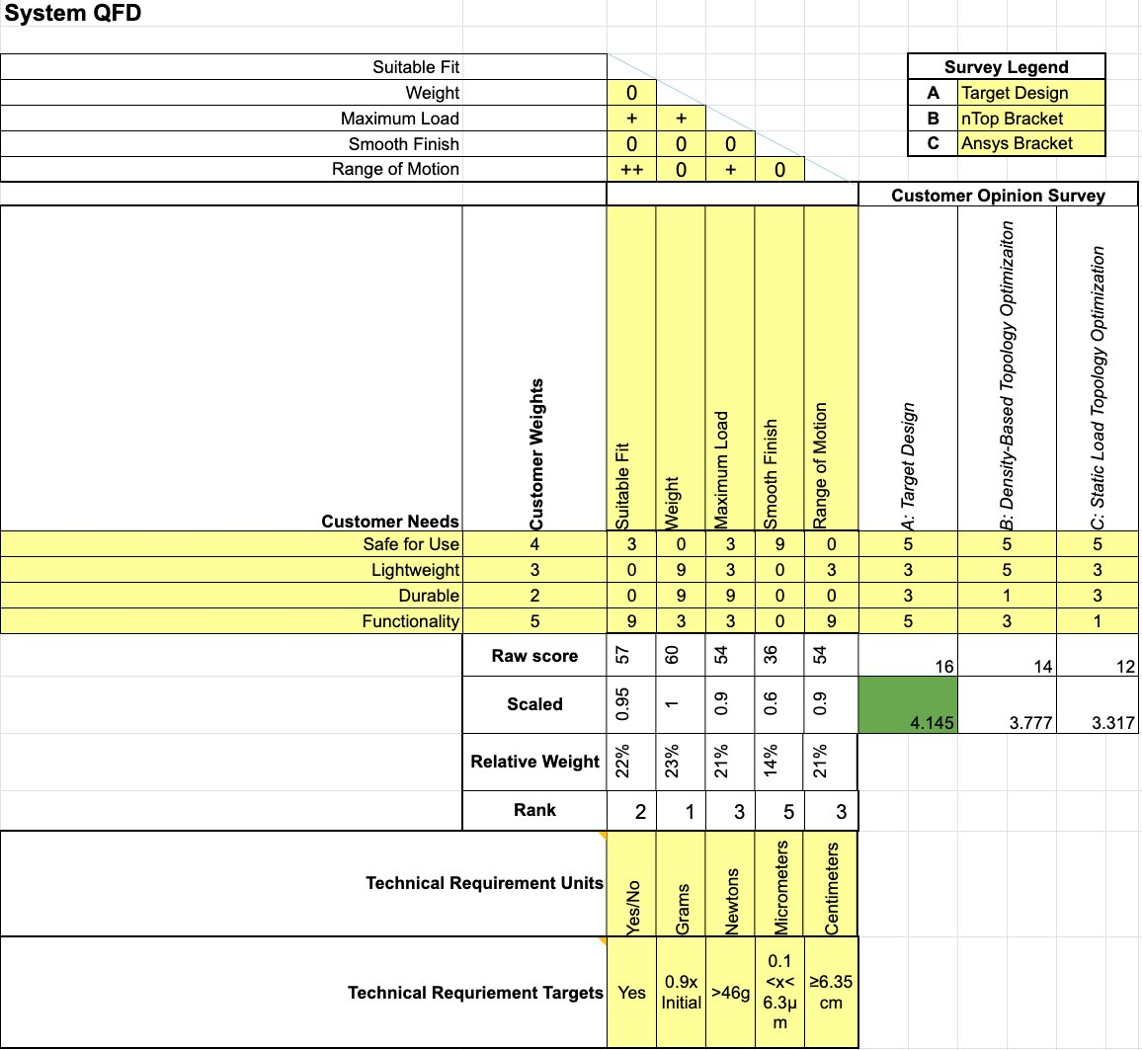

Steering Knuckle House of Quality
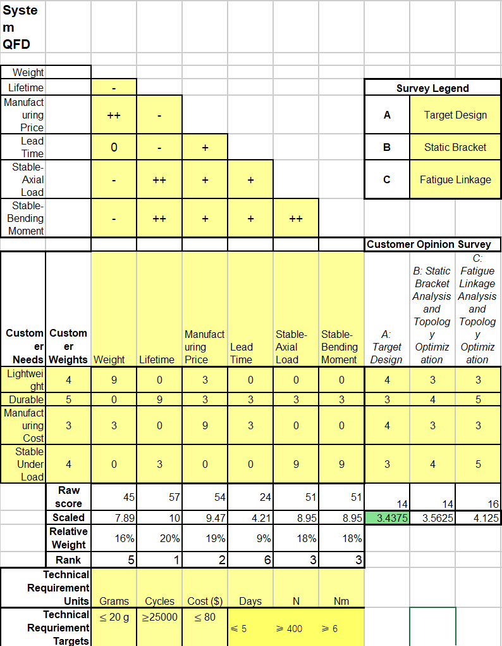

Hip Bracket House of Quality
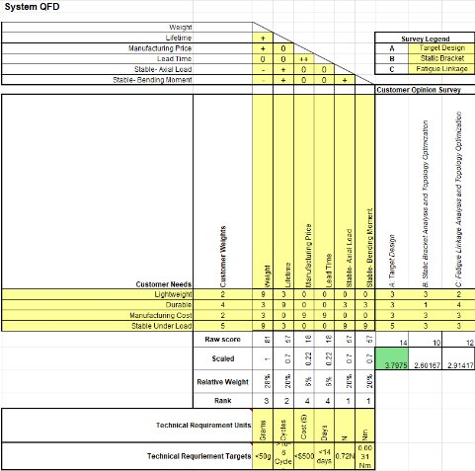

Research Within Your Design Space

Benchmarking

RC Excavator Arm Topology Optimization Benchmarking
Optimizing an RC excavator arm means there are no direct benchmarks to compare it to. However, the shape of the stick is not unique, so the benchmarking was done based on topology optimizations done on parts like it.
The first optimization used was density based and provided by nTop. The RC excavator functions with a specific weight and load maximum in mind. The chances of an arm piece snapping are far lower than the chances of the cab tipping over due to an excessive load on the arm. With the goal of reducing the weight of the printed part, or at least maintaining its functionality, reducing the density would help meet the criteria.
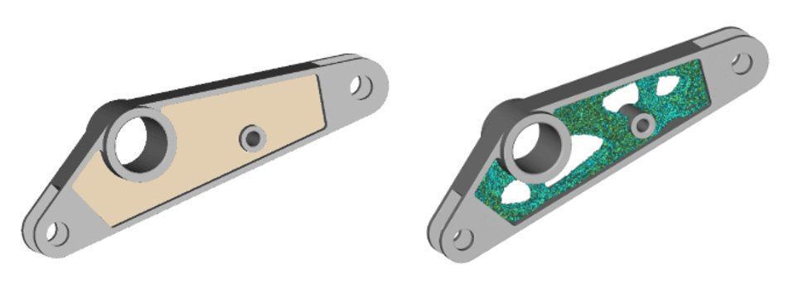
Figure 3: Density Based Optimization [8]

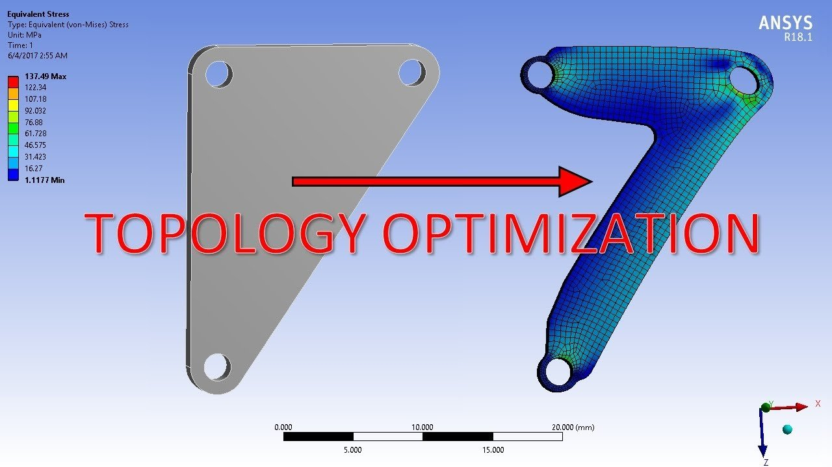
The next optimization considered was static load based, provided by ANSYS. This benchmark provides an example of what static load optimization looks like. With the very minimal forces expected to act on the excavator stick, it is expected for the optimized part to be very thin. However, as seen in Figure 3, static load optimization may prevent the excavator from functioning based purely on its shape.
Figure 4: Static Load Based Optimization [22]
The final benchmark considered is a fatigue analysis on a mounting bracket, also provided by ANSYS. As the RC excavator is a toy that will be used at school demonstrations, prolonged use must be considered. The metal used to print may be stronger than plastic, but it is still susceptible to fatigue. The example shown in ANSYS’s fatigue analysis is like the excavator stick in shape, as well as in load location.
The small amount of bending seen in Figure 4 is the deformation that is expected in the excavator after prolonged use.
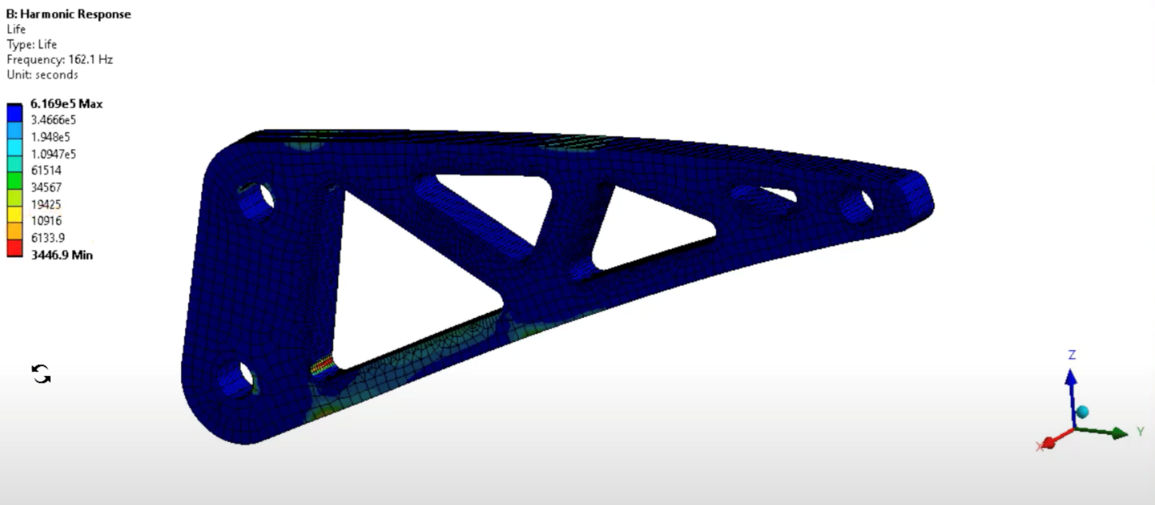
Figure 5: Fatigue Analysis Example [22]

Steering Knuckle Topology Optimization Benchmarking
To support the design process, benchmarking was performed by analyzing current RC car steering knuckle configurations and assessing their performance relative to the proposed topology-optimized concept. The primary objective of this benchmarking is to evaluate current state-of-the-art aftermarket and OEM knuckles to understand their structural performance, weight, cost, and manufacturability. This provides a foundation for determining how the team’s topology optimization and additive manufacturing approach can offer measurable improvements in strength-to-weight ratio and durability.
The first design benchmarked is an OEM plastic steering knuckle that comes standard with the Slash 2WD platform. This reference is crucial for establishing baseline mechanical performance. The stock knuckle is injection molded, lightweight, and inexpensive, but it suffers from low stiffness and is prone to deformation and cracking under high steering loads. The results from this reference are used to define the minimum performance targets for the new design, especially in terms of allowable deformation and failure load.
The second benchmarking reference is a CNC-machined aluminum aftermarket steering knuckle designed for competitive racing. This part is manufactured from 6061-T6 aluminum, providing significantly higher strength and rigidity compared to the OEM part. However, its weight is almost double that of the stock knuckle, which increases the unsprung mass and affects handling response. This trade-off between strength and weight is a key factor that the topology optimization will aim to address.
The third reference is a commercially available 3D-printed nylon composite knuckle. This design offers improved weight reduction over aluminum and is relatively easy to produce with short lead times. However, its fatigue performance is lower than that of metal, and dimensional tolerance is less precise, which may lead to alignment issues during high-speed cornering. The results from this benchmark are important for evaluating the manufacturability and precision of additive manufacturing methods.
For the proposed design, topology optimization using ANSYS and nTop Platform will be applied to maximize stiffness while minimizing weight, targeting a 20–30% reduction in mass compared to the aluminum version while maintaining or exceeding its strength. Finite Element Analysis will be performed under steering load conditions, including lateral cornering forces and vertical bump forces. Benchmark results will be compared using deformation plots, stress distribution, and factor-of-safety analysis.
This benchmarking provides a structured way to evaluate how the optimized metal-printed knuckle design improves on existing solutions by combining the light weight of plastic, the strength of aluminum, and the design flexibility of additive manufacturing.

Hip Exoskeleton Bracket Topology Optimization Benchmarking
Due to the nature of this project, benchmarking was completed by gathering other designs to reference and compare with the results of the topology optimization for the hip abduction bracket. The selected designs focused on reporting the outcomes of using ANSYS to complete a topology optimization on parts with loading and boundary conditions. The team can complete their topology optimization in several different software packages, but ANSYS has the widest breadth of applications and documentation. The new hip abduction bracket design will utilize both ANSYS and nTop to generate topologically optimized designs for the given loading cases. The focus of this benchmarking is to look at some state-of-the-art methods for conducting topology optimizations.
The first design to benchmark with the proposed hip exoskeleton bracket comes from a publication that explores topology optimization of an aerospace bracket [R1]. The methodology of this numerical and experimental investigation utilizes ANSYS static loading analysis, topology optimization, and optimization for additive manufacturing to complete the final design. This resource is relevant to this project because it provides information on the methods of topology optimization in ANSYS. The design can be used to compare the proposed hip bracket design based on the finite element plots and comparing the material reduction. This paper uses the density method for topology optimization, the method the team is planning on using based on its availability and resources.
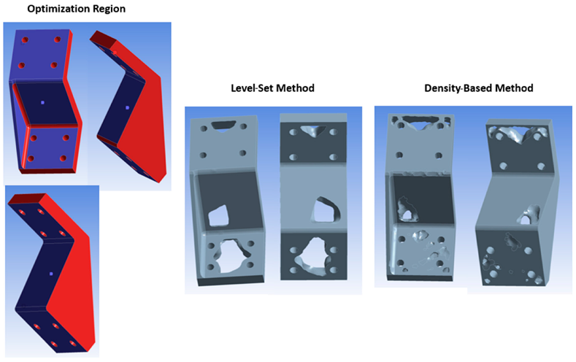
Figure 6: Topology Optimization of Aerospace Bracket Results [1]
The second benchmarking reference is a fatigue-based topology optimization for an aircraft torque link using ANSYS software [2]. The torque link is specifically adjusted for additive manufacturing which directly applies to the team’s deliverable of completing a topologically designed part to showcase in a final assembly. The paper reports on the fatigue analysis for the specific component of aircraft landing gear and looks more specifically at crack propagation. The finite element models were manipulated and optimized based on the loading criteria for fatigue analysis. The paper also discusses the use of numerical simulation to inform additive manufacturing decisions, offering some additional insight to printing parts on an LPBF (laser powder bed fusion) system, which is very similar to the Concept Laser MLab Cusing 100R 3D printer that the team will be using to manufacture parts. As the fatigue life of any given component is important to the functionality of a high cycle system, completing the fatigue life analysis of the new hip bracket design is imperative to prove the design’s reliability. This resource will be beneficial for comparing the results of the hip bracket fatigue analysis and informed topology optimization.
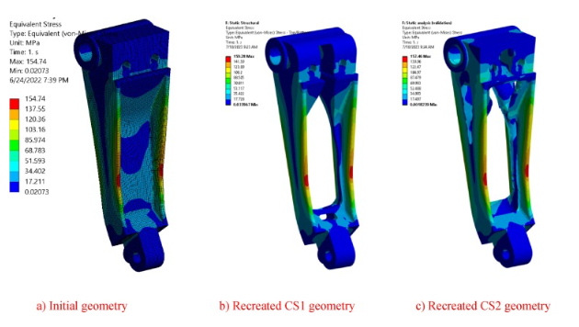
Figure 7: Deformation Comparison of the Optimized Aircraft Torque Link [2]
The final reference to be used for benchmarking the new design for the hip bracket is nTop software. NTop is a software package considered to be a leader in topology optimization and additive manufacturing software recommended by the team’s industry contact Justin Sokel. This software offers a more efficient workflow for completing FEAs and using the results to parameterize the topology optimization process. NTop also has several tutorials for completing FEAs and topology optimizations, which will be a great reference for using the software effectively to obtain accurate results. The FEA results collected from NTop will be compared to the FEA results of ANSYS analyses. NTop with be helpful in comparing the topology optimization results of ANSYS software as another check to ensure the results are reliable. If the final model produced by ANSYS needs additional smoothing and post-processing, NTop will be a powerful platform for completing additional improvements for the team’s additive manufacturing process.
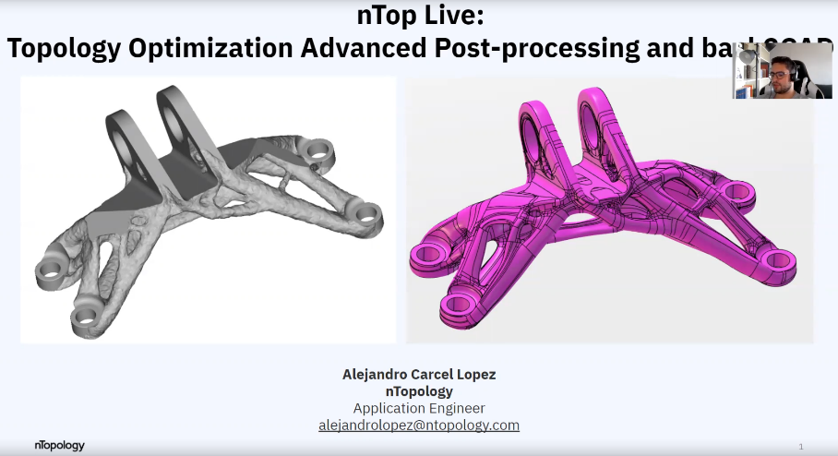
Figure 8: nTop Topology Optimization Post-Processing and Back CAD Tutorial [3]

Literature Review

Lit. Review- Erik
[4] Mlab cusing R: Translation of Operating Manual
This resource comes from the physical manual provided with the metal 3D printer. It includes all necessary information such as hazards, safety requirements, and a step-by-step guide on how to operate and clean the printer. It also provides specific parameters to operate the printer depending on the material, as well as a standard list of materials that are compatible with the printer.
[5] Instruction Manual: Wet Separator
Also provided in the physical manual is the information on how to use the wet separator. Although the model in the IdeaLab is newer, this manual still proves useful in its operation. It includes basic operation instructions, safety information, and instructions on how and how often to clean it.
[6] Mlab cusing: Concept Laser Software
The final major resource from the physical manual is software information. This provides information on the different applications installed on the printer and which ones are needed to print. There is also a brief troubleshooting section for any issues that may occur during the print.
[7] QM Powder: Automatic Sieving Station Operation Manual
The sieve station section of the physical manual is for a completely different unit. As such, the team found an online manual for the model in the IdeaLab. That manual provides instruction for operation, cleaning, and maintenance.
[8] nTop: How to Get the Most Out of Topology Optimization
nTop as a whole is software used to create 3D models of parts as well as optimize them for slicing and therefore printing. The website is full of tutorials ranging from simple object creation to mesh making to density-based topology optimization. This resource will be used to optimize the individual design as well as the service part, and then have the file ready to be uploaded into a slicing software.
[9] Young’s Modulus - Tensile and Yield Strength for Common Materials
As part of the commissioning, the team will be doing tensile tests on a variety of printed metal materials. This resource will be used as a baseline to compare the properties of the printed parts to the properties of their respective materials overall.
[10] Finite Element Analysis of Components of Excavator Arm—A Review
This review is a finite element analysis of the different parts of an excavator arm. While the individual design is specifically the stick, seeing the load cases of the bucket and boom are important considerations for an FEA. This review also provides a solid baseline of how an FEA on an excavator arm should be conducted, albeit the team’s analysis will be on a much smaller scale.
[11] Adaptive Sterile Modular ISO Class 7 Manufacturing Biomedical Cleanroom
This is the clean room team from the ME Capstone 23-24. While their research does not directly help the team with the printer or optimization, it is a good reference for a clean room. Their dimensions and purpose are different, but they provide resources for the framing as well as where to find filter fans.
[12] Terra Universal
Terra Universal is the company which the Clean Room capstone team purchased their fans from. While more research needs to be conducted on exactly which fans our team needs, this resource will ultimately be where those fans are sourced.
[13] DoE HEPA Standards
This document contains the Department of Energy’s standards and information regarding requirements, construction, and quality assurance procedures. As the team plans to use HEPA fanfilters for the cleanroom, this information will be vital to the final design.

Lit. Review- Sichao
[14] Lightweight Design of a Steering Knuckle via Topology Optimization and Additive Manufacturing
This reference is a journal publication that presents a lightweight steering-knuckle design using topology optimization combined with metal additive manufacturing. The study details FEA-based load cases, constraint definitions, and density-based optimization procedures to reduce mass while maintaining stiffness. Results include stress/strain plots and weight-reduction percentages that serve as a benchmark for our knuckle’s optimization targets and validation workflow.
[15] Structural Analysis and Optimization of an RC Car Steering Knuckle Under Extreme Cornering Loads
This reference reports finite element modeling and optimization of a steering knuckle subjected to lateral cornering forces typical of RC racing. The paper specifies boundary conditions, material assumptions, and failure criteria used to evaluate deformation and factor of safety. These procedures guide our load-case definition and acceptance metrics for durability.
[16] Slash 2WD OEM Steering Knuckle: Geometry and Assembly Interfaces
This reference provides the baseline OEM geometry, interfaces, and assembly relationships for the Slash 2WD platform. Dimensions, mounting locations, and tolerance expectations are summarized to establish fit and integration requirements. The OEM part functions as the comparison baseline for weight, stiffness, and manufacturability when evaluating redesigned concepts.
[17] 6061-T6 Aluminum Aftermarket Steering Knuckle: Performance Characteristics
This reference describes a CNC-machined aluminum steering knuckle used in competitive racing. Reported benefits include increased rigidity and damage resistance relative to plastic OEM parts, with the trade-off of higher mass. The information is used to benchmark strength versus weight and to motivate topology optimization for unsprung-mass reduction.
[18] Additive Manufacturing for Lightweight Steering Components in Small-Scale Vehicles
This journal article investigates the use of AM to achieve lightweight steering components, highlighting design freedoms, minimum feature sizes, and process-driven constraints. Case studies report shortened lead times and opportunities for internal lattice or material removal strategies. These insights inform our manufacturability considerations and post-processing plans.
[19] Topology Optimization Workflow for Additive Manufacturing Using nTop Platform
This reference outlines a practical workflow for density/level-set optimization within nTop, including meshing, constraint setup, response selection (compliance/stiffness), and parameter tuning. It also discusses exporting print-ready geometry and smoothing strategies. The methods will be used to parameterize our knuckle’s topology study and prepare the final printable model.
[20] ANSYS Mechanical Procedures for Structural and Topology Analyses
This technical reference summarizes procedures in ANSYS for linear static analysis, modal checks, fatigue assessment, and topology optimization. It specifies solver settings, convergence criteria, and result interpretation. These procedures support our verification steps and ensure repeatable FEA results under defined steering and bump load cases.
[21] nTop Platform Documentation: Parameter-Based Modeling and Optimization Tutorials
This reference provides step-by-step tutorials for building parameterized CAD, constraining optimization regions, and controlling feature thickness for AM. Guidance on lattice insertion, filleting/smoothing, and export settings is included. The documentation will be used to refine the optimized knuckle, maintain manufacturable wall thicknesses, and streamline iteration.
[22] Mechanical Performance Optimization of Aluminum Suspension Components Using Additive Manufacturing
This study evaluates the redesign of small-scale suspension components using aluminum alloys produced through metal additive manufacturing. The researchers compare conventional CNC-machined 6061-T6 knuckles with topology-optimized AM versions, demonstrating a 22–30% weight reduction while maintaining equivalent stiffness. The paper also details common failure regions in steering knuckles, such as caliper mounting tabs and spindle attachment points.
[23] Finite Element Analysis of RC Car Steering Knuckle Under Braking and Cornering Loads
This conference paper presents an FEA-based investigation of a 1:10-scale RC car steering knuckle fabricated from 6061-T6 aluminum and ABS plastic. The authors analyze combined braking and cornering loads, highlighting high-stress regions around the kingpin bore and caliper mounting features. They compare elastic deformation, maximum principal stress, and von Mises stress for different materials.
[24] Design Verification of Additively Manufactured Ti-6Al-4V Components for Small Mechanical Assemblies
The authors investigate the fatigue reliability, dimensional accuracy, and post-processing requirements for Ti-6Al-4V components printed on small-format metal printers such as the GE MLab series. The paper highlights the importance of support removal, surface finishing, and tolerance compensation when designing small mechanical parts such as brackets, joints, and linkages.

Lit. Review- Riley
[1] Topology Optimization of an Aerospace Bracket: Numerical and Experimental Investigation
This reference is a journal publication reporting the findings of using topology optimization on an aerospace bracket and completing numerical and experimental procedures. The analysis uses ANSYS Workbench to complete all computational analyses for finite element analysis and topology optimization. It states the methods and procedures to complete the design iteration for both the level-set and density-based methods. Following the topology optimization results, test results are included showing the stress-strain curves gathered through experimental testing of all types of topology optimizations. This reference is used as a benchmark to compare the results of the hip bracket topology optimization. Additionally, this will be a source to use when completing the topology optimization of the hip bracket, as well as determining the preferred method.
[2] Fatigue Life Prediction of Topologically Optimized Torque Link Adjusted for Additive Manufacturing
This reference is a journal publication discussing the use of ANSYS to estimate component lifetime and optimize geometries based on fatigue loading constraints. The paper also focuses on adjusting the geometries to align with additive manufacturing requirements. The methods for generating multiple iterations of part files for simulation is included with the results and findings from the simulation results. The paper takes a deeper look at crack propagation and improving design methods for the aerospace industry utilizing advanced manufacturing technologies. The paper discusses the models used for simulating crack propagation in the torque link geometry and reports the experimental results to prove the viability of the model. Additional analyses were completed to ensure the additive manufacturing process is effective, showing simulation and selected print parameters for the machine and material used. This reference will be helpful in completing a fatigue-based topology optimization for the hip abduction bracket. This paper is also used as a benchmark for the topology optimization that will be completed.
[3] nTop
This resource is software that uses implicit modeling techniques to complete finite element analysis, computational fluid dynamics, topology optimization, latticing and more. The software was recommended and is considered to be a leading company in computational topology optimization. This software works in blocks to allow the user to build unique and configurable workflows for completing complex functions. The software has impressive meshing and computational capabilities allowable through implicit modeling. The company also offers many resources for using all the different functionalities of the software. This resource will be helpful to completing the topology optimizations and has the potential to import FEA data from ANSYS, meaning that the team can complete fatigue finite element analyses to use in nTop.
[25] Additive Manufacturing Technologies and Applications
This reference is a textbook discussing the technologies behind and applications of additive manufacturing. The text includes a chapter titled, “Overhanging Features and the SLM/DMLS Residual Stresses Problem. This chapter covers the challenges of overhangs in additive manufacturing and the concerns for residual stresses that the part develops through the laser sintering process. This reference will be helpful in providing the team with additional factors to inform our designs and printing for the project.
[26] Developing Topology with Additive Manufacturing Constraints in ANSYS
This reference is a journal publication discussing the development of a topology optimization for additive manufacturing. This paper looks for a solution for additive manufacturing, allowing for parts to be printed without support materials by estimating overhang sensitivities. The work uses ANSYS Parametric Design Language (APDL) to develop two different case studies for structural members. This resource will be a helpful reference when the team wants to complete additional topology optimizations for additive manufacturing to improve our individual design part models for manufacturing using the printer.
[27] Design for Metal Additive Manufacturing Part 2: topology Optimization and Build Preparation
This reference is a tutorial on how to use ANSYS software to complete topology optimization for additive manufacturing. This resource provides a case study to follow in completing the topology optimization with safety margin constraints and then preparing the build for additive manufacturing. The tutorial includes the optimal build orientation and generation of support structures and completes with the generation of machine files. This reference will be beneficial as an alternative for slicing if the team wants to test additional parameters not present in Autodesk Netfabb. With the caveat of not having compatible export files to the Concept Laser machine, this would help inform the team on how to create slicing files in ANSYS. The topology optimization and print orientation will be helpful for the team exporting a final model for printing into slicing software. The inclusion of optimizing build orientation will allow the team to print more complex geometries reliably.
[28] Safety Management in Metal Additive Manufacturing
This reference is a website that lists and discusses the many dangers that come with handling metal powder and operating a machine that uses additive manufacturing. The resource talks about the material, equipment, and facility requirements and factors that lead to accidents. The handling of metal powders poses toxic and hazardous dangers to operators. The powder can explode under certain conditions, requiring care when handling. This page also lists a number of accidents that have occurred and the causes leading up to them. It includes many precautions to take to prevent accidents and ensure safe operations. This aligns with the team’s task to provide safety handling manuals to ensure the printer is operated safely.
[29] Specification for Additive Manufacturing Stainless Steel Alloy (UNS S31603) WITH Powder Bed Fusion
This is a published standard for additive manufacturing components with powder bed fusion using stainless steel alloy. The paper discusses multiple methods of manufacturing and print preparation. It includes experimental methods, testing, and results for each procedure and compares the differences. The analysis also includes the print parameters used and recommends specific procedures to ensure part quality. This reference will be helpful in informing the team what steps should be taken to print high quality and reliable parts for the success of the overall project.
[30] Test Methods for Tension Testing of Metallic Materials
This reference is the ASTM E8/E8M testing procedure which outlines the standard and ASTM compliant testing procedure for metallic materials. This document includes various test specimen types, applications, and testing procedures to align with generalized processes to provide accurate data. The specifications for what type of test specimen should be used for the type of material whether that be metal sheets, rods, or additively manufactured parts. This resource will allow the team to make sure the test specimens printed using the printer are compliant with accepted standards to provide accurate data during tensile testing.
[31] Dimensional accuracy of fabricated geometries through powder bed fusion: An overview and a new benchmark artifact proposal
This is a published journal article that compiles many different types of geometries used to validate the dimensional accuracy and printer capabilities for powder bed metal 3D printing. The paper shows many of the different geometries made for this type of validation along with some analysis of each type. The paper also includes all the sources of the other publications that have used the specific model. This resource was helpful in informing the team on some important features that should be included in diagnostic prints.

Mathematical Modeling

Excavator Arm Force and FEA
The analysis of the excavator arm was done in two parts. The first analyzed the expected loads produced from the excavator bucket being full of sand, while the second used those calculated forces to conduct an FEA using a static load.
MATLAB was used to calculate the expected loads using the following equations:
τ = r × F p = mv
With a bucket length of approximately 0.15m and a load of 0.0041N, the maximum torque was found to be 6.137e-4 Nm. Using a mass of ~1g and a velocity of 30rpm, a moment of 4.37e-4 kg*m/s is reached.
Part two uses those found values to create an FEA model using nTop.
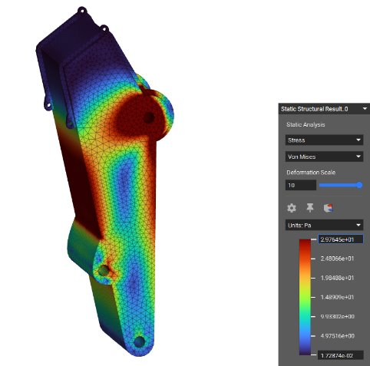
Figure 9: Stress Model
The first figure demonstrates the stress distributed throughout the excavator stick. The dark red sections represent the highest stress points, while the purple sections represent little to no stress. As the figure shows, the highest stress points are at the stick connection to the boom, as well as the faces directly opposed to and next to it. According to the calculations, the highest stress in the part is 2.98Pa. However, the excavator stick is nowhere near a square meter in area. A closer approximation would be in psi where the stress is 4.31e-4. This shows that regardless of which metal the part is printed in, there is no risk of stress being an issue.
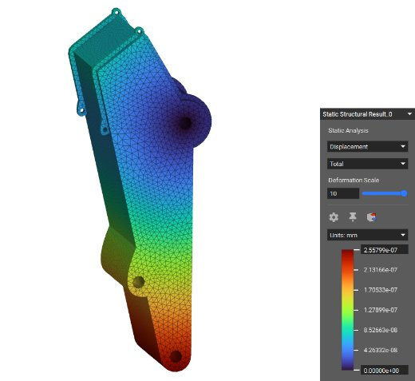
Figure 10: Displacement Model
The second model shows the overall displacement of the part. Similar to figure 9, the dark reds show high displacement while the purples show low displacement. Just as expected according to benchmark 3, the most displacement occurs at the end of the stick connected to the bucket. At its highest, the displacement is 2.56e-7mm. The “Deformation Scale” setting amplifies the visual displacement of the object. As demonstrated, even with that setting maxed out, the displacement is not visible. This shows that no matter the possible load, the part will not deform.

Steering Knuckle Static Safety Factor
A preliminary static safety factor analysis was performed for the steering knuckle under a lateral loading condition applied at the wheel axle. In this load case, the knuckle was modeled as a bending member, and the critical location was identified as the stepped hollow cross-section near the axle connection.
The applied lateral load was taken as:
F=60N
and the lever arm from the load application point to the critical section was estimated as:
L=40 mm
Thus, the bending moment at the critical section is:
M=FL=60×40=2400 N*mm
The steering knuckle material is 316 stainless steel, with an approximate yield strength of:
σy =205 MPa
Based on the measured cross-section, the approximate section properties were determined as:
Ix ≈6.35×102 mm4 c≈7.91 mm
Using the bending stress equation,
σb = Mc /I
the maximum bending stress at the critical section is:
σb =6.35×1022400×7.91 ≈29.9 MPa
The static safety factor was then calculated by comparing the material yield strength to the bending stress:
n= σy /σb = 205/29.9 ≈6.9
Therefore, the steering knuckle has an estimated static safety factor of approximately 6.9 under the applied 60 N lateral load. This result indicates that the part remains well below the yield limit under the simplified static loading condition. This hand calculation primarily considers dominant bending behavior; local stress concentrations and detailed geometry effects were further evaluated through FEA.

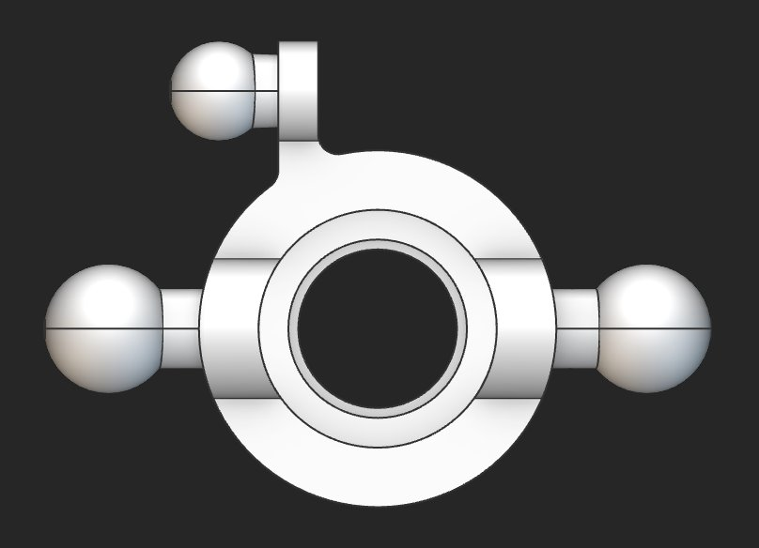Figure 11: Steering Bracket Loads

Bracket Force Analysis and FEA- Riley
The mathematical modelling completed for the hip bracket is separated into two phases. The goal of the first phase of mathematical modelling is to outline the load paths and calculate the loads applied to the part based on the motor. This uses basic equations to find the axial force, shear stress, and bending moments associated with the expected motor commands for walking assistance. The goal of the second phase of mathematical modeling is to complete the current motor bracket FEA and read the results to prepare for topology optimization. The analysis was completed with Matlab, SolidWorks, and nTop software. The first phase of mathematical modelling requires a free body diagram to understand the loading conditions and important distances based on the part geometry.
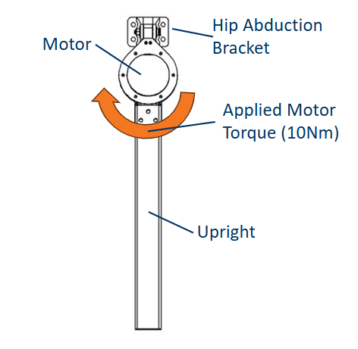
Figure 12: Free Body Diagram of Hip Exoskeleton
The above free body diagram shows the geometry and loading of the system. The bright orange arrow represents the expected applied motor torque applied by the device during walking. The distances between the motor axis and specific features of the bracket were found using the measuring tool in SolidWorks with the complete 3D model. The first equation was used for relating torque to force and additional equations were used to determine the loading on the bracket.
$$F=T×r$$
The next equation was used to determine the shear forces on the bolts to provide additional loading conditions for the finite element model. Due to the components connecting the motor to the bracket not being welded together, the force analysis was applied to determine the force applied at the bolts and their corresponding shear stresses.
$$τ=\frac{F}{A_{S}}$$
This equation was used to find the shear stressed on the steel bolts connecting the motor bracket to the lower half of the hip abduction bracket. The shear strength of the bolts was also calculated to ensure that the M3 bolts are strong enough to withstand the expected loads. Using two equations derived from a publication analyzing the estimation of bolt shear strength based on the Birnell hardness value [27].
$$HB=0.3σ_{b}-25 [27]$$
$$τ_{Sh}=0.6σ_{b}-25 [27]$$
The last equation used in the Matlab analysis is the summation of moments about a point. Based on the static loading conditions, the body must be in equilibrium, meaning the sum should add up to zero, allowing the bending moment about the bracket pivot point can be found.
$$\sum{M_{A}=0}$$
Using these equations, the values for the shear stress per bolt (total of 4), the shear strength of the bolts, the axial load on the bracket, and the induced bending moments were obtained. The individual shear stress on each bolt is 0.0025MPa, the shear strength is 780MPa, the axial load is 0.72N, and the bending moment is 0.0031 Nm. These results are reasonable considering a maximum torque of 10Nm with a average distance of 60mm from motor axis to corresponding bearing faces and geometry. The Matlab script is provided in Appendix B for reference.
These values were used to constrain a static structural finite element analysis in nTop. Using the nTop import function, the part geometry was gathered into the software and pre-processed for analysis. The bracket was analyzed as two separate parts with the corresponding loads applied. The solution required that the parts be properly meshed, using a refined surface mesh to generate a finite element volume mesh. The finite element volume mesh was parameterized with a maximum element edge length being constrained to 1mm. For the hip side bracket component, the boundary conditions constrained the through holes for mounting to the hip belt with displacement constraints in all 3 coordinate directions. The bending moment was applied on the surfaces of the geometry that interfaces with the steel ball bearings. This allows for the analysis to include the bending moment applied to the motor side component. The axial force was applied to the inner bearing surfaces to apply the force to both sides of the hinge. The motor side component of the bracket had boundary conditions defined by the forces applied by the motor at the interfacing fastening locations. The central pivoting axis has a displacement boundary condition, fixing the location of the bore in all 3 coordinate directions and an axial force and bending moment condition. The bending moment was applied about the two vertical surfaces that help retain the distance between bearings. The structural analysis was then solved and provided both displacement and stress plots. Through post-processing, the scaling was adjusted to provide a clearer visualization of stress concentrations. The following figures show the displacement and stress plots for each of the hip bracket components.
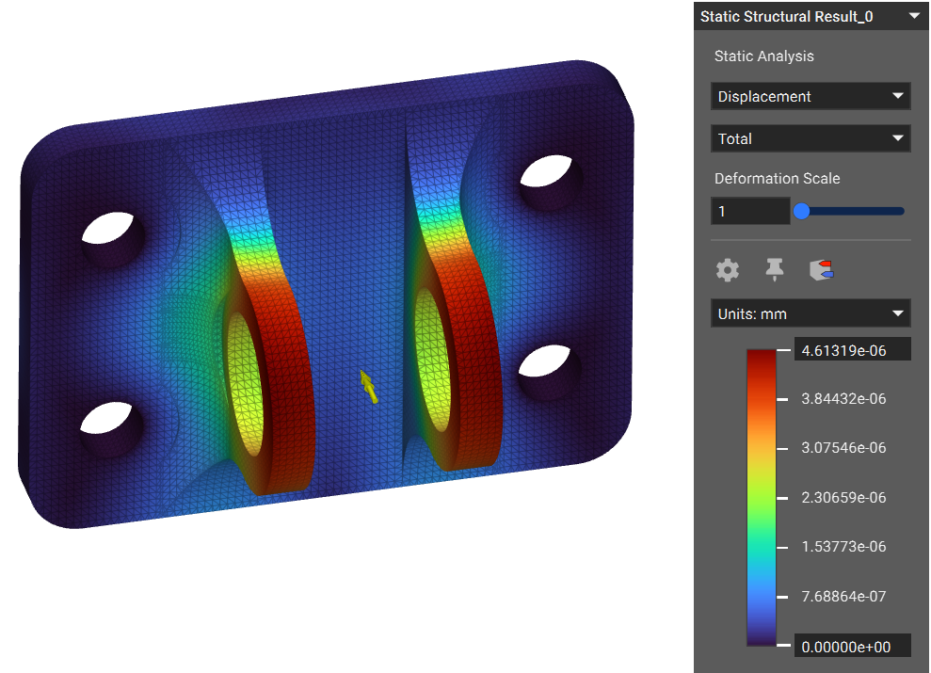
Figure 13: Displacement Plot for Hip Side Bracket

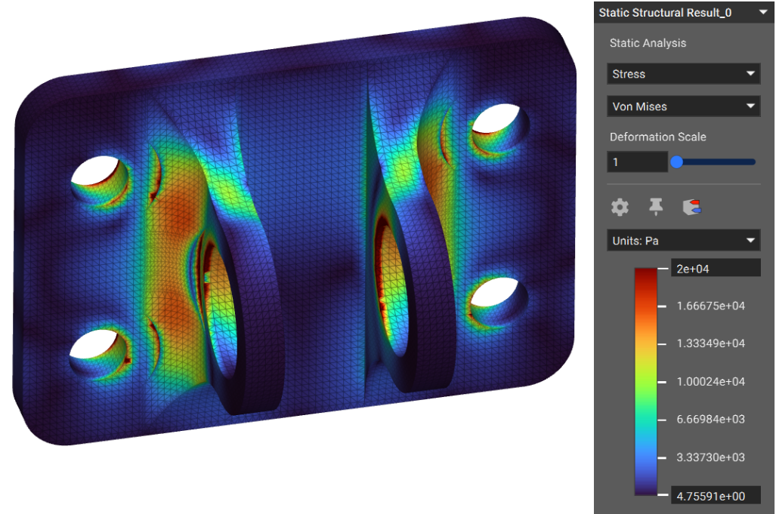
Figure 14: Stress Plot for Hip Side Bracket
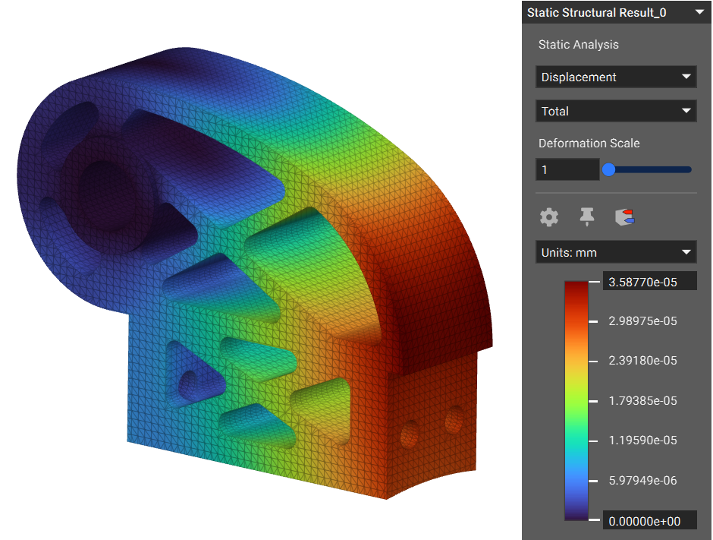
Figure 15: Displacement Plot for Motor Side Bracket 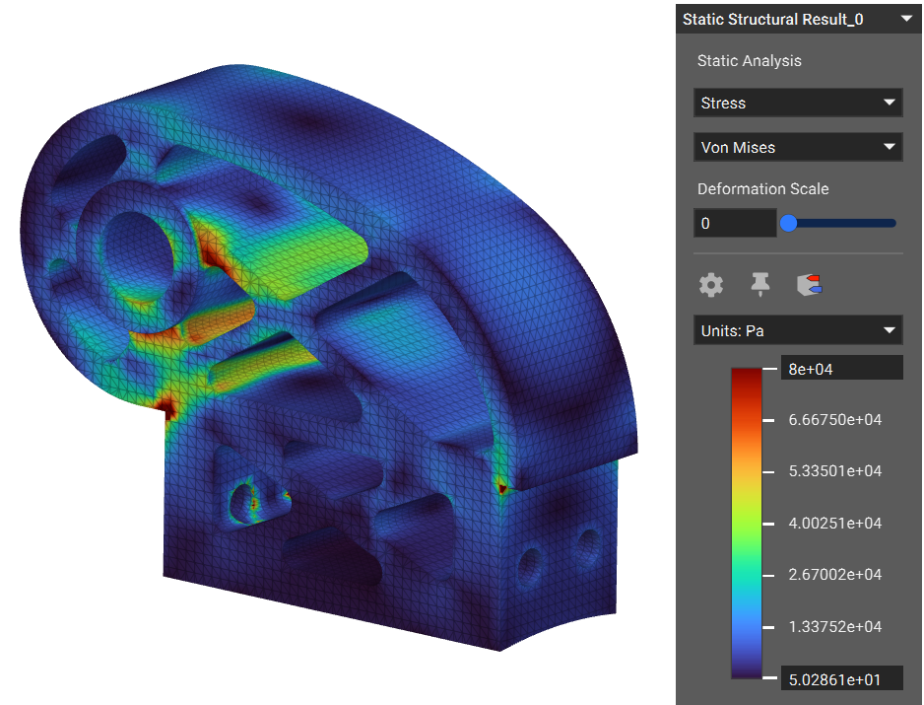
Figure 16: Stress Plot for Motor Side Bracket
The following plots show the displacement and stress data to visualize the parts’ structural integrity under the specified loading conditions. The data found in these analyses will be used to constrain topology optimizations to be completed on the bracket components. Some additional analyses that need to be completed for the design include a fatigue loading analysis in ANSYS. The static structural analysis will be included when outlining a fatigue analysis. The vector field data may be exported from ANSYS and imported into nTop for topology optimization capabilities in the purpose-built software.

Design Concepts

Functional Decomposition
The functional decompositions completed for this report include a black box model and a flowchart. These figures are relevant to the printer’s function as the individual design projects look only at a single component in a system.

Black Box Model
The black box model aims to show the system’s functions independent of any specific design concept. The model looks at the inputs and outputs of the system, focusing on the materials, energy, and signals. The materials is shown with thick arrows, the energy shown with thin arrows, and the signals shown with dashed arrows. The printer inputs are metal powder and inert gas with the outputs of the sintered final part. The energy input is the electrical energy required to operate the machine and support the laser. Lastly, the signals used by the printer are the slicing files/print commands with the output of the completed print process.
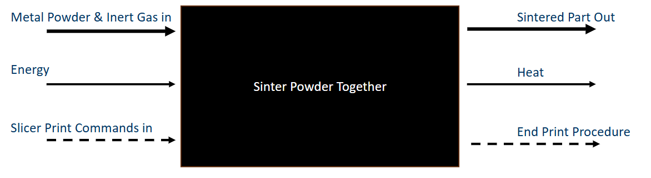
Figure 17: Black Box Model

Functional Decomposition Flowchart
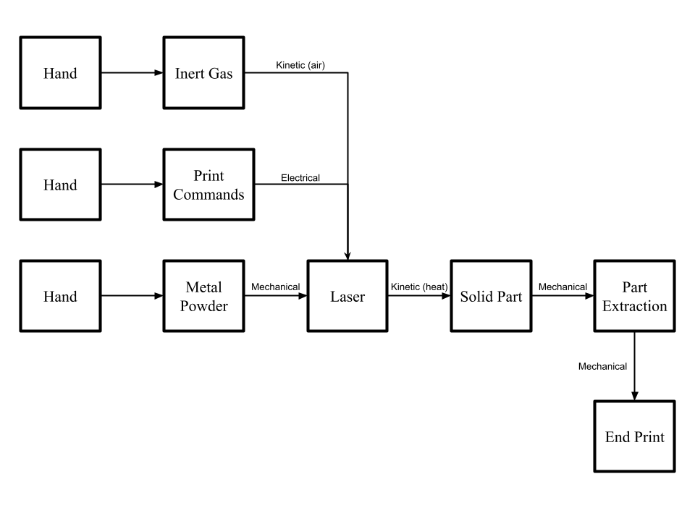
Figure 18: Functional Decomposition Flowchart
Using the material, energy, and signal flow shown in Figure 17, the above functional decomposition flowchart is produced. It has three separate ‘hand’ inputs, which then turn to kinetic (heat), electrical, and mechanical energies, ultimately resulting in the completed print. The importance of this functional decomposition is that it outlines the inputs required to use the printer. The key materials needed are metal powder and argon gas. These materials will generally define the costs of printer operation per build and will be used to define the cost analysis of the printer. Additionally, the power required to operate the laser is another cost of operation but may be challenging to estimate with the team’s current resources. To solve this, the team may be able to acquire resources from the department to complete this analysis. Lastly, the diagram offers a clear visualization of the print process very simply, aiding in understanding the process.

Concept Generation

Partition
The generation of the partition had two variables: the number of walls and the height of the room. The figures below show the models of the two-wall with a height of 86 inches and the three-wall with the same height.
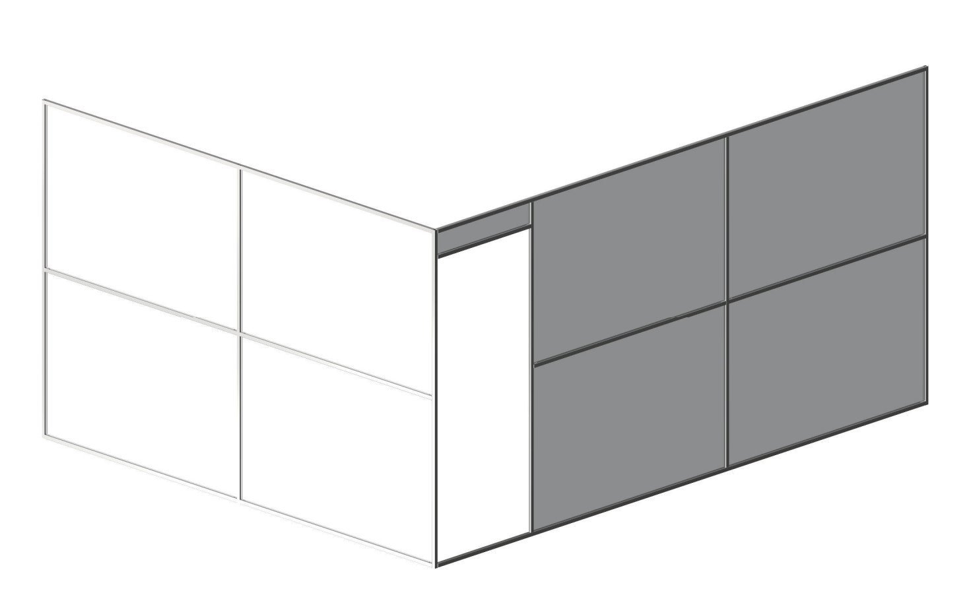
Figure 19: 2-Wall, 86”
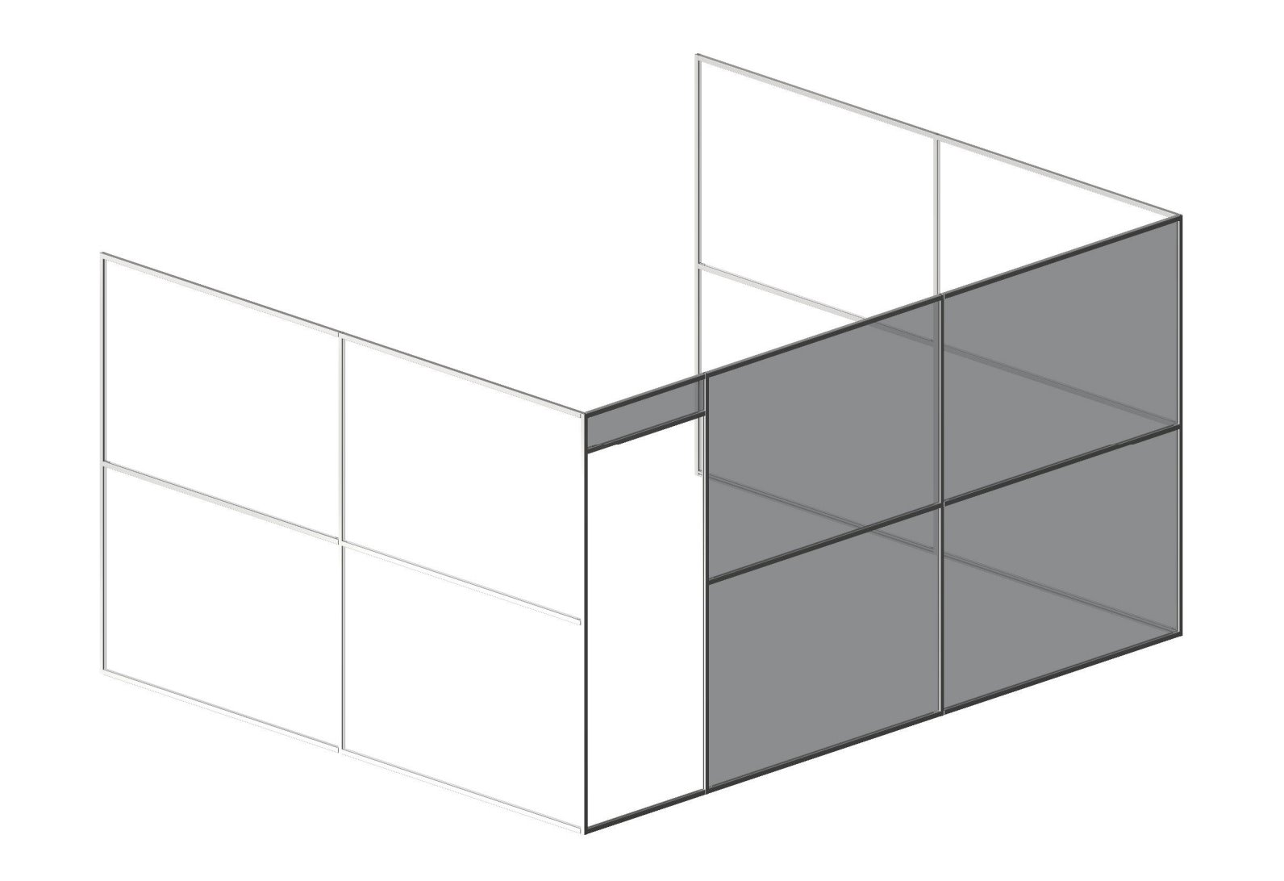
Figure 20: 3-Wall, 86”
The initial pros of the 2-Wall option were that it would be much cheaper to manufacture and would likely take less time to install. However, the main con was that having only two walls meant that the safe room would have a garage door to its right (as is the layout of the IdeaLab), meaning it would not be sealed. The 3-Wall concept completely removes that con, but in doing so the cost is increased significantly. The 96” variations of both looked very similar to the 86” and posed similar pros and cons.

Erik
There was not a real concept generation when it came to choosing the individual design. The initial idea was to focus on fatigue testing, and this led to the initial design being a hanging pot for a plant. After a discussion with Dr. Willy, it was agreed that the pot did not have a suitable engineering application, so the idea of a crane hook was proposed instead. Upon further research, the crane hook seemed like it would not be applicable for topology optimization, so staying within construction a remote-controlled excavator was chosen with the intention of optimizing and replacing part of its arm.
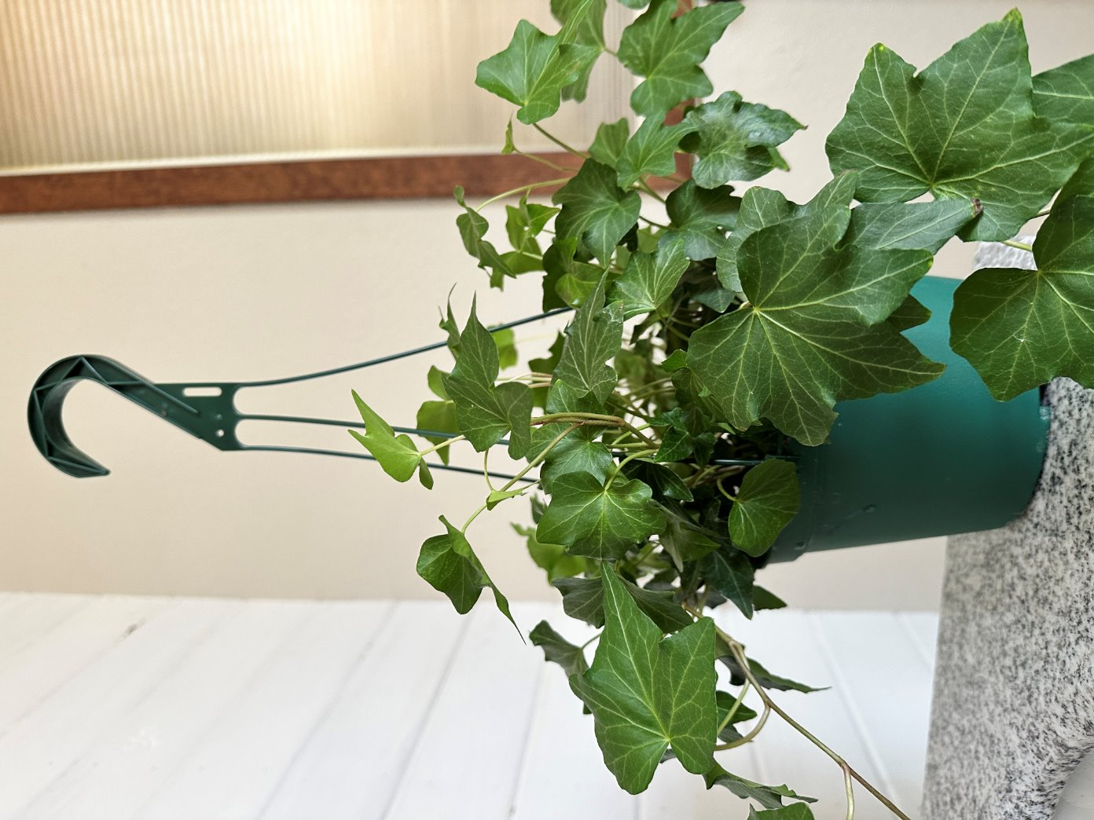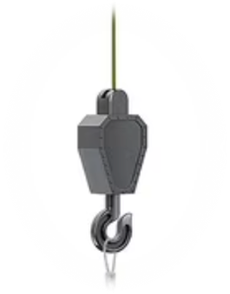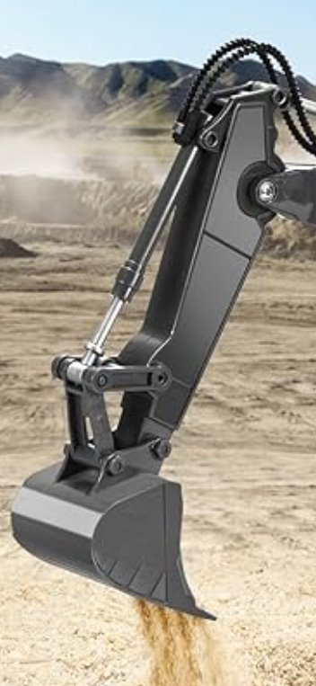
Figure 21: Hanging Pot Figure 22: Crane Hook Figure 23: Excavator Stick

Sichao
The concept generation process began by identifying a range of potential components that could demonstrate increasing levels of structural complexity and design challenge. Three initial concepts were proposed: (1) a basic magnetic hook, (2) a pegboard power drill holder, and (3) an RC car steering knuckle.
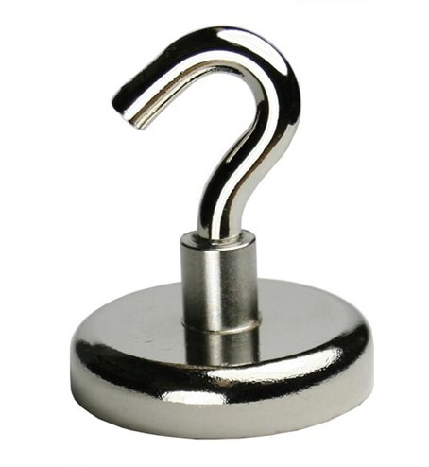
Figure 24: Magnetic Hook 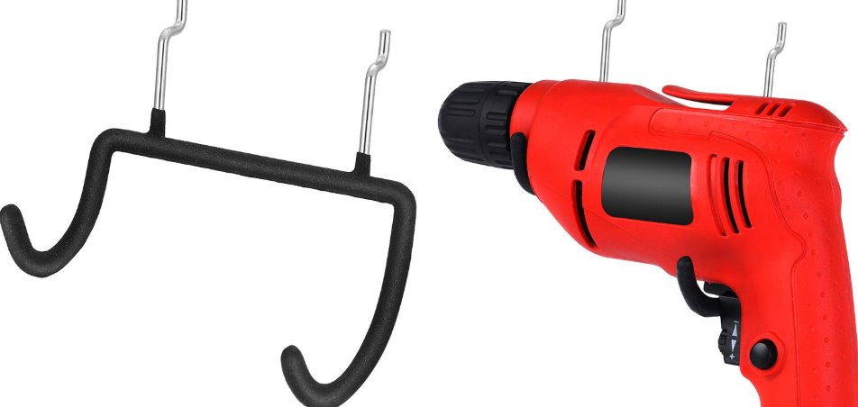
Figure 25: Pegboard Drill Holder
These concepts were selected to represent different functional and geometric complexities, ranging from simple, low-load components to high-load structural parts. The intent was to create a clear comparison between simple geometries that require minimal engineering analysis and complex components that are well-suited for advanced structural optimization techniques such as topology optimization. The RC car steering knuckle was included as the most technically challenging option, representing a real-world suspension component requiring precise tolerances and load-bearing capabilities.
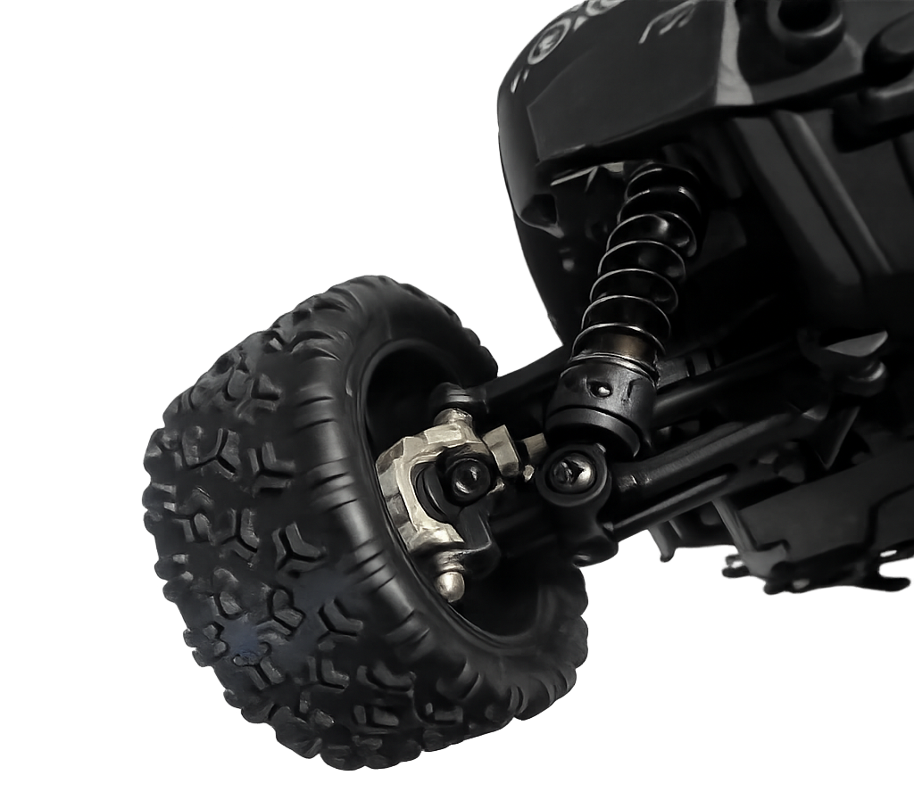
Figure 26: RC Car Steering Knuckle

Riley
The concepts generated for applying topology optimization to existing parts are based on the availability of machined parts for optimization within the Biomechatronics Laboratory. A number of crucial parts for exoskeletons are machined out of aluminum for its lightweight properties. This requires that the parts have thicker geometries to ensure safe operation during use. There are 3 components that the lab are manufactured through conventional manufacturing methods (mill and wire EDM). The components are included on different exoskeleton assemblies, one for the hip exoskeleton and 2 for the current ankle exoskeleton undergoing engineering validation testing. The following figure is provided to show the two individual exoskeletons.
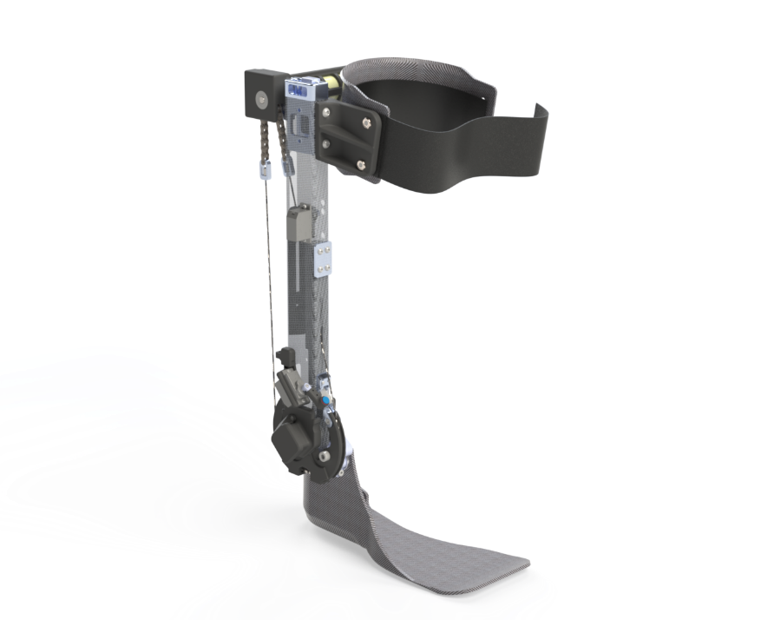
Figure 27: Spark Plug V2 Ankle Exoskeleton Assembly
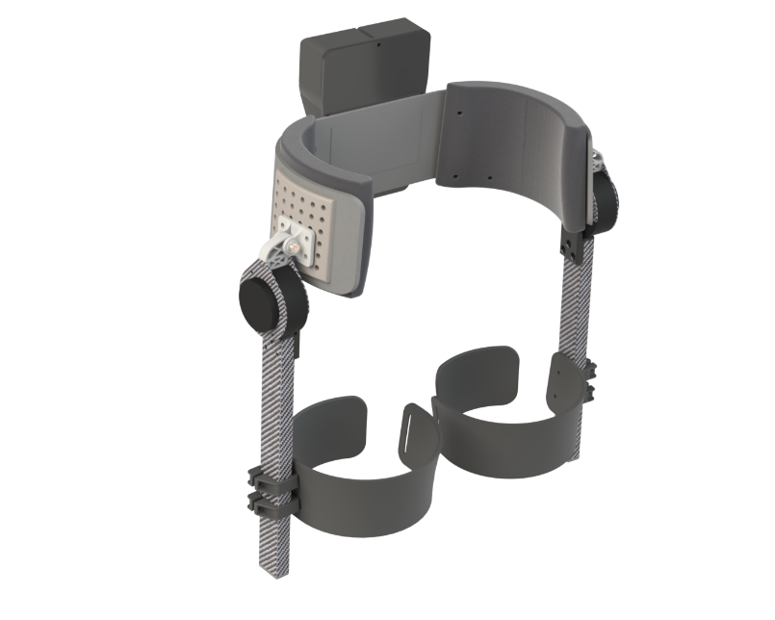
Figure 28: OpenExo Hip Exoskeleton Assembly
The three potential components for selection are the hip exoskeleton abduction bracket, the ratchet bridge on the ankle joint, and the motor mount for the ankle exoskeleton. The hip abduction bracket allows for the abduction degree of freedom for the hip which is necessary for functionality and comfort. It features a hinge connected with bearings and a shoulder bolt. The ratchet bridge component features 13 sets of teether separated by a channel necessary for the actuation cable to smoothly ride in. The bridge closes the pulley that control the ankle joint, adding the needed rigidity for responsive assistance. This bridge allows the device the functionality of a clutch for the ankle joint. The ratchet offers multiple locations for engagement of a pawl connected to a leaf spring mounted inside of the upright. The Maxon motor bracket allows for the motor to be mounted normal to the sagittal plane positioning the power transmission cables to pass through the upright, aligning with the ankle pulley. The following three figures show the individual components.
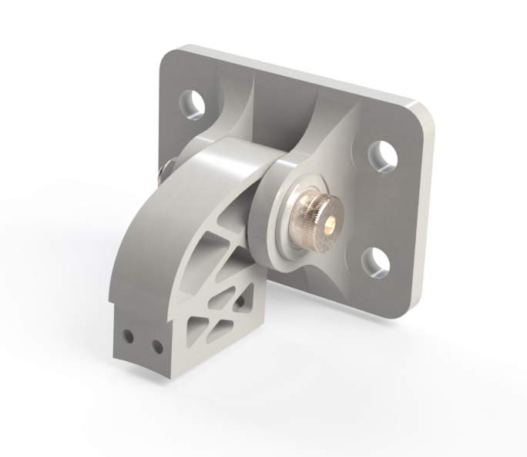
Figure 29: Hip Abduction Bracket Subassembly
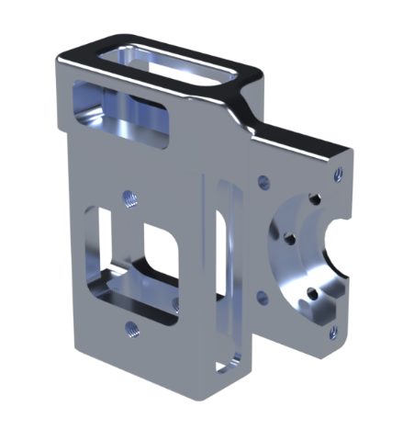
Figure 30: Maxon Motor Bracket
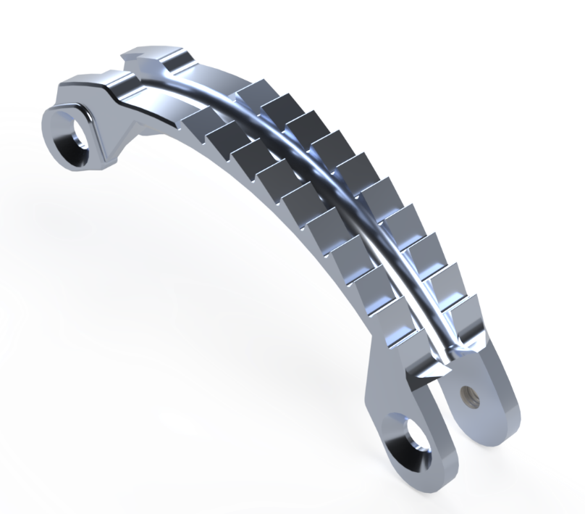
Figure 31: Pulley Ratchet Bridge

Selection Criteria

Partition
For the safe room, the previously mentioned engineering requirements were used to make the selection.
Cost was not weighted as heavily as the other two criteria. Dr. Ciocanel provided the team with a very flexible budget, specifying that he wanted to prioritize safety above all else. The cost of the partition still played a decent role in the selection since the team is expected to fundraise 10% of the total budget.
Safety was weighted the heaviest by far. With Dr. Ciocanel’s specification as well as the research the team had done into the hazards posed by the metal powders being used, ensuring negative pressure and minimal dust spreading was an absolute need.
Ease of Construction wasn’t weighted as heavily as safety, but the team deemed it more important than the cost of the room. The team is expected to build the room as well as design it, so choosing the option that requires less time to construct and has less complex geometry to worry about would be beneficial.

Erik
As briefly mentioned in concept generation, the process of selecting the individual design was rather streamlined. The important criteria for it to meet were complexity, fitting the print volume, having the potential to be topologically optimized, having the potential to replace the original part, and it had to have an engineering application.
Complexity was judged based on the geometry found throughout the part. As part of the project is to 3D model the part and then optimize it, having a design that is too complicated to replicate would stunt the project entirely.
Fitting the Print Volume was also an important criterion. The build volume of the metal printer is around 80x80x90mm, so aiming to have a design that fits those dimensions is ideal. It is possible to scale down whatever design is chosen, but doing so would change its application and sabotage the following criteria.
Topology Optimization Potential was arguably the most important criteria, as it makes up the majority of the overall capstone. This criterion was judged by how optimized the part already was, and whether or not it had any material that could be removed in optimization.
The Replacement Potential of the design was also very important, as one of the goals of the project is to demonstrate the printer’s ability to produce parts that can be used in assemblies. If the individual design chosen was not part of an assembly or could not be replaced, then it negated this portion of the project.
Lastly, the design had to have an Engineering Application. This criterion is simply meant to ensure that the project sticks within the boundary of the field of engineering. It is judged purely on if the individual design had some sort of assembly or mechanical application.

Sichao
The three concepts were evaluated based on functional complexity, fit and integration with assembly, and suitability for topology optimization.
- The magnetic hook showed low functional complexity and low optimization potential.
- The pegboard drill holder demonstrated moderate complexity and moderate optimization opportunities, requiring more structural consideration.
- The RC car steering knuckle scored high across all criteria, with high functional complexity, tight integration requirements, and strong potential for optimization.
This evaluation was performed qualitatively to highlight which concept aligns best with the project goals. By comparing these criteria side by side, it became clear which concept provides the greatest engineering challenge and learning value for this project.

Riley
The evaluation criteria for the selected designs were chosen to align with the team’s overall goal to promote the NAU Idea Lab’s new manufacturing capabilities, leveraging the use of a DMLM (direct metal laser melting) metal additive manufacturing machine. Each criterion can be applied to the design to determine whether or not the design is viable, or which design would be the preferred option based on the scoring of each condition. The evaluation uses 4 unique criteria: topology optimization potential, post-processing requirements, fits within print volume, and visualization in assembly. All criteria can be scored on a high-medium-low scale for simplicity.
The first criterion is the component’s potential for topology optimization. This is important as the difference in design is directly correlated to the component’s potential for minimizing material. This focuses on the ability to reduce the weight of the component based on the expected loading conditions. The team needs to meet the requirements of visually interesting designs for promotion of the machine and the ability to complete work orders.
The following criterion is the post-processing requirement based on the part’s functions. In many cases, post-processing a additively manufactured part is necessary, but the focus for this is to evaluate each design on how much post processing would be required to use the part in the assembly. Metal additive manufacturing has the tendency to have rougher surface finishes right off the print bed, requiring machining to be completed after the build to ensure specific features meet tolerances and use-case specific requirements.
The third criterion is whether or not the evaluated component fits within the printer’s build volume. The Concept Laser MLab Cusing 100R has a build volume of 80mmx80mmx90mm, inhibiting the size of what can be printed. This is a crucial aspect to determine if a design can be manufactured using powder bed fusion. In some cases where a part is too large for the build plate, the design can be split up and fastened together after manufacturing.
The final criterion for the evaluation of the generated options involves the component’s visibility in the full assembly. Because the motivation of the project is to complete a design that can be compared to the conventionally manufactured design. The ability to see the topology optimized part is important to intrigue viewers and want to learn more about the methods used for manufacturing a complex and organically shaped part. The team is expected to show the capabilities of topology optimization and more importantly, the capabilities of additive manufacturing.

Concept Selection
The final CAD models are not included on the concept selection as the team did not create specific assemblies based on the design projects to be completed. The CAD models are shown in the individual sections preceding the concept selection.

Partition
Based on the established criteria, the following Pugh chart was produced:
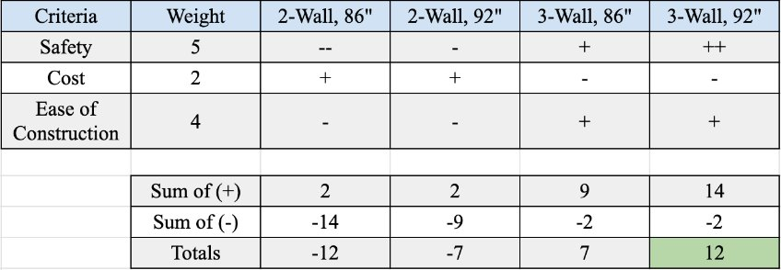
Table 1: Pugh Chart for Partition
Each design was scored individually with “+” representing a positive relationship, “++” representing a strong positive relationship, and “-” representing the inverse. After the partitions were scored, they were multiplied by the weights of the criteria. Finally, the sum of their positive and negative scores is calculated to find a total score. As shown in the chart, the 3-Wall 92” partition was selected.
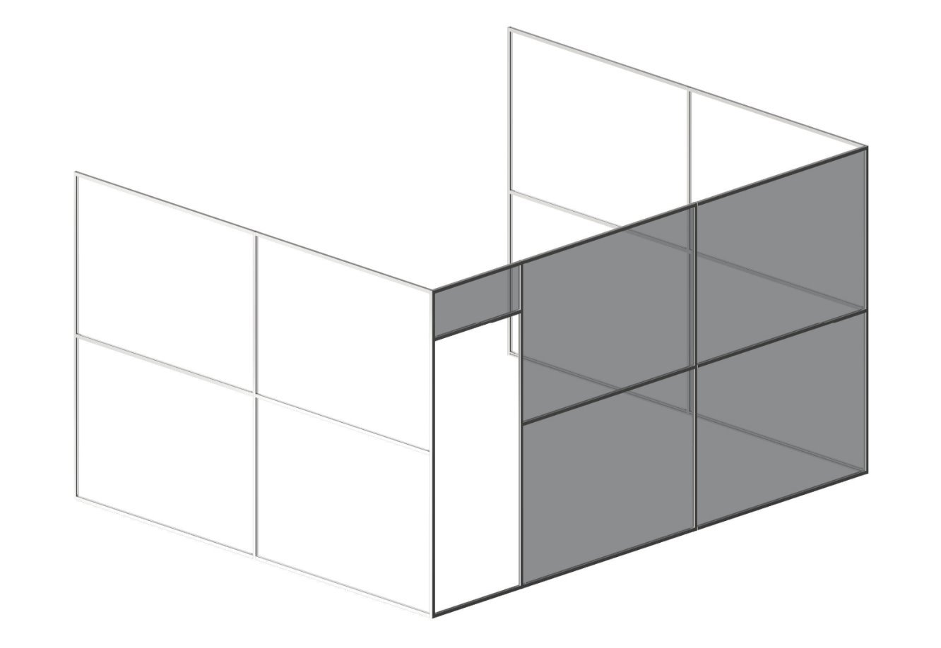
Figure 32: 3-Wall, 92” Partition Design

Erik
Reviewing each of the engineering criteria and the possible designs, the figure below is created:
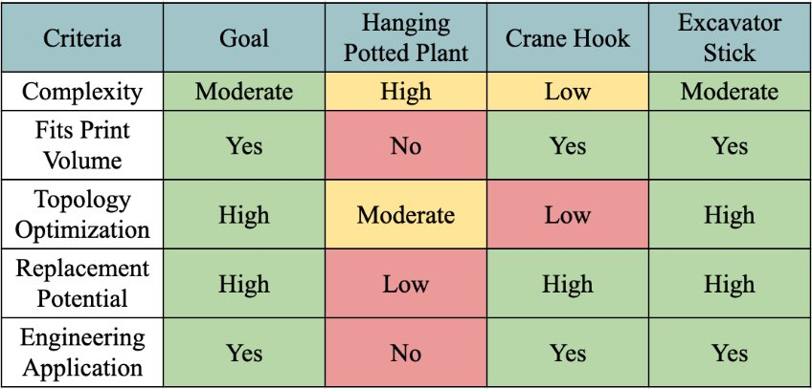
Table 2: Erik Concept Evaluation
The table is organized by criteria, goals to meet, and then each design option. The goal section reflects the ideal ‘measurement’ that each design should meet. A green background shows that the ideal measurement is met, while yellow shows that the measurement is close, and red shows that it is far off.
For the hanging pot, the complexity of the part is very high. Its connections from hook to pot are not symmetrical, and they do not fuse directly in the border of the rim either. The pot is also too big to fit the print volume, and it cannot be optimized thoroughly due to it needing to hold soil and a plant. Since it isn’t part of an assembly, it can’t be replaced. Lastly, because it is a potted plant, it doesn’t have an engineering application either.
As for the crane hook, its complexity was too low. As shown in Figure 32, its design is basically a box with a hook at one end and a loop at the other. Since it was part of an RC crane, it would have fit the print volume. However, there was very little optimization to be done with the design. Aside from turning it into essentially a fishhook, no material could be removed. As part of an assembly of a construction too, it did have replacement potential and had an engineering application.
According to the criteria, the goals, and the ratings, the Excavator Stick is the best design choice. It has moderate complexity in regard to its design, and it does fit the print volume since it is part of a toy. There is a lot of material that can be removed through optimization, and as part of a construction assembly it has both an engineering application and high replacement potential.

Sichao
Based on the evaluation results, the RC car steering knuckle was selected as the final design concept. This concept offers the highest functional and geometric complexity, making it ideal for applying advanced analysis methods such as topology optimization and finite element analysis.
Unlike the other two concepts, the steering knuckle must interface precisely with multiple components in the suspension system, bear significant steering and vertical loads, and maintain dimensional accuracy. These requirements align closely with the project objectives of designing a lightweight, high-performance component through additive manufacturing.
Additionally, the original concept was considered too simple and lacked meaningful engineering challenges, which limited its value for optimization and structural analysis. The material cost for that initial design was also relatively high compared to its functional benefit, making it an impractical choice for this project. In contrast, the RC car steering knuckle provides a more efficient balance between complexity, performance, and material usage, ensuring both technical depth and cost-effectiveness.
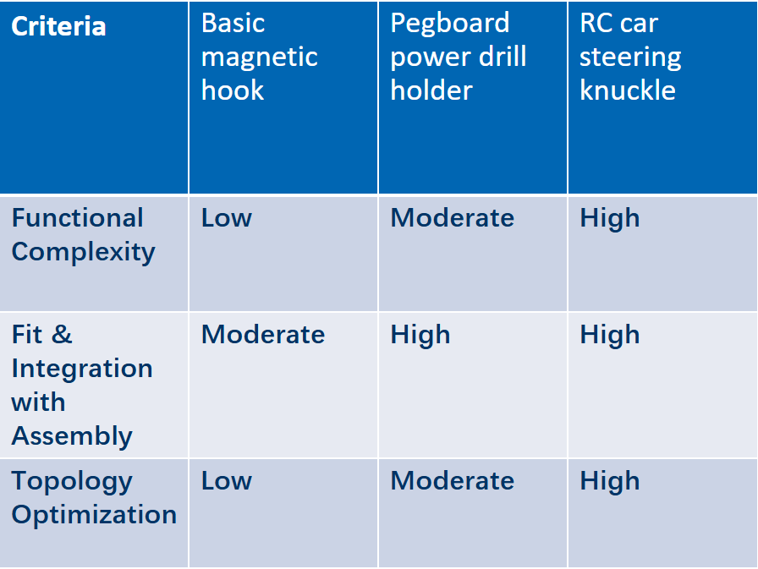
Therefore, the RC car steering knuckle was chosen for detailed design development, topology optimization, and structural testing in the next phases of the project.
Table 3: Sichao Concept Evaluation

Riley
The components were scored individually, and the results were compiled into a table for clear communication of the results. The target score is also included to compare the scoring of each criterion. Colors were included to prominently show whether a criterion is met or if the component is less preferred. The justification for scoring is included following the results table.

Criteria​
Topology Optimization Potential ​
Post- Processing Requirements​
Fits within print volume​
Visualization in Assembly​
Table 4: Riley Concept Evaluation Results

The hip abduction bracket has the highest topology optimization potential due to the geometry of the current design. The current design has a square form factor to better accommodate the subtractive manufacturing (milling) process. The other two designs were already designed with the requirement of lightweight size and construction. This prevents both the Maxon motor bracket and the ratchet bridge from being good choices for the project. The hip abduction bracket requires the least amount of post processing, potentially only needing a few features to be machined to achieve the target surface finish and tolerancing. The bearing bores and threaded holes are likely to be the features requiring post-processing. The Maxon motor bracket requires more post-processing due to the need for smooth surface finishes on the faces mating with the carbon fiber upright. If the interfacing surfaces are not smooth, the bracket will wear away the carbon fiber, causing a shorter lifetime of the upright. The ratchet bridge needs the most post-processing in order to function effectively. The ratchet needs smooth surfaces for the pawl to slide against, making engagement smoother and more reliable. Although all components fit within the print volume, some components are better suited for printing than others. The hip abduction bracket and ratchet bridge fit easily into the print volume and can be oriented in any direction for optimal results. The Maxon motor bracket is too tall to be printed vertically and would require many supports to print properly. If the part were oriented with a surface parallel to the build plate, the print would have poor quality on the overhanging surface due to the inherent overhang sensitivities in additive manufacturing. Lastly, the hip abduction bracket has the best visualization in the final assembly due to the location being on the lateral sides of the hip with no additional components covering it. The ratchet bridge passes through the bottom part of the upright, covering 80% of the component when the user is standing straight. The Maxon motor bracket is covered by a PCB and housing (not shown in the figure), and this means the component would be nearly impossible to see at a glance. The hip abduction bracket is the only option that meets all target criteria, justifying it as the selected concept.

Schedule and Budget

Schedule
For each of the semesters, the GANTT chart is provided showing all the required tasks the team needs to complete, how the tasks are categorized, the general flow of project completion, and the planned timeline. The commissioning tasks are shown in orange, the course deliverables are shown in blue, the individual design projects shown in yellow, and the service work shown in green. Many tasks are linked together with a leader to show how they connect, providing the process for the multiple aspects of the project. Images of each semester are shown below, but the draft created for the spring semester is a basic draft that does not include the course deliverables because a tentative schedule was not provided for the second semester of capstone. Following each figure, all tasks will be listed with a brief description in chronological order.
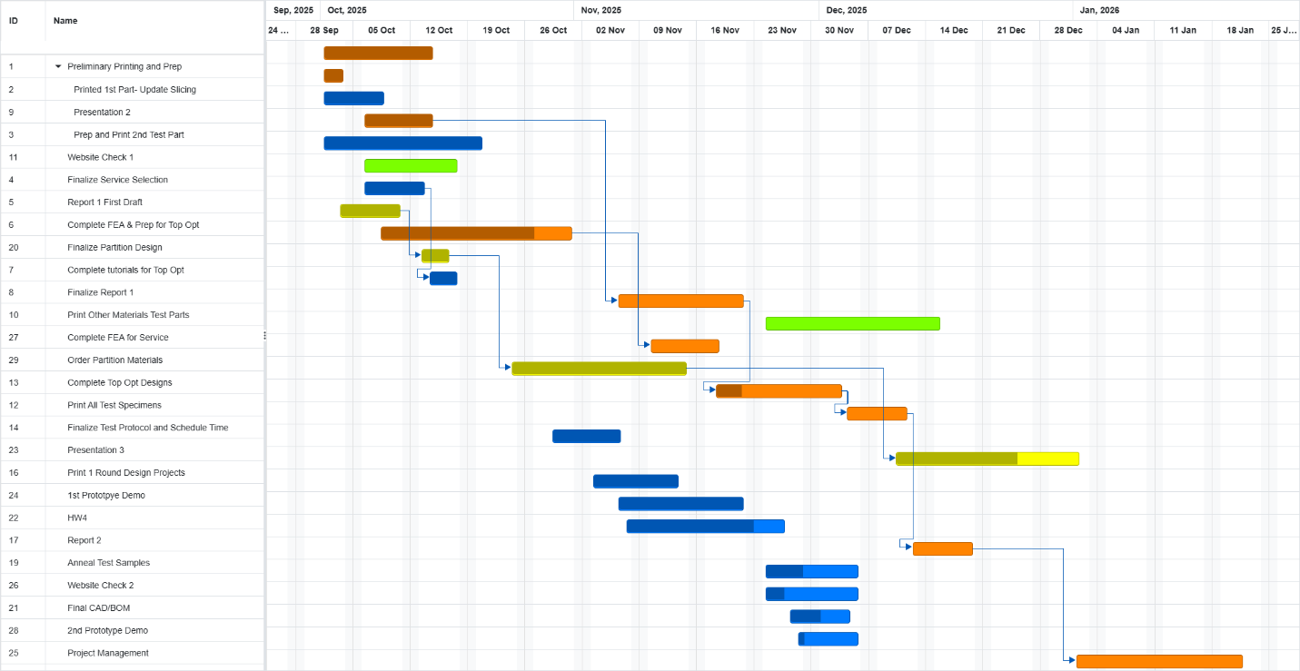
Figure 33: Fall Semester GANTT Chart
Preliminary Printing and Prep is the first category encompassing the initial tasks for using the printer. Printed 1st Part consists of ensuring the printer can function and manufacture parts reliably. The purpose of this task is to get the team started with printer by familiarizing the team with the operational procedures. Presentation 2 is the concept generation and evaluation presentation and required the team to make the first GANTT chart. Prep and Print 2nd Test Part is to get another part printed as the initial part had print quality issues the team needs to resolve. Website Check 1 was completed to ensure that the team will have the website started and ready to be added to as the project progresses. Finalize Service Selection involves choosing the other capstone teams that the team will manufacture topology optimized parts for. Report 1 First Draft is the initial draft of the first report. It is a separate task to ensure the team has time to make any necessary revisions. Complete FEA & Prep for Topology Optimization includes preliminary work to make sure the team can successfully optimize geometries using nTop. Finalize Partition Design includes preparing the team to order all required materials to make a partition for the IDEAL Lab. Complete Tutorials for Topology Optimization is important to make sure the team has the resources to define and run a topology optimization that will produce reasonable results. Based on the previous capstone team’s topology optimization, it is important to have sufficient models to promote the capabilities of metal additive manufacturing. Finalize Report 1 consists of the revisions made before submitting the report for grading. Print Other Materials Test Parts involves printing more than the 316 stainless steel that the printer has been exclusively printing. Complete FEA for Service involves the initial steps to complete the team’s service responsibilities and will be the parameters for the following topology optimizations. Order Partition Materials will allow the team to prepare for building the partition and will define the timeline for the installation. Complete Topology Optimized Designs is for the individual design projects so that the team can stay on track to complete all project requirements. This will signify the end of the design and building process, shifting plans to testing and validation. Print All Test Specimens includes the manufacturing of all materials the team plan to print. This will provide the team with the specimens to complete tensile testing. Finalize Test Protocol and Schedule Time will outline the testing procedure and require the team to select a time to work with Dr. Ciocanel to test the material properties. Presentation 3 is the initial design presentation focused on the preliminary design and work complete based on the concept generation and evaluation. Print 1st Round Design Projects is completing the prints for the initial designs of the individual topology optimized parts. 1st Prototype Demo showed the team’s initial prototypes for the project. This involved answering initial questions in the design process. HW4 is an individual assignment completing further analysis towards project success. Report 2 completes all updates to the initial report and acts as the documentation for the metal 3D printer project. Anneal Test Samples includes getting the test specimens heat treated to see the effects of not annealing the samples. Website Check 2 requires updates to the website so that they are up to date. Final CAD/BOM is the final design and CAD package that is a major deliverable for the capstone course. 2nd Prototype Demo is further prototyping to answer more questions and will improve the design of the project. Project Management is an evaluation of the first semester and looks ahead towards the final semester of capstone, focusing on logistical improvements that the team can make to be successful.
The team is not on track with this GANTT chart, and as it was made, the deadlines set were very ambitious to push the team to complete as much progress as possible. This is due to many issues using the printer and numerous expectations added to the project. This has made it very challenging for the team to be successful, but despite all challenges, the team has been able to achieve significant progress. Although the team is behind based on this GANTT chart, the timeline still allows for the team to complete all responsibilities and have a successful outcome.
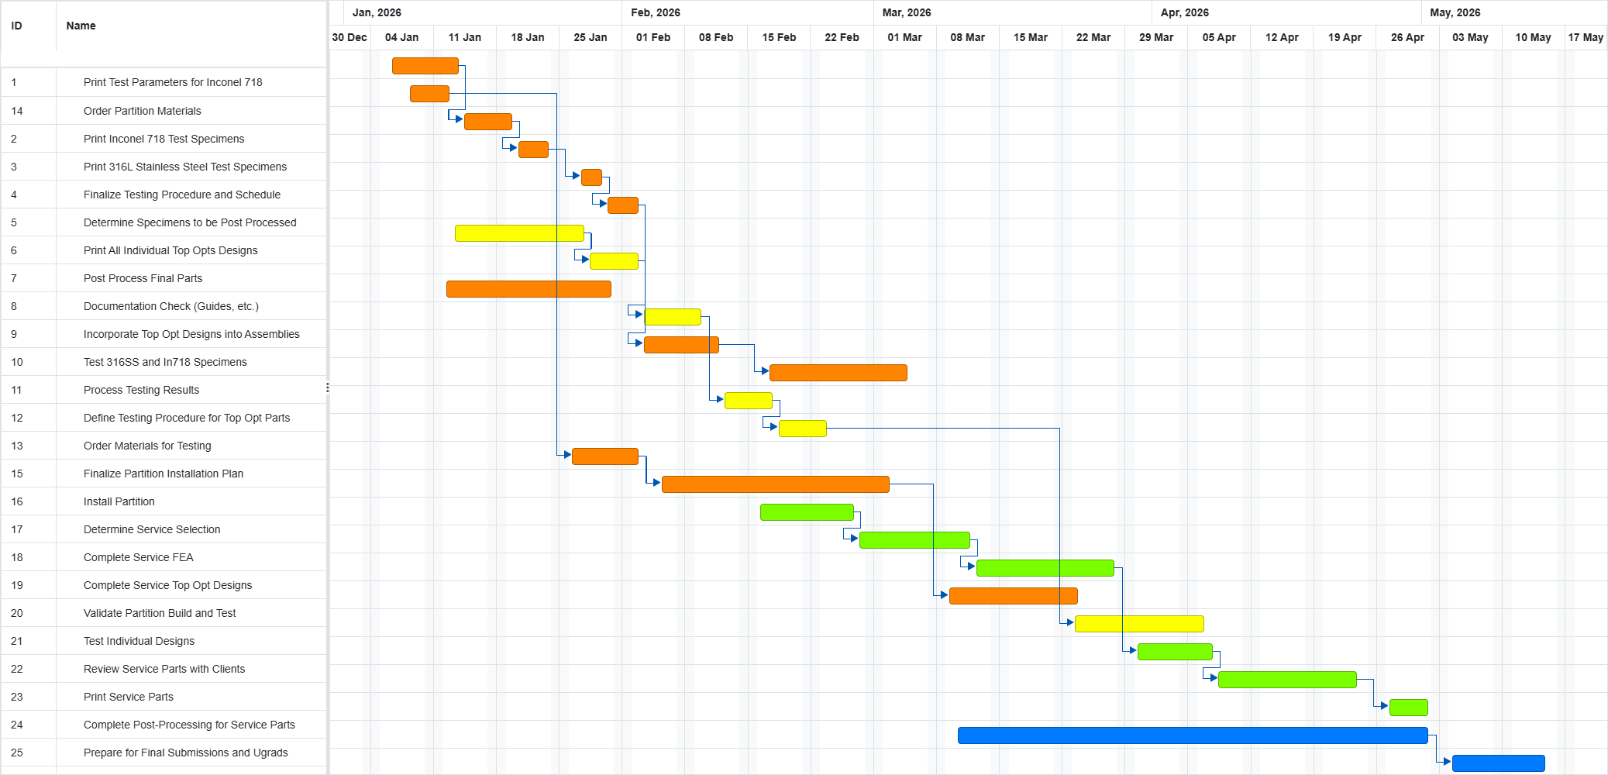
Figure 34: Spring Semester GANTT Chart Draft
The tasks for the second semester include previous tasks in the fall semester GANTT chart to accommodate for the team’s current progress.
Print Test Parameters for Inconel 718 focuses on validating the parameters defined for printing this new material. Order Partition Materials will complete the design phase of the partition. Print Inconel 718 Test Specimens will provide the team with another engineering material to be tested and validated for printing on the machine. Print 316L Stainless Steel Test Specimens relies on the ordered material to arrive but would complete the test specimen manufacturing. Finalize Testing Procedure and Schedule require the team to prepare all necessary documentation and coordinate with Dr. Ciocanel for testing. Determine Specimens to Be Post-Processed is supposed to evaluate what materials should be annealed and HIPed. Print All Individual Topology Optimized Designs are the conclusion to manufacturing the individual design projects. Post-Process Final Parts prepare the designs to be incorporated into the corresponding assemblies. Documentation Check (Guides, etc.) ensures that the team is completing the required documentation for future students to reference when using the printer. Incorporate Topology Optimized Designs into Assemblies showcases the parts and NAU’s capabilities of additive manufacturing. Test 316SS and In718 Specimens provides the team with the data to report on the printer’s ability to manufacture reliable parts. Process Testing Results convert the gathered data and draw conclusions informing the team on the properties of metal sintered parts. Define Testing Procedure for Topology Optimized Parts validates the individual design projects. Order Materials for Testing includes acquiring all sensors and materials to precisely test the individual design projects. Finalize Partition Installation Plan outlines how the team will install the partition to ensure powder is contained. Install Partition completes the commissioning requirements given by Dr. Ciocanel. Determine Service Selection allows the team to prepare all parts to complete the service component of the capstone project. Complete Service FEA provides the initial parameters for topology optimization. Complete Service Topology Optimized Designs prepares the team to print service work parts. Validate Partition Build and Test ensure the partition is functioning properly making the IDEA Lab safer. Test Individual Designs validates the individual designs with methods discussed later in this report. Review Service Parts with Clients ensures that the final parts are sufficient and ready to manufacture. Print Service Parts completes the team’s service commissioning. Complete Post-Processing for Service Parts prepares the parts to be delivered to the other capstone teams for use in their projects. Prepare for Final Submissions and Ugrads completes the project and will allow the team to graduate.
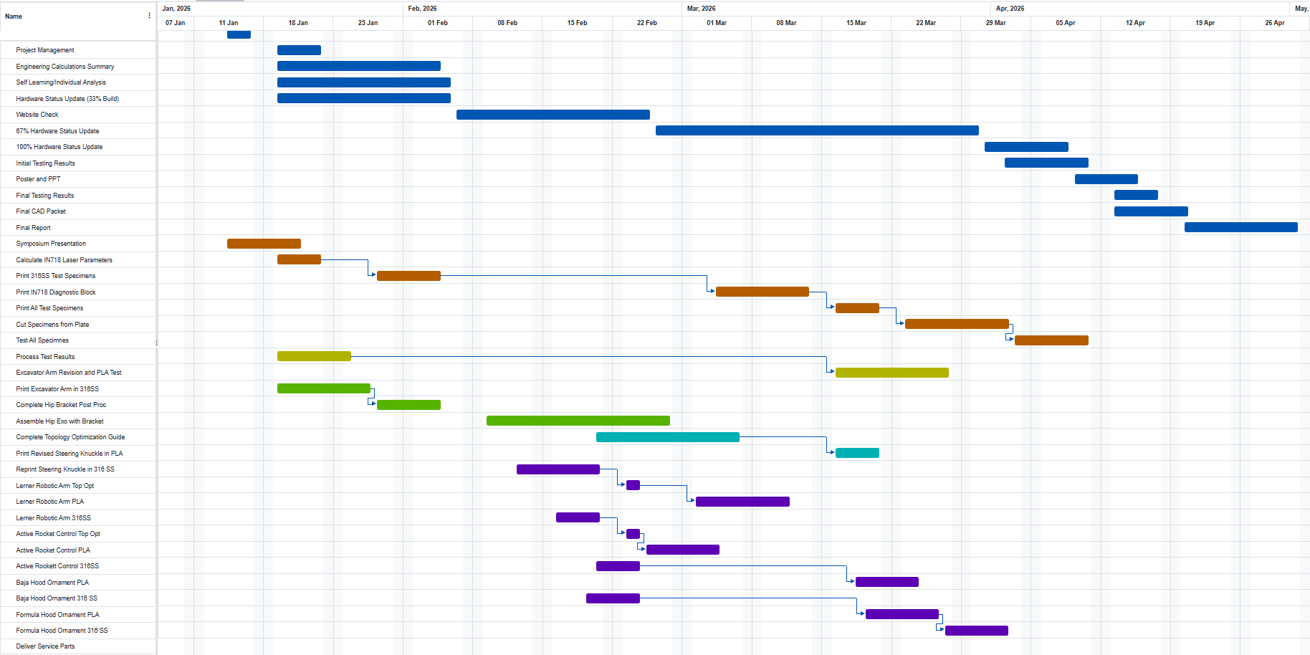
Figure 34.5: Spring Semester GANTT Chart Draft
The finalized GANTT chart is shown above and include many of the task in the draft and more tasks to complete the project in the final semester. The tasks shown in blue represent the course deliverables including project management, design calculations summary, self-learning/individual analysis, 33% hardware status update, website check, 67% hardware status update, 100% hardware status update, initial testing results, poster and PowerPoint for UGRADS, final testing results, final CAD packet, final report, and symposium presentation. These assignments consisted of reports and presentations which offered key deliverables and deadlines to prepare the team for project completion and dissemination.
The orange boxes represent the rest of the commissioning tasks to complete printer validation and operation. These include the testing and validation of the Inconel 718 laser parameters, printing Inconel 718 diagnostic blocks and test specimens, and heat-treating half of the specimens, and testing all specimens. Due to challenges with the lead time for post processing, the heat treated specimens have yet to be tested by the submission of the final report.
The yellow tasks are related to completing the manufacturing of the excavator arm. This included printing the part and completing post processing to install it on the final assembly. The tasks are separately broken down into validating the updated design and printing the arm in two separate parts. The parts were post processed before installation.
The green tasks represent responsibilities of the team lead, Riley Shepard. This included finalizing the assembly of the hip exoskeleton and creating the topology optimization guide. The abduction bracket was tested on the hip exoskeleton and part of the initial and final testing course deliverable tasks.
The teal tasks show the steps in completing the steering knuckle individual design project. The steering knuckle needed to be validated in PLA before printing in 316L stainless steel. Then after manufactured in metal, the parts were post processed by removing the part from the build plate and cleaning all support materials from the final part.
Lastly, the purple tasks relate all steps for the service requests part of the project. This included the completion of topology optimizations for the Active Rocket Control and Lerner Robotic Arm capstone teams. After the topology optimized models were validated through FEA, the models were printed in PLA to ensure fit and function. Then the parts were printed and post processed to prepare for handoff. Additional service requests included both SAE teams and consisted of hood ornaments for the Formula and Baja racing teams.

Budget
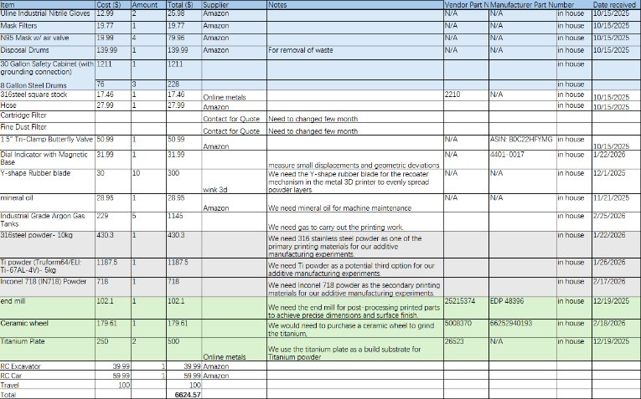
Figure 35: Budget
A comprehensive Bill of Materials (BoM) was developed to outline all components, consumables, and equipment required for the successful execution of the metal additive manufacturing and steering-knuckle prototyping project. The BoM includes both purchased components and materials that will be machined in-house. Key cost drivers include metal powders (Ti-6Al-4V and 316 stainless steel), safety and filtration equipment, and the safety cabinet for powder-handling safety measures. Several consumables—such as N95 masks, nitrile gloves, fine-dust filters, and cartridge filters—are listed due to the need for periodic replacement as part of standard metal-powder safety protocols.
Materials such as titanium plates, 316 stainless steel stock, and end mills will support the fabrication and post-processing of printed components, while items like the Y-shaped recoater blade and mineral oil are required for printer maintenance. Measurement tools, including the dial indicator with magnetic base, are included to ensure dimensional accuracy and geometric verification of printed parts. The BoM also differentiates between purchased components and those requiring in-house machining, specifies suppliers (Amazon, Linde, Online Metals, 80/20, Wink3D), and documents relevant part numbers where available. Lead times vary from immediate shipment (Amazon items) to multi-day procurement (Linde powders, 80/20 partition panels).

Bill of Materials
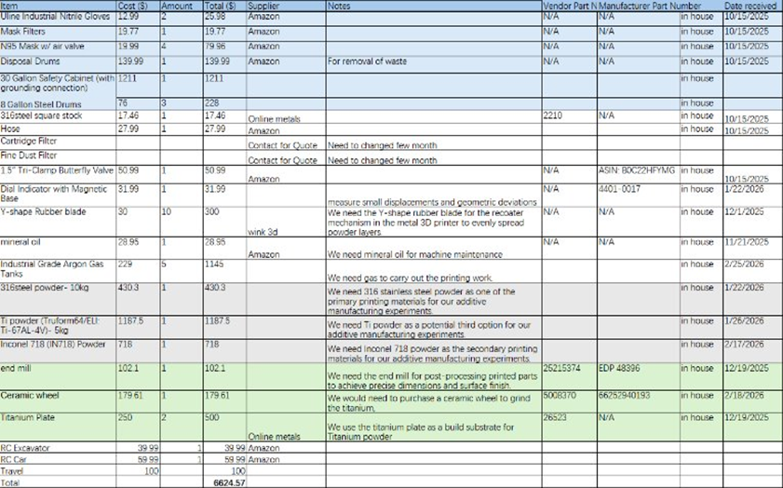
Figure 36: BOM
A detailed Bill of Materials (BoM) was constructed to document all components, raw materials, consumables, and tooling required throughout the metal additive manufacturing workflow for this project. The table includes unit cost, quantity, total cost, supplier information, vendor part numbers, and manufacturer part numbers whenever available. For items purchased through Amazon or other consumer-grade suppliers, many products did not provide standardized part numbers; therefore, these fields are listed as N/A with notes indicating that the supplier does not publish a formal identification code for these commodity items.
Key materials such as 316 stainless steel powder, Ti-6Al-4V powder, and titanium build plates were sourced from specialized industrial suppliers (e.g., Linde and OnlineMetals) and include verified part numbers such as OnlineMetals part 26523. Tooling required for post-processing—such as the Helical Solutions end mill—includes both a supplier SKU (25215374) and a manufacturer EDP number (48396), ensuring full traceability for machining operations.
Items such as PPE (N95 masks, nitrile gloves), disposal drums, and hose connections are also included because they are essential for safe and compliant metal powder handling. These products are typically general-purpose consumables and therefore do not provide a unique vendor or manufacturer part number.
Overall, this BoM provides a comprehensive overview of the materials and equipment necessary to support the metal 3D printing process, from powder handling and machine preparation to part post-processing and inspection. This documentation ensures traceability, facilitates future procurement, and aligns with the project requirements for a complete and transparent materials listing.

Design Standards
The design standards for this project are particularly important due to the nature of the parts the team produces. Especially with the service work done for other teams, it is essential for the parts produced by the printer to have the appropriate tolerances labeled.
Tolerances in general are an important part of the engineering industry as a whole. More precise tolerances mean significantly higher prices for machining, but wider tolerances could cause parts to be unusable in their designs. Learning how to label, read, and design around design standard tolerances is what will allow our team’s service work to be of any use to the team’s requesting it.

Design Standards Research
[30] ASTM E8/E8M
These are the basic standards that define how to go about designing and completing a tensile test. It identifies acceptable dimensions for the tensile specimens themselves, as well as machine speeds and potential applications of the results depending on that speed.

[31] Dimensional Accuracy of Fabricated Geometries Through Powder Bed Fusion
As the name suggests, this source was a study on a variety of prints done through powder bed fusion, which is what the MLab Rcusing uses. Specifically, this source covers what sort of dimensions and geometries the PBF additive manufacturing can handle with minimal deformation.

[32] Ultimate and Yield Strength Relations to Shear Strength and Hardness
This source serves as a simple reminder of how to calculate shear strength and material hardness when given the ultimate tensile and yield strength of a material.

[33] Metallurgy & Process Development
The focus of this source is on metallurgy as a whole and the different versions of manufacturing (such as casting). This source serves as further background into metal AM and safety procedures regarding it.

[34] Open-source Modular Exoskeleton to Augment Human Function
As stated in the name, this source is a modular exoskeleton very similar to the one that Riley used in his individual design project. It outlines several features and safety measures.
[35] AISI 316 Stainless Steel Properties
Since SS316 is one of the materials we will be testing, having a list of all relevant material properties will be essential for our testing comparisons. This source provides those properties.

[36] Additive manufacturing: General principles—Part 2: Overview of process categories and feedstock
This source covers the general process of metal AM as well as a variety of potential feedstock (i.e. potential powders to print in). It also covers safety recommendations for that variety of materials.

[37] Additive Manufacturing: Test Artifacts—Geometric Capability Assessment
Similarly to source 31, this one discusses the geometric capabilities of metal AM.

[38] Additive Manufacturing: Feedstock Materials—Methods to Characterize Metal Powders
Adding to source 36, this source covers specific properties of metal powders used in metal additive manufacturing. While 36 discusses general powder safety, this source covers specific issues that each material may have (e.g. aluminum being exceptionally combustible).

[39] Digital Product Definition Data Practices
This source outlines specific data and specifications to show when creating drawings of 3D models.

[40] Additive Manufacturing: General Principles and Terminology
[41] Additive Manufacturing: General principles, Requirements for Purchased AM Parts
[42] Additive Manufacturing: Design, Requirements, Guidelines and Recommendations
Sources 40-42 all describe ASTM GD&T requirements for drawings.

Design Standards Used
Sources 30, 32, and 35 will all be directly used in our testing of the 3D printed tensile specimens. Those sources outline the exact procedure to follow while testing, how to find the properties of our tested specimens, and what properties the material would have if it were milled rather than printed.
Sources 31, 33, 36-38 refer to the printing process itself. This includes the behavior of the materials, the safety recommendations for printing in them, or the geometries to design when setting up the print. This of course will indirectly affect our tensile specimens, but it is applicable to any and all prints we do.
Lastly, sources 39-42 all outline formatting and required information for the drawings the team will need to compile at the end of the project. Whether this be orientations, dimensions, or tolerances, these sources will ensure that the team produces drawings that are up to industry standards (GD&T).

Erik- Excavator Arm
As is the purpose of this project, the team aims to print several tensile test specimens in 316SS as well as Inconel 718. To ensure the printed specimens are compatible with readily available data for machined pieces of the same materials, the ASTM E8/E8M standards were used while designing the team’s pieces [30]. There are various test specimen types, applications, and testing procedures to align with generalized processes to provide accurate data. The specifications for what type of test specimen should be used for the type of material whether that be metal sheets, rods, or additively manufactured parts.

Sichao- Steering Knuckle
When designing and manufacturing a 316L additively manufactured steering knuckle, standards are needed to control the full workflow from process selection and powder qualification to design-for-PBF rules and drawing/model communication. ISO 17296-2 [31] provides a high-level overview of AM process categories and associated feedstock, which is useful for justifying the selection of a metal powder-bed fusion route and documenting how the chosen process uses metallic powder to create geometry. For system verification and dimensional capability, ISO/ASTM 52902 [32] defines geometric test artifacts and assessment methods that can be used to benchmark machine performance and dimensional accuracy—helpful for validating whether the printer can reliably produce small features and interfaces relevant to a wheel-end component. Because powder condition strongly influences spreadability and defect formation, ISO/ASTM 52907 [33] specifies technical requirements and characterization methods for metal powders intended for AM (e.g., sampling, PSD, chemistry, morphology, flowability, contamination, and storage), supporting traceability and lot-to-lot consistency for 316L powder. For geometry rules specific to laser powder-bed fusion of metals, ISO/ASTM 52911-1[34] provides detailed design recommendations tailored to PBF-LB/M (e.g., process-driven constraints that affect feature formation, supports, and manufacturability), which is directly applicable when topology optimization generates complex shapes that still must be printable and post-processable. Finally, to ensure manufacturing and inspection interpret the design consistently, ASME Y14.41 [35] supports model-based definition (digital product definition datasets), and ASME Y14.5 [36,37] governs GD&T practices; together they help standardize how critical interfaces (bearing seats, bolt patterns, link attachment points) are specified and inspected for the steering knuckle.

Riley- Hip Abduction Bracket
There are several standards associated with the design and manufacturing process when considering additively manufactured metal components. The standards include ASTM F42 which discusses terminology, materials and processes, test methods, and design considerations.
ASTM F42.91 [38] defined the categories of additive manufacturing while defining key terms including build direction, support structure and lack of fusion porosity. ASTM F42.92 discusses the additive manufacturing process requirements, characteristics, and performance to validate the process for aerospace applications. This standard is especially helpful in ensuring the team is abiding by the proper expectations. This includes information on machine qualification, process control, powder handling, and repeatability and reproducibility, all crucial considerations in the team’s objective.
ASTM F42.93 [39] discusses the mechanical property evaluation of metal additively manufactured materials. This section reviews build orientation effects, anisotropy, porosity considerations, and post processing requirements. The team is planning on having some test specimens post processed to compare the differences in thermal and pressure post processing on the part’s tensile strength. This standard connects to ASTM E8/E8M standards by discussing the application of testing procedures while complying with the tensile test specimen standards.
The last section that still applies to the project pertains to the design of additively manufactured arts. ASTM F42.94 [40] covers the design for additive manufacturing, load paths, minimum feature size, overhang angles, and supports minimization. These considerations are crucial to the project as the parts should be optimized for the proposed manufacturing method. This standard will help the team ensure that the topology-optimized designs are acceptable under widespread agreement in the field.

Design Validation and Initial Prototyping

Failure Modes and Effects Analysis
While running diagnostic prints in the mLab Cusing 100R, the team ran into several issues. The following figure details what the issues were, their severity (sev.), frequency of occurrence (occ.), and how detectable the error was (det.). After rating them on a scale of 1-5, the values are all multiplied together to produce a final Risk Priority Number (RPN). The RPN, ranging from 0 to 125, represents how significant the error is and how drastically it affects the printed products. The ‘p’ variations of each category are treated as the real versions, while the earlier versions are treated as the most drastic results. The final ΔRPN signifies the difference between the real results as opposed to the hypothesized ones. Higher positive values mean the danger was overestimated, negative values show underestimation, while 0 means the hypothesized risk is reflected in the actual one.
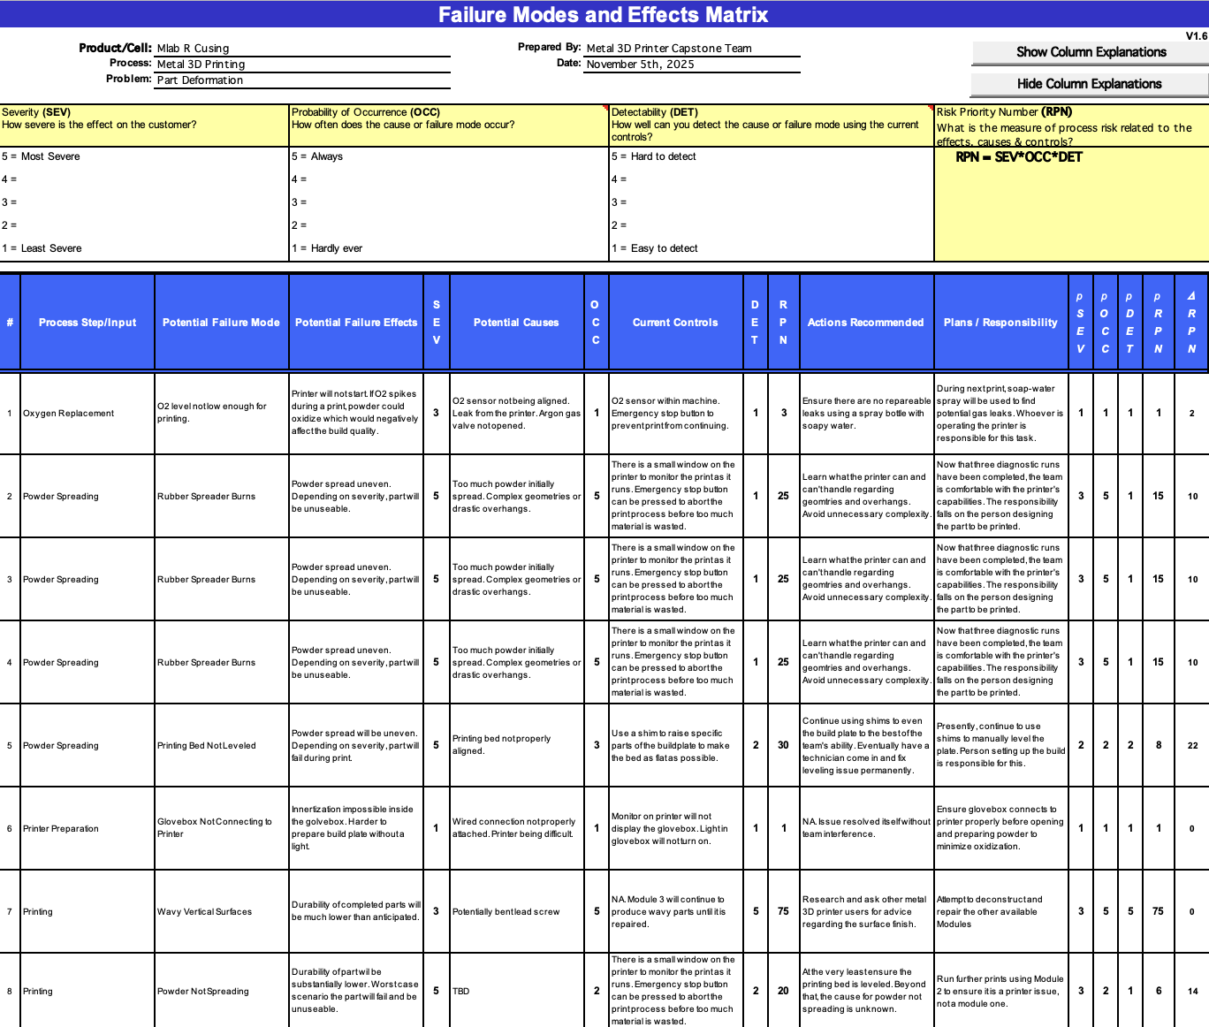Figure 37: FMEA
Considering the results of the FMEA, the team has prioritized minimizing complex geometries and severe overhangs, as well as the repair of other Modules in hopes of removing the wavy surface finish issue. With recent prints, the team has managed to reuse the rubber coater blades since they hadn’t burned in prior prints. The team also disassembled modules 1 and 2, took parts from each that worked, and then reassembled module 2 using all of the functional sections. This resulted in a print that no longer had the wavy surface finish. The next goal is to repair module 3 for the sake of having two separate functional models, but at the very least the team has managed to resolve the issues identified in the FMEA thus far.

Initial Prototyping

Erik
For the initial prototyping, the focus was on producing a topology optimized excavator stick that would retain its necessary geometries and fit into the original excavator assembly. Using the stress and displacement models shown in Figures 9 and 10, nTop was used to complete a topology optimization using a density parameter. With the initial excavator stick being made of plastic, the goal of the optimized part is to retain its predecessor's functionality while either increasing the range of motion and/or increasing the part’s durability.
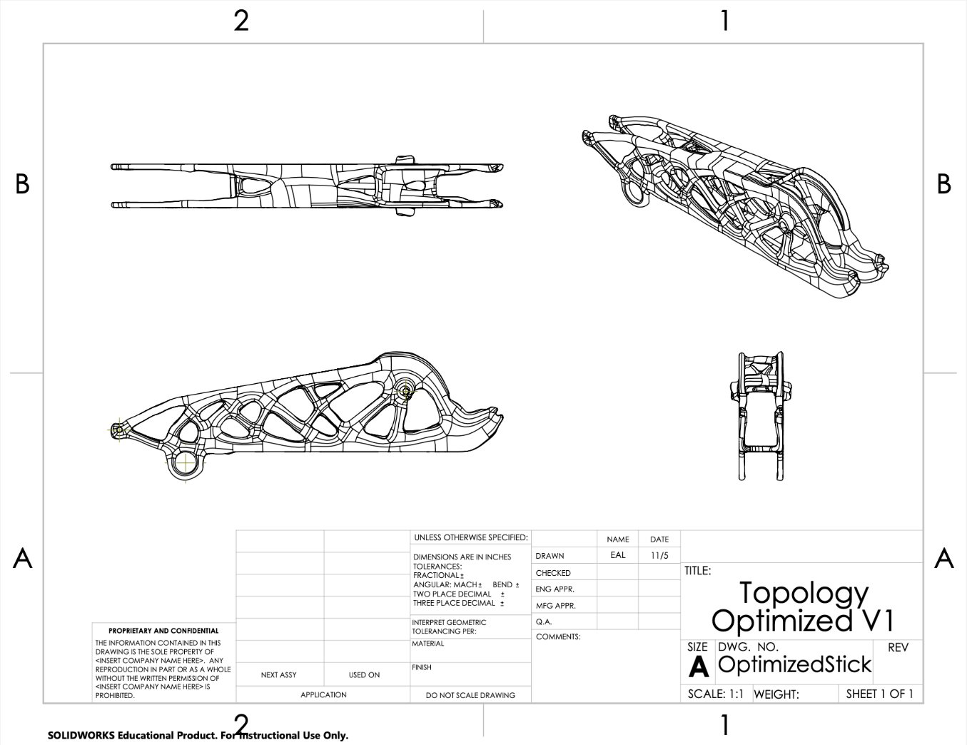 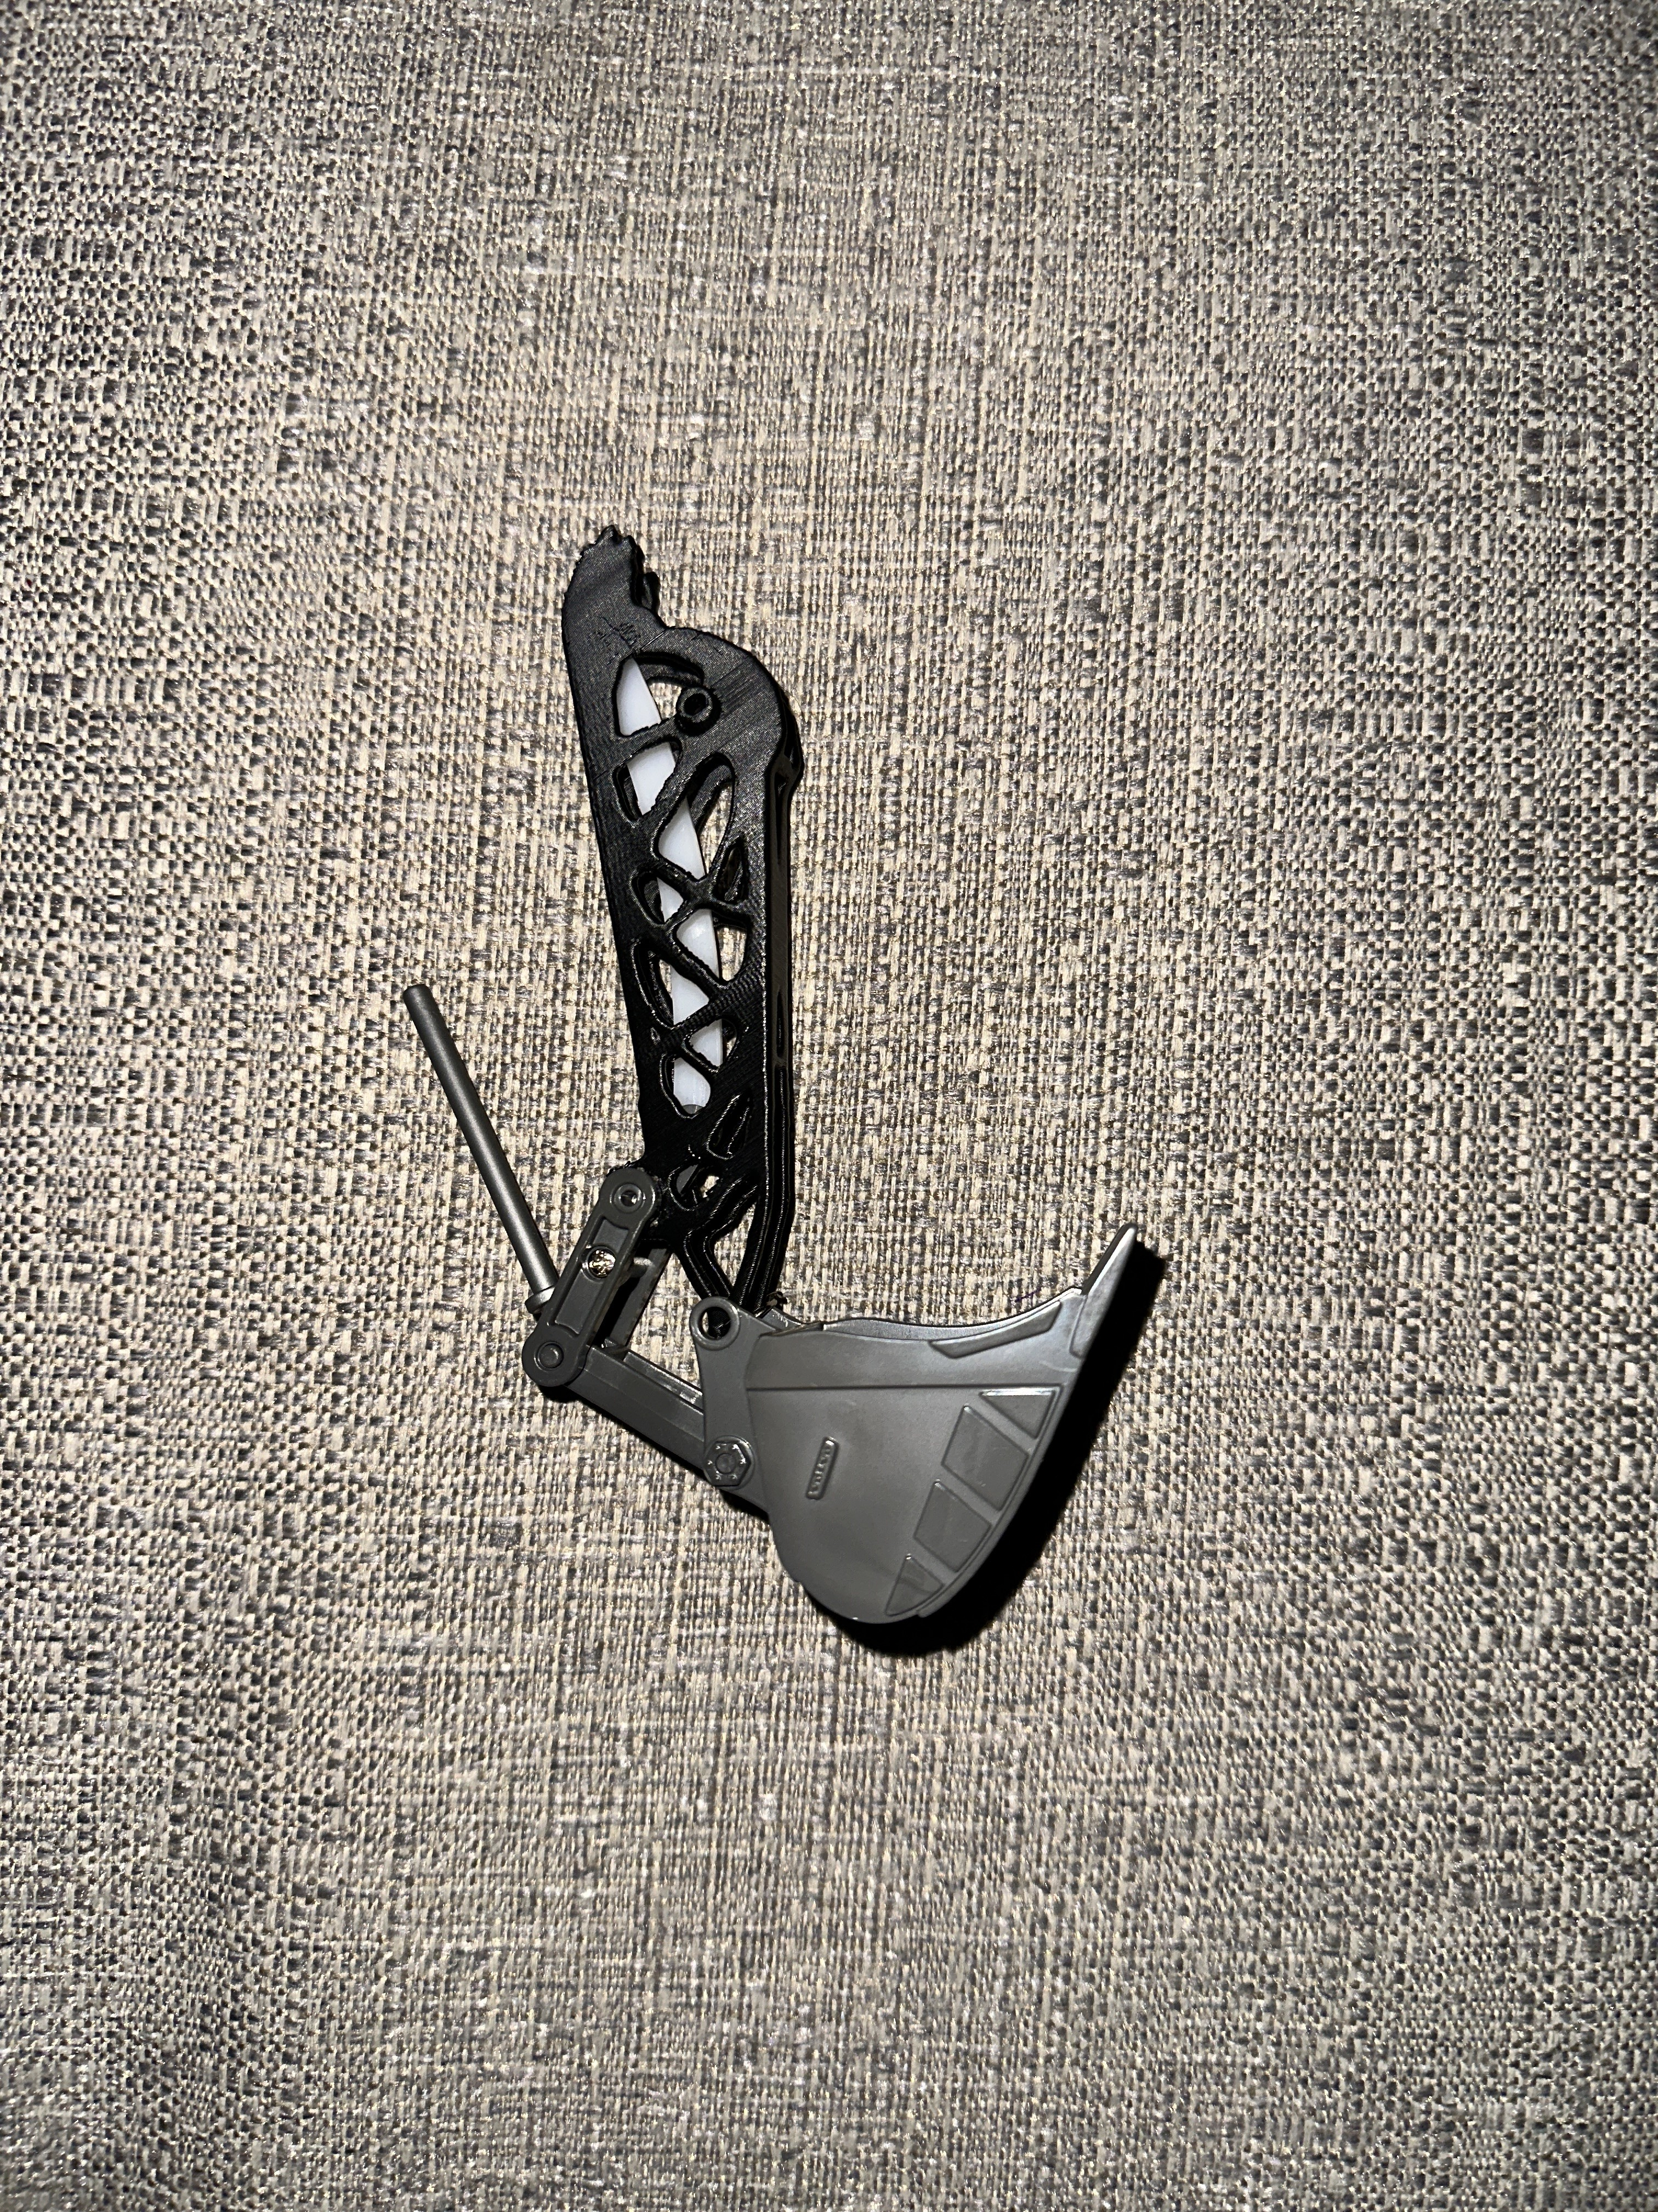 Figure 38: Optimized Stick Drawing Figure 39: Optimized Stick + Bucket
As seen in Figure 39, the optimized stick was printed in PLA on Riley’s printer and was able to connect to the bucket attachment, albeit with some filing to reduce the size of the insert. Unfortunately, the radius and diameter measurements were mixed up for the boom attachment, so the the prototype did not fit the assembly as a whole. The bucket system does function as intended, so the optimal next step is to readjust the dimensions for the boom connection.
There was also an initial error transporting the part file from nTop back into SolidWorks to add the necessary geometries. While the print was able to run despite that error, it will need to be remedied to produce a precise part to be used in the final assembly.

Sichao
To evaluate the manufacturability of my steering knuckle design, I produced an initial metal 3D-printed prototype using the LPBF process and inspected the part directly on the build plate. The purpose of this prototype was to verify whether the topology-optimized geometry could be fabricated cleanly, whether the support strategy was appropriate, and how the complex features of the part behaved during printing. The prototype successfully formed the complete geometry, demonstrating that the overall design can be printed; however, several areas exhibited rough surfaces, excessive support attachment, and visible artifacts caused by the print orientation and thermal accumulation rather than by structural thinness. In particular, certain overhangs and intersecting features produced dense support regions that were difficult to remove and contributed to the uneven surface quality. These observations indicate that the design itself is feasible, but the build setup needs significant optimization, including revising the part orientation, improving heat dissipation paths, and redesigning support structures to minimize stress concentrations and post-processing challenges. Based on what I learned from this prototype, I will iterate by adjusting the model to be more self-supporting where possible, redistributing or reducing support contact zones, and planning machining allowances on key functional surfaces. This initial print provided valuable insight into the real printing behavior of the geometry and will guide the next design and process-improvement cycle.
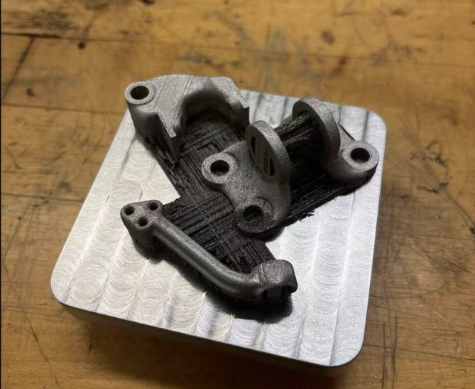Figure 40: Metal 3D Printed Steering Knuckle Prototype on Machined Build Plate

Riley
For the initial prototyping, the focus was to validate that the topology optimized design both fits the mating components holding the hinge together while ensuring an adequate range of motion when inserted into the hip exoskeleton assembly. The motor side bracket design needed to have a close fit for the shaft and the bore, allowing the components to pivot while maintaining structural stablity. The mounting points to the motor also need to be validated to ensure the geometries are correct for the carbon motor plate to mount to the bracket properly. The hip side bracket design requires a press fit for the bearings that allow smooth and reliable rotation, where the dimensions are critical to the function of the exoskeleton. Additionally, the mounting points to the hip belt need to fit correctly so that all four mounting points can securely fix the bracket to the belt. The questions the prototype answers are whether or not the topology optimized design will be acceptable to be swapped into the current design and to see the design in hand, allowing the design to be evaluated intuitively. This is helpful in seeing how part size and the geometries to see if the design would be adequate for the application.
The initial prototype was printed out of PLA on Riley’s personal 3D printer. The build time was quick with the ability to print PLA quickly. The parts will likely take a significantly longer time to manufacture using the MLab cusing 100R. The parts were then cleaned and the bracket components (bearings, shaft, mounting bolts) were inserted. The shaft bore was tight but allowed the shoulder bolt to fit securely. The bearings were also a tight fit, resulting in the necessary press fit for the components. The mounting bolts for the motor and hip belt aligned properly, ensuring that the part will be able to be swapped into the existing assembly. The prototype successfully proved that the design meets all key requirements to use with the hip exoskeleton device.
For future improvements, the part needs to be sliced in the Autodesk Netfabb software to prepare the part to be printed in metal. Additionally, the final part would benefit from the implementation of a print orientation constraint with the goal of providing a part that can better be additively manufactured. The part will likely require some support material to be printed inside the bearing bore to maximize dimensional accuracy. This involves the generation of support structures which should be further investigated and validated to provide optimal results. The following figure shows the bracket assembled with the bearings, shoulder bolt, washers, and locknut. Due to the black color of the plastic, some features are challenging to see, but the geometries can be easily seen in later figures with the additional engineering calculations.
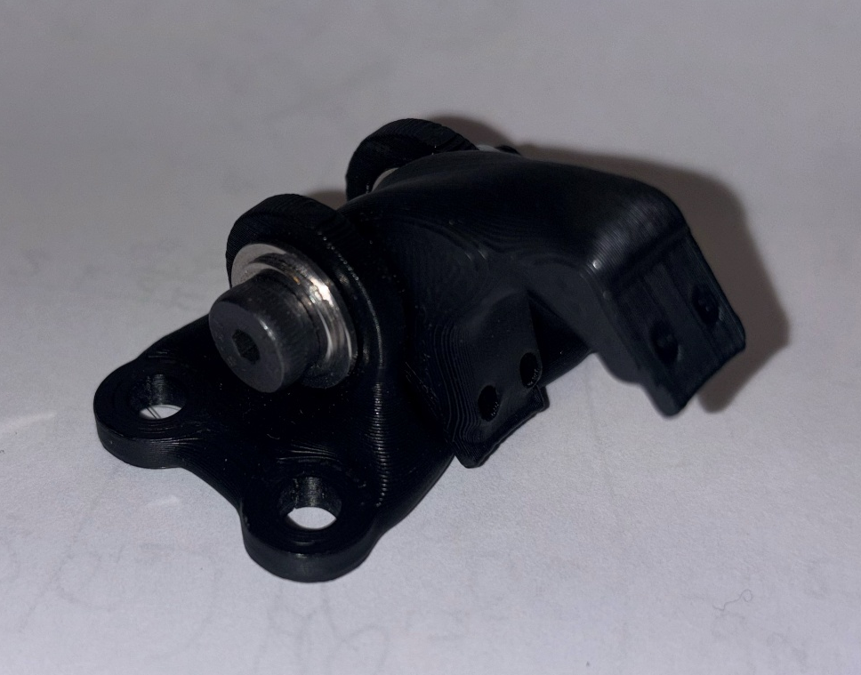
Figure 41: PLA Prototype Topology Optimized Hip Abduction Bracket

Other Engineering Calculations

Erik
The biggest portion of new engineering calculations was the creation of an optimized part based on the previously calculated static load analysis. To do this, a new CAD model was made in SolidWorks with more detailed geometry. Once the part is imported, a surface mesh of the CAD body needs to be created, then a volume mesh after that. Using the volume mesh, a “Boundary by Flood Fill” is used to be able to reference the faces of the part accurately. Using the flood fill, the faces connecting to the bucket are selected as the location for the load, while the connection to the boom is selected as an anchor.
Using the previously calculated ‘maximum force’ value, the load is applied at the bucket connection in the direction that the bucket rotates. This is then used to complete a static analysis as shown in section 3.3.1. An optimization function is then used with the static analysis as a baseline, and for this particular optimization a volume constraint of 0.5 was used. The volume constraint makes it so whatever optimization is complete will have 50% of the volume that the original part had. As the goal of this optimization was to reduce or maintain weight, that constraint was optimal.
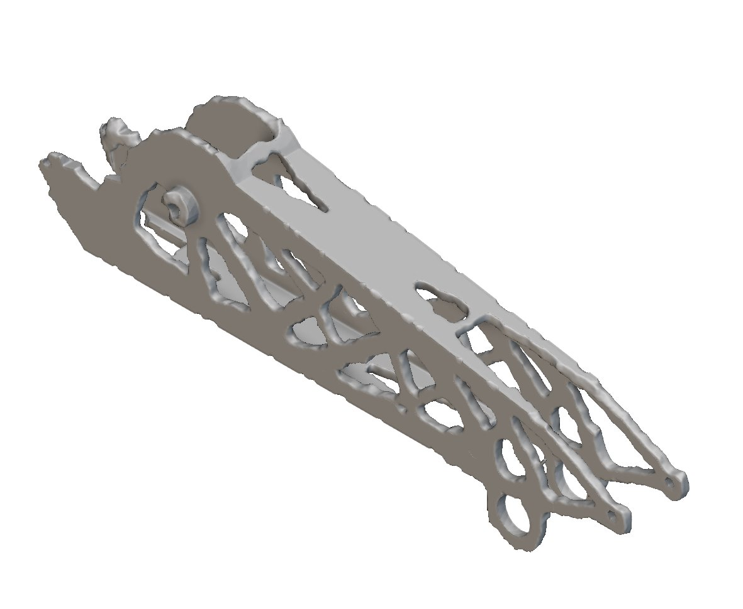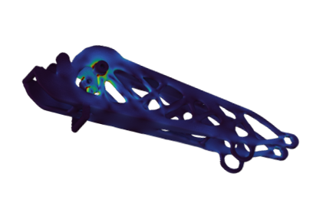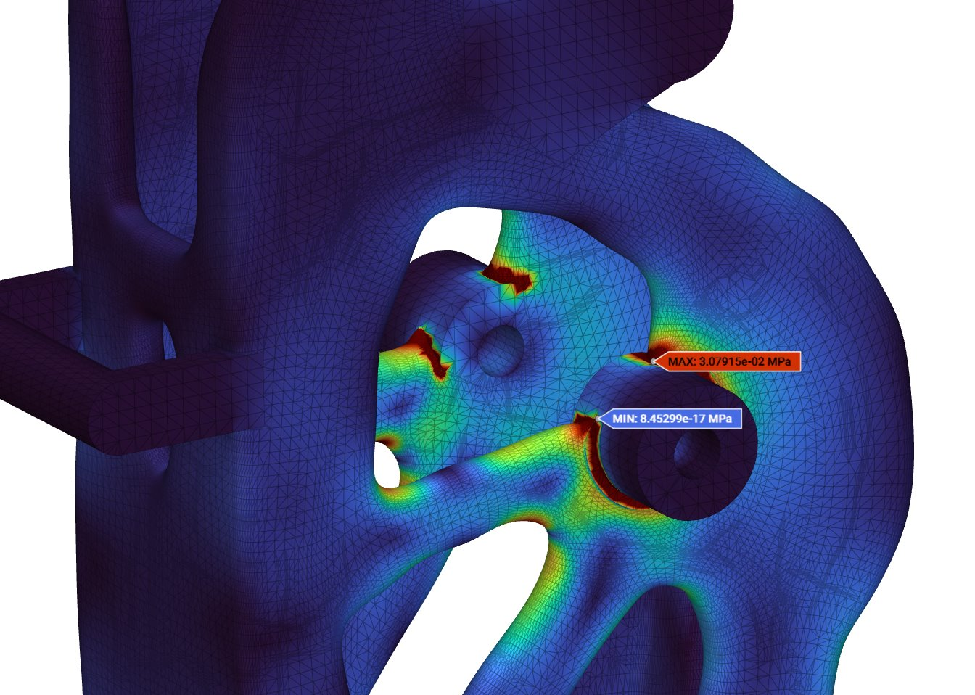
Figure 42: Optimized Stick Model and FEA

As mentioned in section 6.2.1, there were some errors converting the part file from nTop into SolidWorks. After redoing the CAD model to include necessary missing geometries and geometry errors, an FEA was simulated using nTop. Applying the same loads as initially stated, the optimized stick has a maximum stress of 0.031MPa. With SS316L having a yield stress of 170MPa, this means the optimized stick has a factor of safety of 5483.

Sichao
A linear static finite element analysis was performed on the steering knuckle to evaluate the stiffness and strength of the baseline geometry under the representative static loading condition. The steering knuckle model was analyzed in nTop using a fine finite element mesh under the prescribed loading case. The constrained connection region was fixed to represent the mounting condition, and the applied load was used to simulate the representative service loading experienced by the component. Material properties for Al 6061-T6 were assigned in the analysis, including an elastic modulus of approximately 69 GPa, a Poisson’s ratio of 0.33, and a yield strength of approximately 276 MPa.
The resulting von Mises stress distribution is shown in Fig. X. The peak stress occurs at the transition region between the upper arm feature and the main body of the steering knuckle, where the geometry changes and local stress concentration develops. The maximum von Mises stress was approximately 4.60 × 10^5 Pa. Stress levels in the rest of the component remained significantly lower, indicating that most of the structure was only lightly stressed under the applied load.
The total displacement field is shown in Fig. Y. The maximum displacement was approximately 9.49 × 10^-5 mm, occurring near the outer loaded feature of the model. This extremely small deformation indicates that the steering knuckle behaves as a very stiff component under the applied static loading condition.
Comparing the maximum von Mises stress to the yield strength of Al 6061-T6 gives a static safety factor of approximately 600. This result shows that the baseline geometry remains far below the material yield limit for the simulated loading case. Overall, the finite element analysis demonstrates that the aluminum steering knuckle provides sufficient stiffness and strength and serves as a reliable structural baseline for comparison with the 316 stainless steel design.
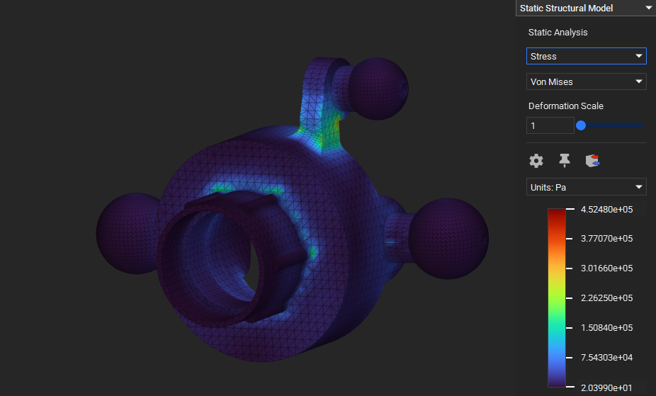
Figure 43: Von Mises Stress Results for Original Steering Knuckle Arm (AL 6061-T6)

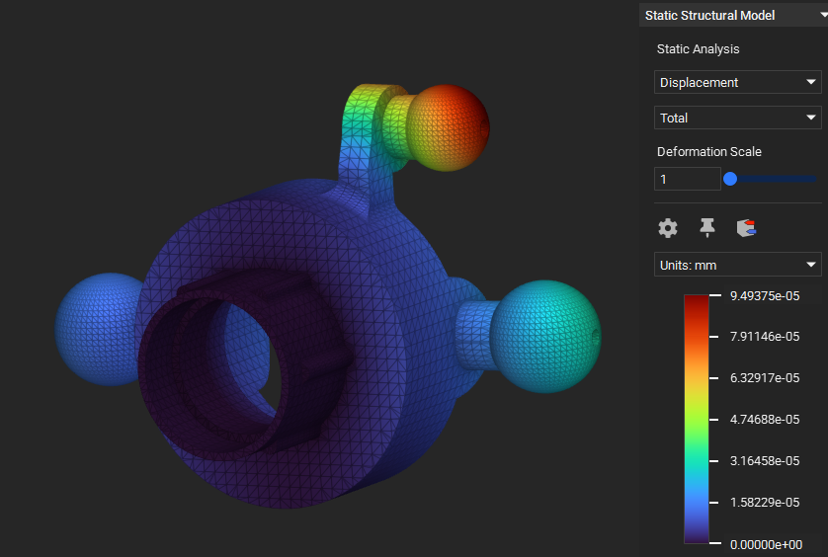Figure 44: Total Displacement Results for Original Steering Knuckle Arm (AL 6061-T6)
A second linear static finite element analysis was performed on the steering knuckle using 316 stainless steel in order to directly compare its structural response with the Al 6061-T6 baseline design. The same geometric model, boundary conditions, and loading case were used so that the effect of material properties on stiffness and stress could be isolated. The model was analyzed in nTop using a fine finite element mesh under the prescribed static loading condition. The constrained connection region was fixed to represent the mounting condition, and the applied load was used to simulate the representative service loading. Material properties for 316 stainless steel were assigned with an elastic modulus of approximately 193 GPa, a Poisson’s ratio of 0.30, and a yield strength of approximately 290 MPa.
The total displacement results are shown in Fig. X. The maximum displacement of the 316 stainless steel steering knuckle was approximately 3.42 × 10^-5 mm, occurring near the outer loaded feature of the model. This displacement is lower than that of the aluminum configuration, which is consistent with the higher elastic modulus of 316 stainless steel. The deformation pattern indicates a stiff, bending-dominated structural response under the applied load.
The von Mises stress distribution is shown in Fig. Y. The maximum stress was approximately 4.60 × 10^5 Pa and occurred at the transition region between the upper arm feature and the main body of the steering knuckle, where local geometric change creates stress concentration. The remaining regions of the component experienced much lower stress levels, indicating that the load was carried safely by the overall structure.
Comparing the maximum von Mises stress to the yield strength of 316 stainless steel gives a static safety factor of approximately 630, indicating that the component remains far below the material yield limit under the simulated loading condition. Compared with the Al 6061-T6 model, the 316 stainless steel design exhibits improved stiffness while maintaining similarly low stress levels. Although the stainless steel configuration would increase part weight, it provides greater rigidity and may be advantageous in applications where minimizing deformation is more important than reducing mass.

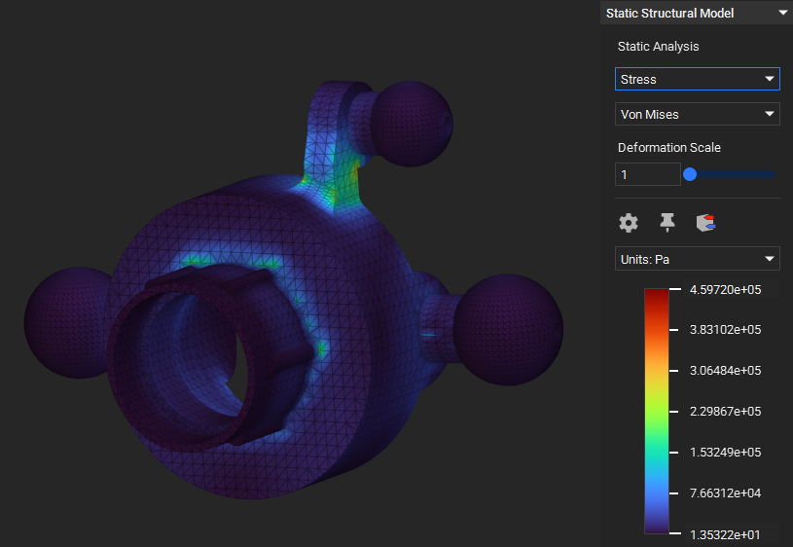Figure 45: Von Mises Stress Results for Original Steering Knuckle Arm (316 Stainless Steel)
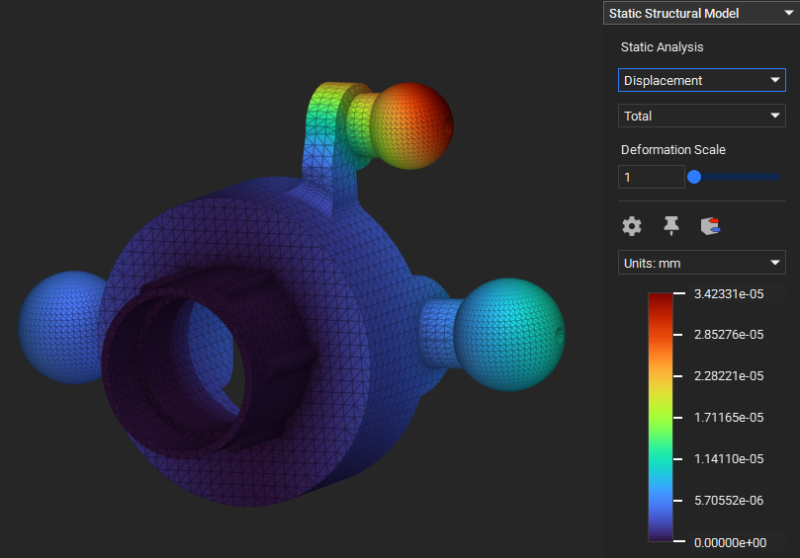 Figure 46: Total Displacement Results for Original Steering Knuckle Arm (316 Stainless Steel)
The topology optimization of the steering knuckle arm resulted in a significant reduction in overall mass while maintaining adequate stiffness and structural integrity under the applied braking load. Using a compliance-minimization objective and a 30% volume-reduction constraint, the optimizer successfully removed non-load-bearing material along the center region of the arm while preserving critical structural pathways near the inboard joint and the caliper-mounting interface.
The final optimized geometry achieved a 30% reduction in mass compared to the baseline design. This reduction was primarily due to the removal of material in low-stress regions identified in the original FEA. Importantly, high-stress areas near the cylindrical bore and the distal bolt-hole cluster were retained or slightly thickened to ensure stiffness and durability. The resulting shape exhibits a smooth, organic structural profile typical of bending-dominated load paths.
After optimization, the raw nTopology output was smoothed to eliminate voxel artifacts, and all critical features—such as the three mounting holes, fillet transitions, and the inboard cylindrical interface—were re-inserted with precise dimensions to ensure manufacturability. The optimized body was then remeshed and prepared for export to SolidWorks for detailed refinement and final drawing creation.
The optimized geometry was subsequently analyzed in a static FEA using the same boundary conditions and braking load. The performance comparison between the original and the optimized arms shows that, despite the significant mass reduction, the maximum von Mises stress remained within safe limits for both Al 6061-T6 and 316 stainless steel. Displacements remained small, and stiffness decreased only marginally, demonstrating the effectiveness of the optimized load path.
These results confirm that a 35% mass reduction can be achieved without compromising structural performance, making the optimized steering knuckle arm a strong candidate for final manufacturing through metal additive processes.
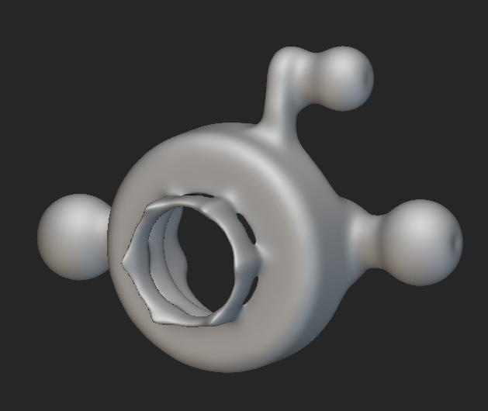Figure 47: Topology-Optimized Steering Knuckle Arm Geometry

Riley
The continuation of the hip abduction bracket analysis included the completion of topology optimization. The previous FEA results discussed earlier in the report were used to define the topology optimization completed in nTop. The boundary conditions and optimizations constraints were applied to produce the initial topology optimized designs to compare to the original design. The constraints used for topology optimizations were the same for the motor and hip side components. These constraints included a compliance response with the target to minimize it, effectively maximizing the stiffness of the part. Additionally, volume and symmetry constraints were applied to the model. The volume constraints reduced the volume of the hip and motor side brackets to 0.3 and 0.35 respectively. The symmetry plane ensures that the parts will handle the loading conditions equally when the motor drives both hip flexion and extension. The optimization used an element edge length of 1mm to reduce processing requirements and the time to completion. The following results are shown for the topology optimization of each of the components in the hip abduction bracket.
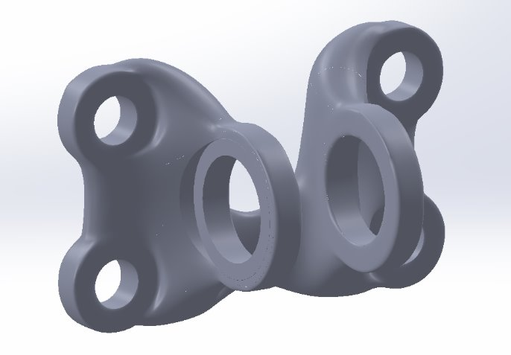
Figure 48: Topology Optimized Hip Side Bracket
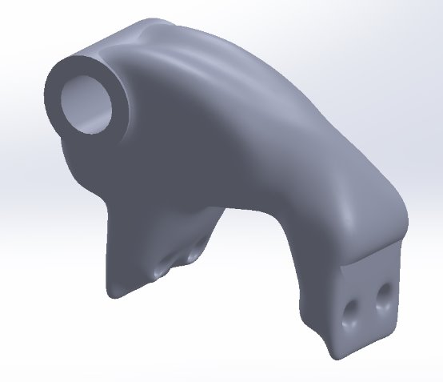
Figure 49: Topology Optimized Motor Side Bracket
In order to produce these parts, several additional processes were applied to the raw topology optimized bodies. The raw body needed to be smoothed, and the threshold applied was 0.2. This rounded the entirety of the body to remove the edges seen from individual elements. Then, key geometries needed to be inserted to ensure that surfaces are flat and dimensionally accurate. Finally, the body was meshed and prepared to be exported to modify further in SolidWorks. The key interfacing geometries were added again to provide the necessary dimensions in drawings. These parts were then analyzed in a static FEA to compare the results with the original FEA of the hip bracket. All boundary conditions were applied identically to the original analysis, and the Von Mises stress results were found. The following figure is included to show the differences between the original and optimized geometry.
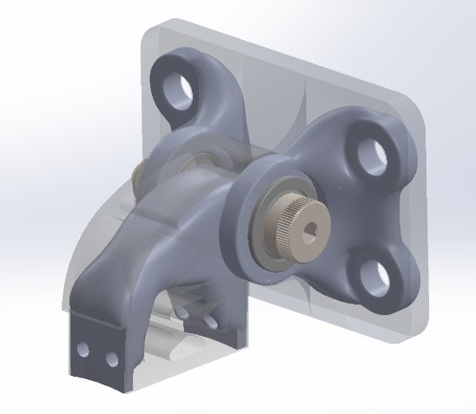
Figure 50: Bracket Subassembly Comparison

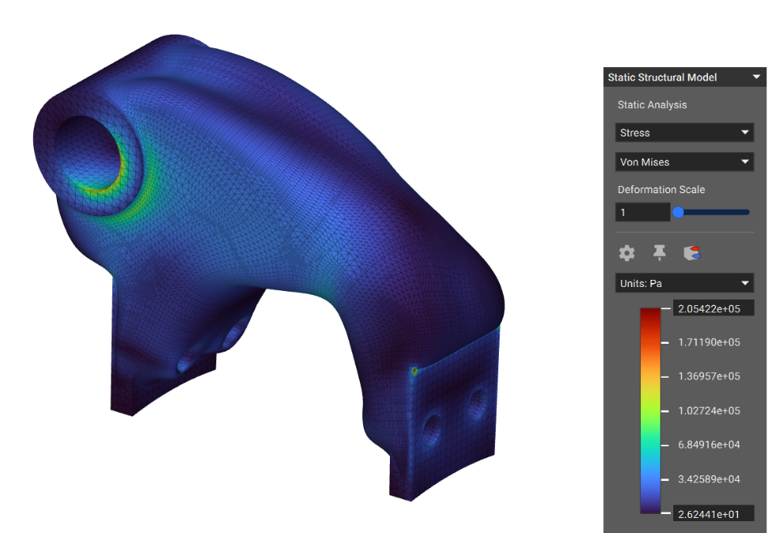
Figure 51: nTop Static FEA Stress Results Optimized Motor Side Geometry

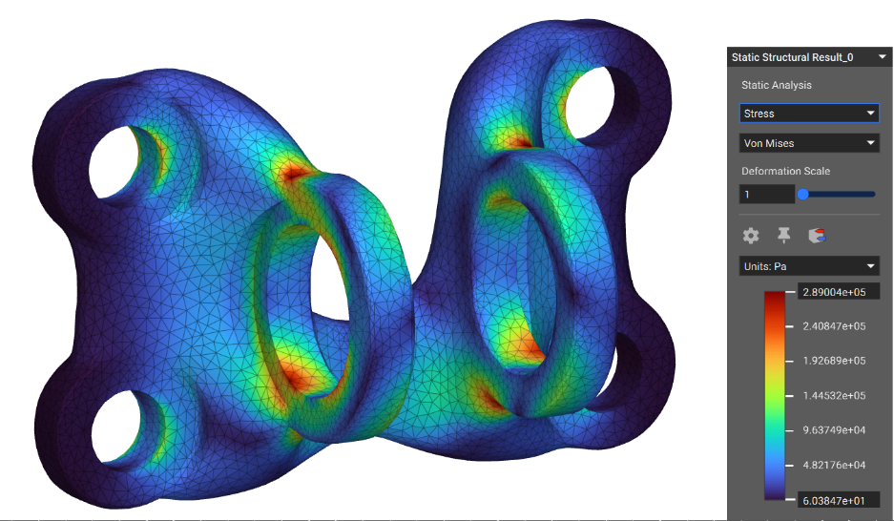
Figure 52: nTop Static FEA Stress Results Optimized Hip Side Geometry

An additional topology optimization was completed in ANSYS Discovery using the same components, boundary conditions, and methodology. The analysis used a minimize compliance constraint with the volume reduction for both parts being 50%. The simulation would run the topology optimization and has the option to immediately include the results in the analysis, providing similar stress results as produced from the nTop analysis. The following figures show contour plots for both components using ANSYS Discovery.
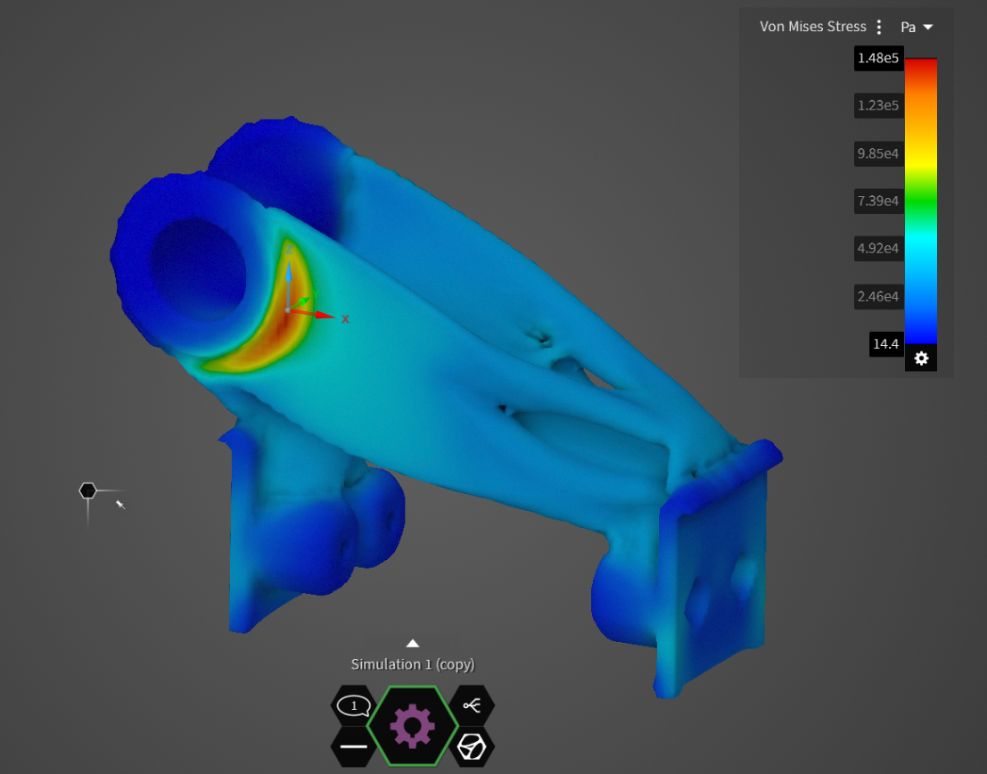
Figure 53: ANSYS Static FEA Stress Results Optimized Motor Side Geometry

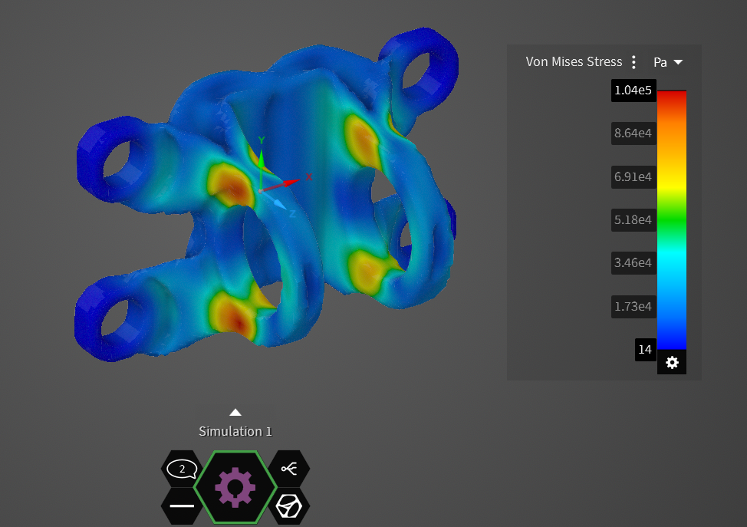
Figure 54: ANSYS Static FEA Stress Results Optimized Hip Side Geometry

The mass results for both analyses were collected and compiled into the following tables to compare the mass results for both designs. The stress results are also shown in a table for convenience.

Material​ | Original Parts Mass (g)​ | nTop Optimized Parts Mass (g)​ | ANSYS Discovery Optimized Parts Mass (g)
AL 7075-T6​ | 50​ | 40​ | 30
316SS​ | 140​ | 100 | 70

Table 5: Compiled Mass Results of nTop and ANSYS Topology Optimizations

Analysis Type | Hip Side Maximum Von Mises Stress [Pa] | Motor Side Maximum Von Mises Stress [Pa]
Original Geometry nTop FEA | 4.96e4 | 3.61e5
Optimized Geometry nTop FEA | 2.89e5 | 2.05e5
Optimized Geometry ANSYS FEA | 1.04e5 | 1.48e5

Table 6: Maximum Von Mises Stress Results

The FEA and mass results of each of these analyses can be further developed with mesh refinement and changes to certain parameters. The ANSYS mass and stress results are lower than the nTop results. Due to less parameters to define in ANSYS, the nTop results may be more accurate for the stresses and final masses of the parts. The meshes for the nTop analysis of the topology optimized parts can be refined to justify the questionable maximum stress location. It is likely that the maximum stress is higher than the actual cause by a large aspect ratio around the bolt hole (refer to Figure 54). The volume reduction was different between the two programs, showing the differences in how each program manages optimization parameters. The best results were obtained from the ANSYS analysis, although additional optimization parameters of optimal build orientation/additive manufacturing constraints would greatly improve the model for building with the printer. This is only available in nTop, another reason why nTop would be more powerful for preparing parts for metal additive manufacturing.

The masses of the components for the hip abduction bracket are lighter for the ANSYS solution. This was likely caused by the higher value for volume reduction. The ANSYS analysis generates peripheral structures for connecting key features whereas nTop results in a singular smooth body. The singular body is better suited for additive manufacturing, although the printer has the ability to manufacture relatively complex geometries. Based on all the previous analysis and experience with the printer, nTop would provide better models and be an improvement over ANSYS.

Service Requests

Active Rocket Control
The Active Rocket Control capstone team requested for their lower fin arm to be topology optimized and printed to use in their linkage mechanism that will translate rotation from a servo to adjust the angle of their rocket’s lower control surfaces (fins). The team was provided with a maximum expected load of 67N with the servo bore constrained in all degrees of freedom. The original part was simulated to be an input for topology optimization. The figure below shows the initial geometry FEA results and loading conditions. The maximum stress as a result was 9.96MPa.
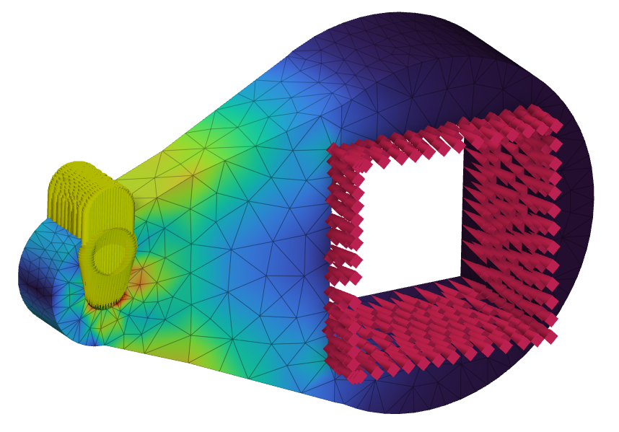
Figure 55: ARC Lower Fin Arm FEA
The topology optimization used the results of the above figure and the constraints of symmetry and maximum stress to complete the optimized model. The figure below shows the results of the topology optimization. The boundary penalty was iterated to result in the adequate reduction and structure of the final part. This allowed the arm to have two structural members connecting the servo bore to the pin connection.
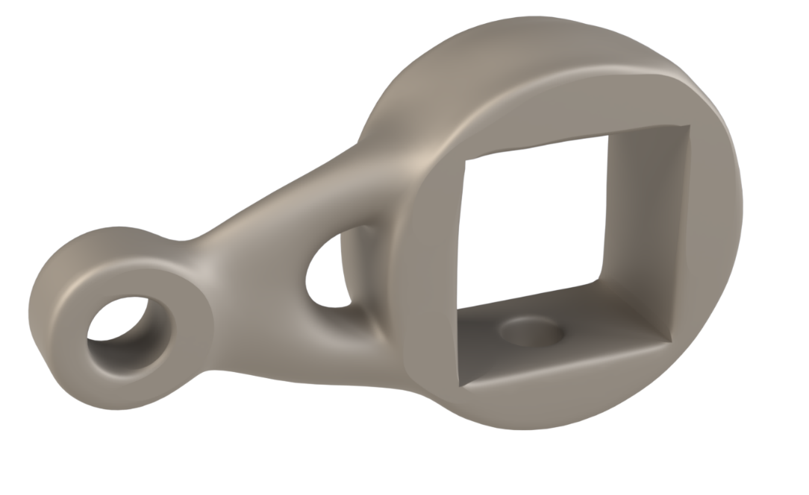
Figure 56: ARC Topology Optimized Lower Fin Control Arm
The following figure shows the static structural results for the optimized part. The maximum stress of this model was found to be 11.2MPa, a small increase from the original maximum stress. The maximum stress constrained limited stresses from being greater than 17 MPa to ensure a minimum factor of safety of 10.
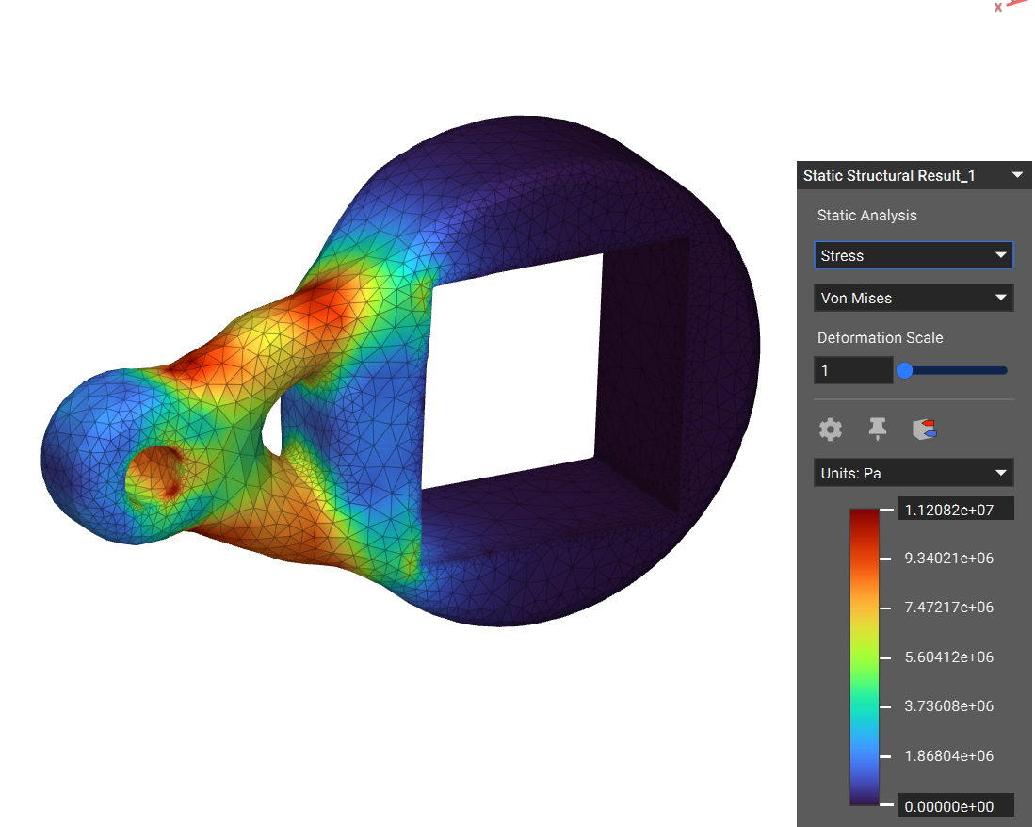
Figure 57: ARC Optimized FEA Results

Lerner Robotic Arm
The Lerner Robotic Arm capstone team requested for their hinged bracket to be printed in 316L stainless steel. The purpose of this component is to allow the arm to be securely mounted to the hip belt while providing a passive point if rotation. The team was provided with a maximum expected load of 30N with a bending moment of 20Nm. The hip side and motor side bracket components were simulated individually to optimize the parts independently. The original part was simulated to be an input for topology optimization. The figure below shows the initial geometry FEA results and loading conditions. The maximum stress as a result for the hip side was 44.95MPa. The maximum stress as a result for the motor side was 35.28MPa.

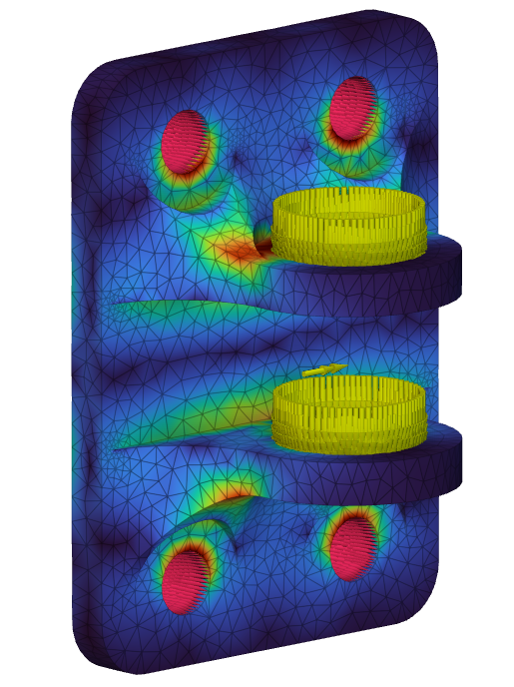
Figure 58: Lerner Hip Side Bracket FEA
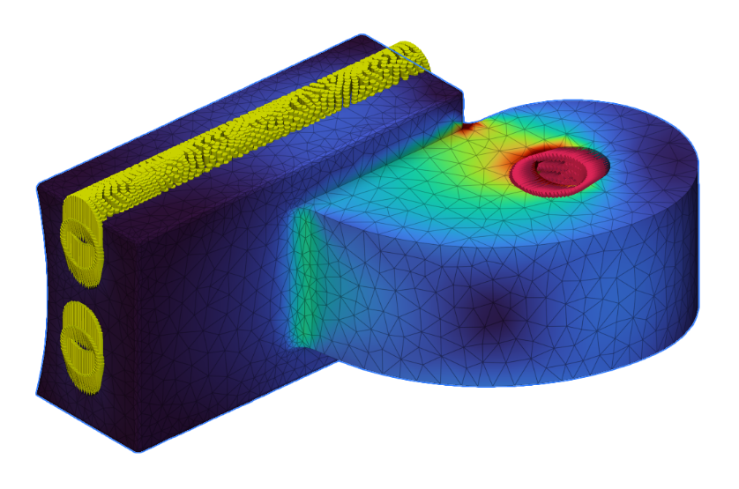
Figure 59: Lerner Motor Side Bracket FEA
The topology optimization used the results of the above figure and the constraints of symmetry and maximum stress to complete the optimized model. The figure below shows the results of the topology optimization. The boundary penalty was iterated to result in the adequate reduction and structure of the final parts.
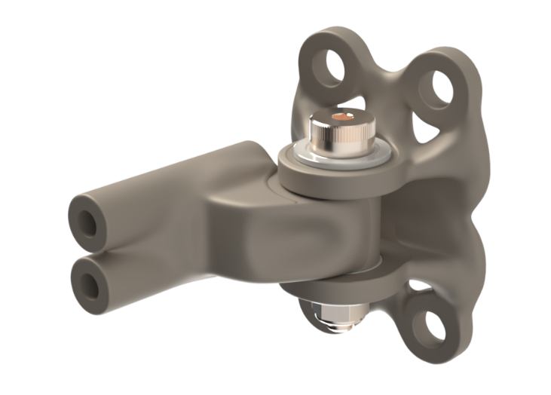
Figure 60: Lerner Robotic Arm Topology Optimized Hinged Bracket
The following figure shows the static structural results for the hip side optimized part. The maximum stress of the hip side model was found to be 67.9MPa, a reasonable increase from the original maximum stress. The maximum stress constrained limited stresses from being greater than 75 MPa to ensure a reasonable minimum factor of safety.
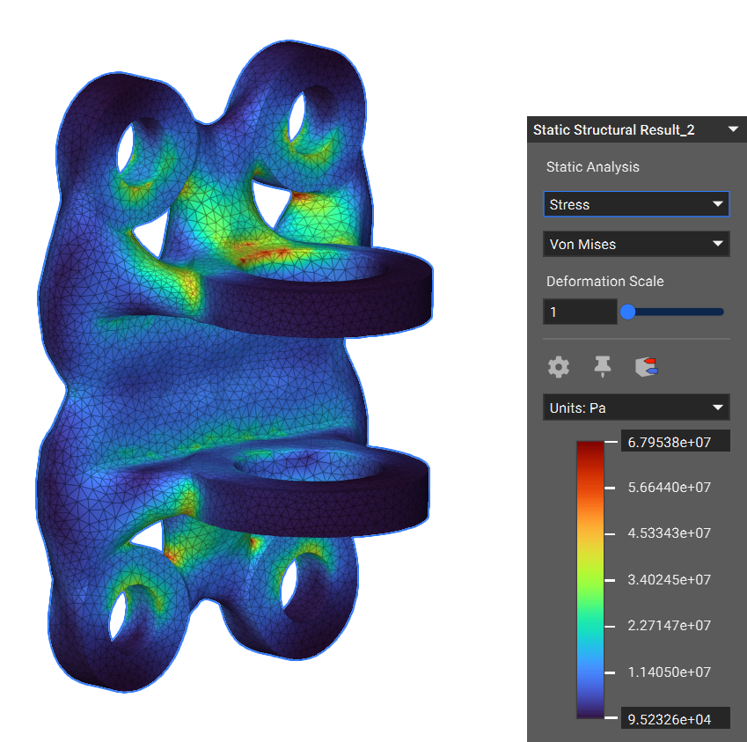
Figure 61: Lerner Robotic Arm Hip Side Optimized FEA Results
The following figure shows the static structural results for the motor side optimized part. The maximum stress of the motor side model was found to be 48.08MPa, a reasonable increase from the original maximum stress. The maximum stress constrained limited stresses from being greater than 50 MPa to ensure a reasonable minimum factor of safety.
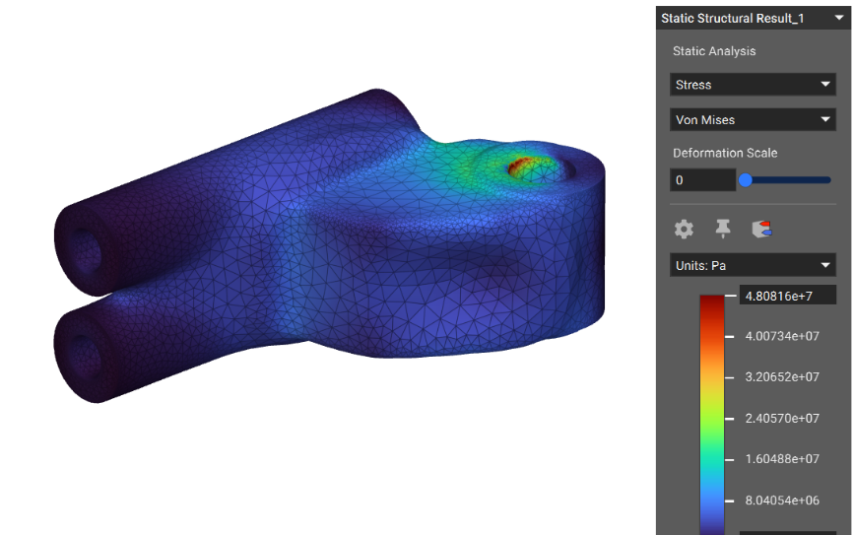
Figure 62: Lerner Robotic Arm Motor Side Optimized FEA Results

Baja SAE
The Baja SAE team requested a hood ornament of an axe head with wings. This part was not topology optimized but instead showcases the capabilities of metal additive manufacturing. The model shown below was what was printed and the following image was the final printed and post processed result.
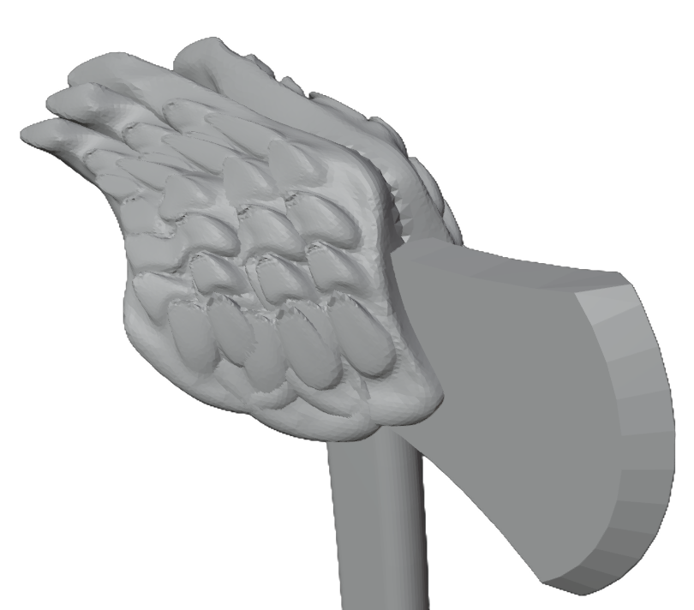
Figure 63: Baja SAE Hood Ornament Model
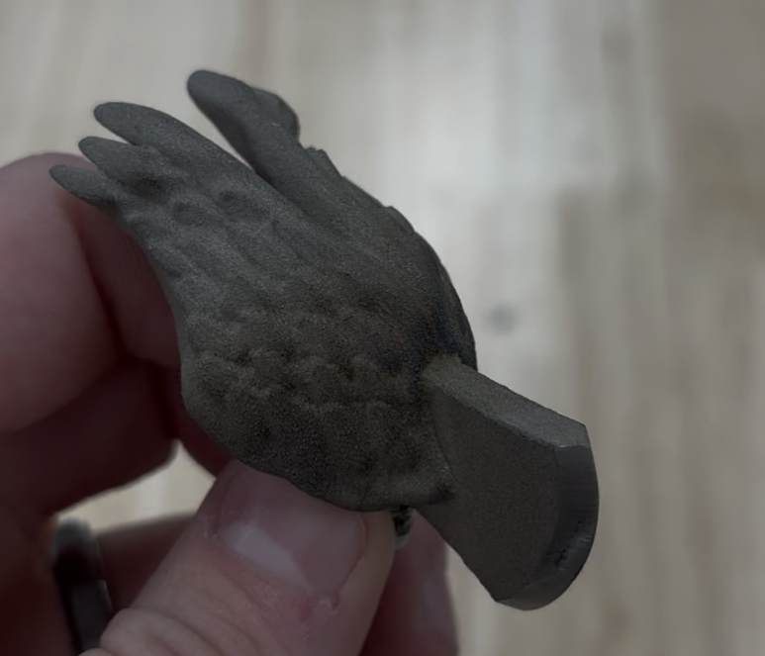
Figure 64: Baja SAE Hood Ornament Final Build

Formula SAE
The Formula SAE team requested a hood ornament of an axe in a stump of wood. This part was not topology optimized but instead showcases the capabilities of metal additive manufacturing. The model shown below was what was printed and the following image was the final printed and pre post processed result.
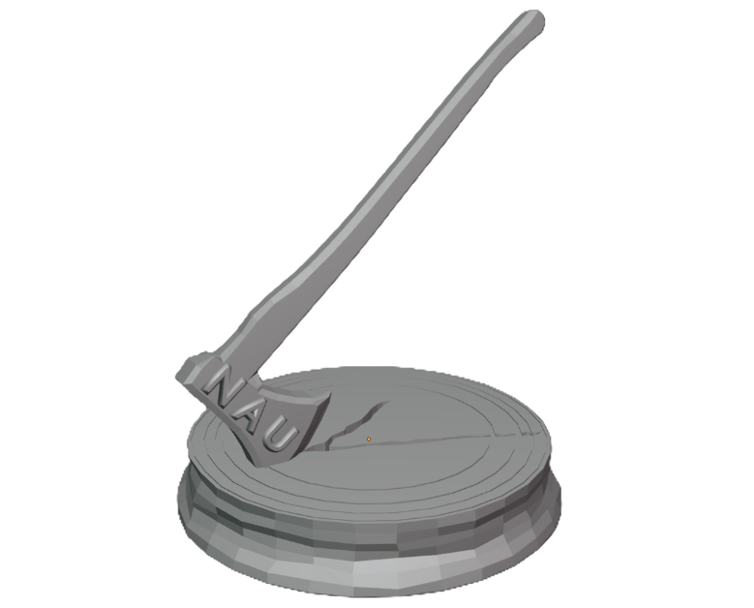
Figure 65: Formula SAE Hood Ornament Model
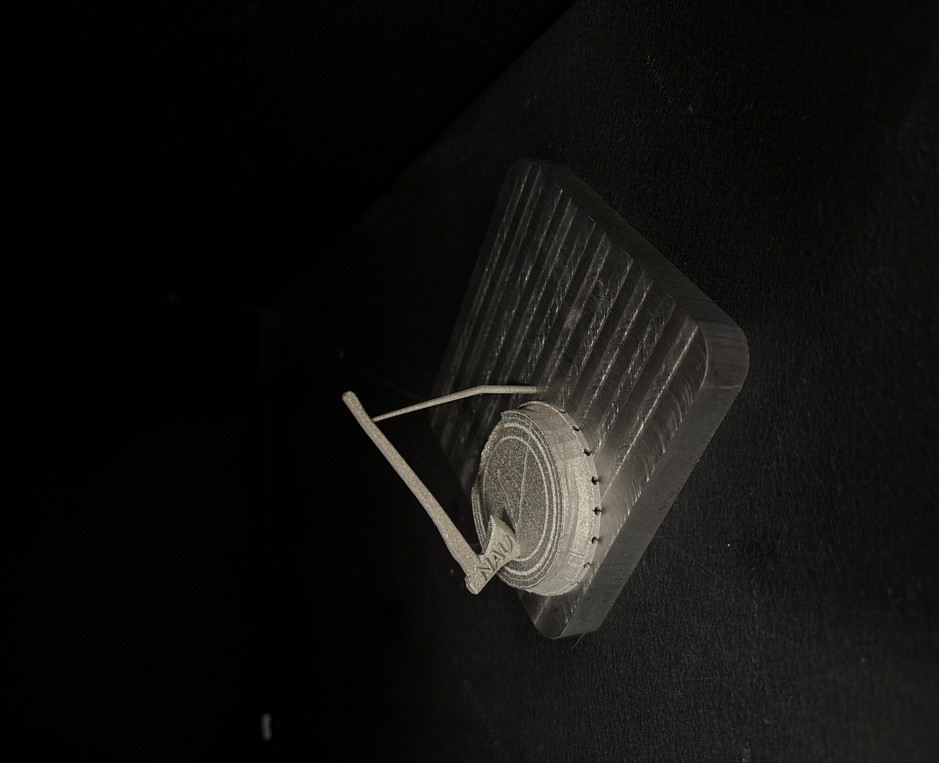
Figure 66: Formula SAE Hood Ornament Final Build

Future Testing Potential

Erik
Assuming the fit is corrected in the next print, the part will be put through several tests to ensure it meets the criteria laid out by the customer requirements. The simple tests will involve weighing and measuring the length of the metal printed part and the original, then comparing the two. Along with this, there is a test fit which should match the results from the initial and second prototypes. Lastly, the corrections we made to the printer modules should enable us to print our parts without the wavy surface finish.
As for more scientific testing, a strain gauge will be used to test potential deflection in the part. The top view of the optimized stick shows a flat portion, which is where the gauge will be placed. Loads will then be put on the boom connection and bucket connection to test to find the maximum load that part can take before permanent deformation occurs. Realistically this optimized stick will be put into the assembly of a toy excavator, and it is far more likely that the cab will tip over before the stick has a load applied that will come anywhere near breaking it.

Sichao
Future testing for the steering knuckle will focus on validating both its mechanical performance and its suitability for metal additive manufacturing at full scale. Mechanical testing may include static load tests to replicate braking and vertical impact forces, stiffness measurements under bending and torsion, and fatigue testing to assess long-term durability under repeated loading cycles. Dimensional inspection using CMM or 3D scanning will confirm geometric accuracy after printing and post-processing, while surface roughness measurements will help quantify the impact of different orientations and support strategies. In addition, thermal distortion analysis during printing could be validated through in-situ monitoring or thermography to compare simulated deformation with actual print behavior. Once design updates are implemented, a second-stage prototype can be tested using more refined support structures and machining allowances to evaluate improvements in manufacturability.

Riley
There are several methods to test the hip abduction bracket. The focus of the testing procedures will determine if the printed optimized hip bracket will meet the customer and engineering requirements outlined earlier in this report. The key requirements are that the bracket needs to be lightweight, have a adequate lifetime, reduce manufacturing costs, and support the applied loading conditions of the bending moment and axial force.
The weight of the components can easily be measured using an electronic balance. The original parts can also be weighed to provide a direct mass comparison between the two sets of components. The lifetime of the component can be evaluated in ANSYS Workbench using a fatigue loading model to determine the estimated lifetime. This would allow the team to complete the fatigue analysis without requiring the part be tested in a completely reversed loading apparatus. The manufacturing costs can be evaluated based on the time it takes to prepare, print, and post-process the parts. This will be compared to the roughly 2-week lead time which is common for the majority of the Biomechatronics Lab’s machined hip bracket orders. The cost can also be compared by monitoring the cost of material and argon required to manufacture the part. Based on the geometry and measures taken when designing the part and preparing the print, all post processing would require minimal effort to achieve the proper tolerances and fitments.
The hip bracket experiences loads when actuating hip flexion and extension assistance. This requires that the parts are functional, reliable, and safe during the operation of the hip exoskeleton. The goal is to design and assemble a test bench to evaluate the subassembly and the individual components. Although ut may be challenging for the team to attach a strain gauge to a suitable surface, there are gauges that are small enough and available on the market. The plan would be to mount the subassembly or component in the testing fixture after applying and preparing the strain gauge and applying the expected load to measure the strain at a specific point in the body. The results of the physical testing can be easily compared to the FEA by selecting the point on the contour plot in nTop. This would provide a sufficient comparison and validation that the physical stresses resemble the stresses determined in an FEA simulation. A potential strain gauge is a SDG-2/350-RY53, which features a 3-element rectangular stacked rosette to measure strain in multiple axes. This strain gauge has a very small footprint of 5mm, making it a potential solution to collect strain data for validation testing. The following figure shows the construction of the gauge allowing 3 axes to be measured using a stacked rosette.
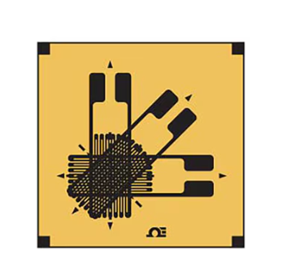
Figure 67: Potential Strain Gauge

Final Hardware

Final Physical Design
The final hardware section individually progresses through each team members’ individual design projects. The excavator arm, steering knuckle, hip abduction bracket, and service requests are shown in drawings and for the real physical assemblies.

Excavator Arm
The excavator stick is a crucial structural component that provides a linkage that allows the scooping motion of the bucket. The stick connects to boom and provides a pivot and space for the additional components to create the motion of the bucket through the range of the excavator. The following figures show the full assembly and final part in drawing format.
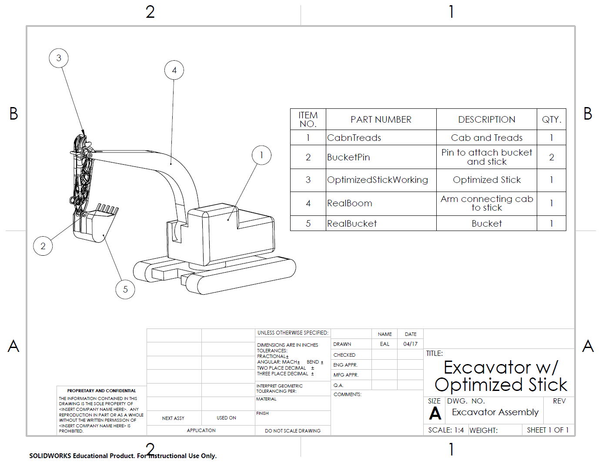
Figure 68: Full Excavator Final Assembly
The excavator stick connects to the bucket with pins and sits within the geometries of the real boom. The part needed to fit snugly in the existing assembly ensure the RC excavator is safe for use. The drawing above shows how the components interface with each other, providing a clear representation of the outcome of the individual design project.
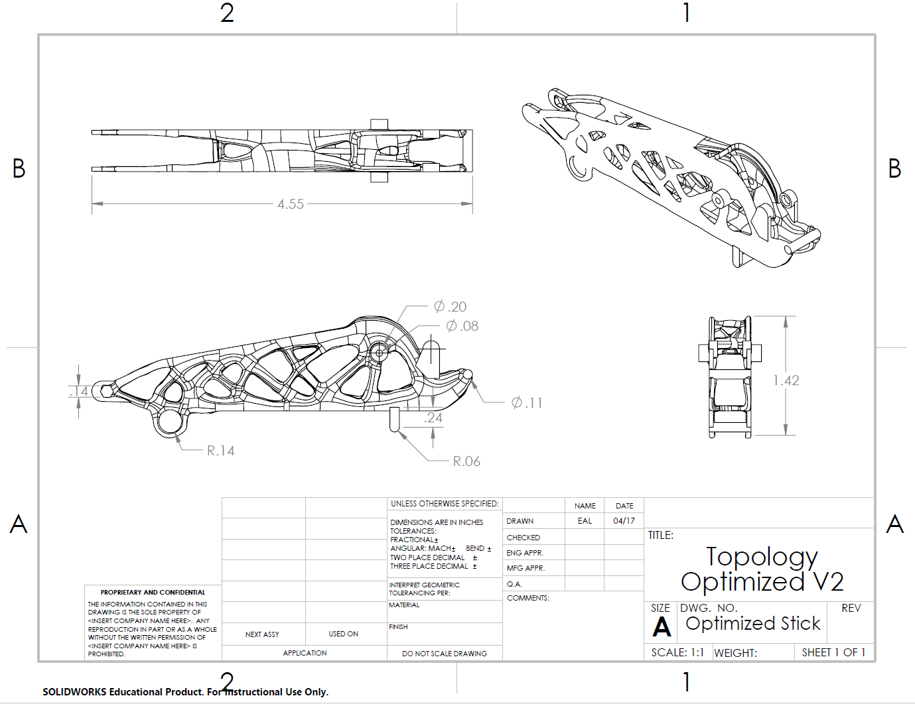
Figure 69: Topology Optimized Excavator Stick

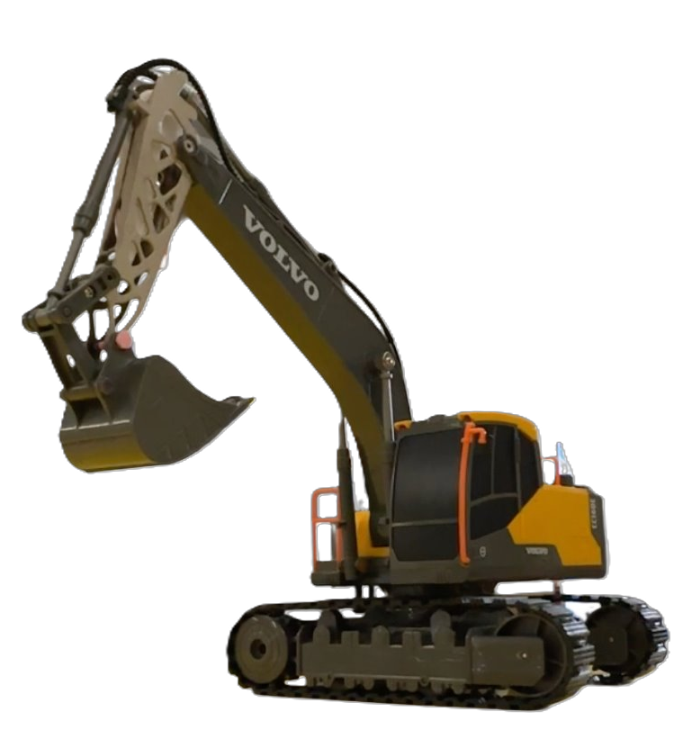
Figure 70: Final Excavator Assembly
The final assembly shows the physical hardware with the topology optimized part installed on the RC excavator. The excavator was fully functional and operated as expected with the modified part.

Steering Knuckle
The steering knuckle is one of the primary custom-designed components in the RC car front-end assembly. In the physical system, it serves as a critical connection point between the wheel assembly, steering linkage, and adjacent mounting features. Since it transfers loads generated during steering, braking, and road impact, the component was designed to provide sufficient strength and stiffness while maintaining a compact geometry suitable for the limited packaging space of the vehicle.
The design process began with a baseline CAD model that satisfied the required mounting interfaces and overall assembly constraints. From this starting point, the geometry was refined through multiple iterations to improve structural reliability, manufacturability, and part fit. Particular attention was given to the connection regions, central mounting features, and local geometric transitions, since these areas had the greatest influence on both assembly performance and structural behavior.
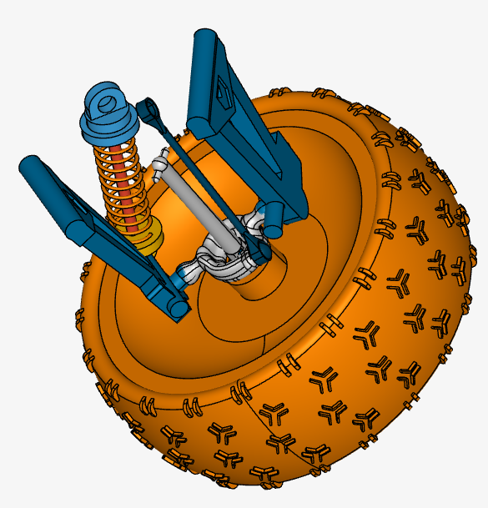
Figure 71: Steering Knuckle Assembly CAD Screenshot
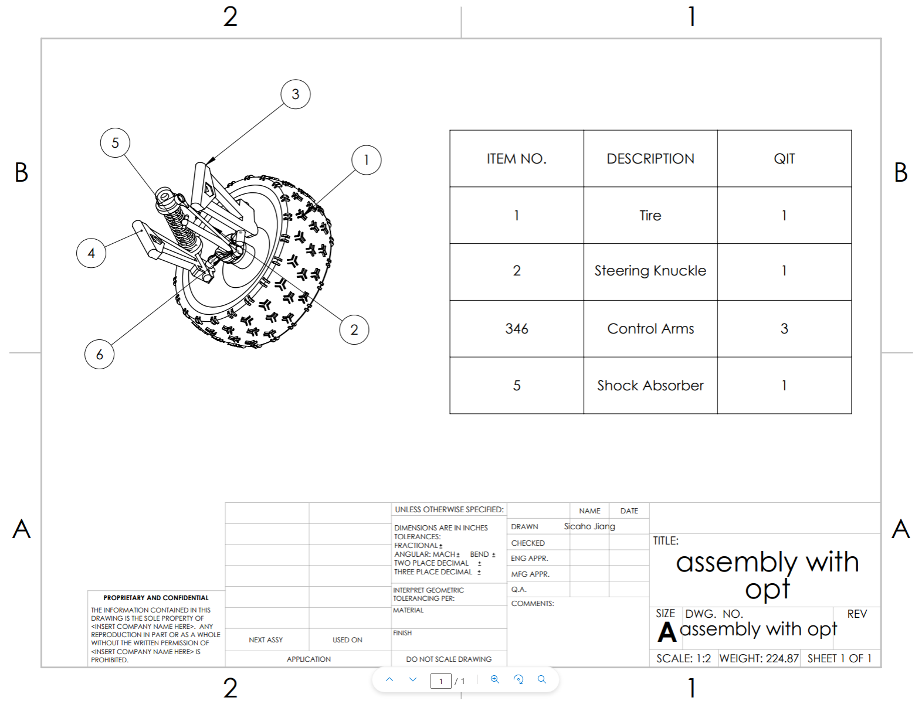
Figure 72: Steering Knuckle Assembly CAD Drawing

One of the most important design iterations involved the ball-shaped connection features. In an early PLA prototype, these connecting ball regions were too small, and one of them fractured during physical testing and assembly. This indicated that the original geometry did not provide sufficient material or structural support at the connection point. To address this issue, the ball features were enlarged in the revised design, which improved the strength and stability of the connection and made the part more reliable for later prototypes and final fabrication. Additional local adjustments were also made to improve fit with surrounding components and to achieve a more robust overall geometry.
The final steering knuckle design reflects a balance between structural performance, geometric compatibility, and practical manufacturing considerations. Presenting photographs of the manufactured part alongside the CAD model helps illustrate how the design evolved from the initial concept to the final physical component and highlights the key improvements introduced during the iteration process.
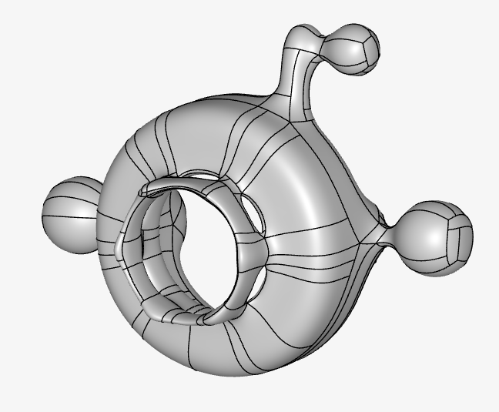
Figure 73: Steering Knuckle Assembly CAD Screenshot

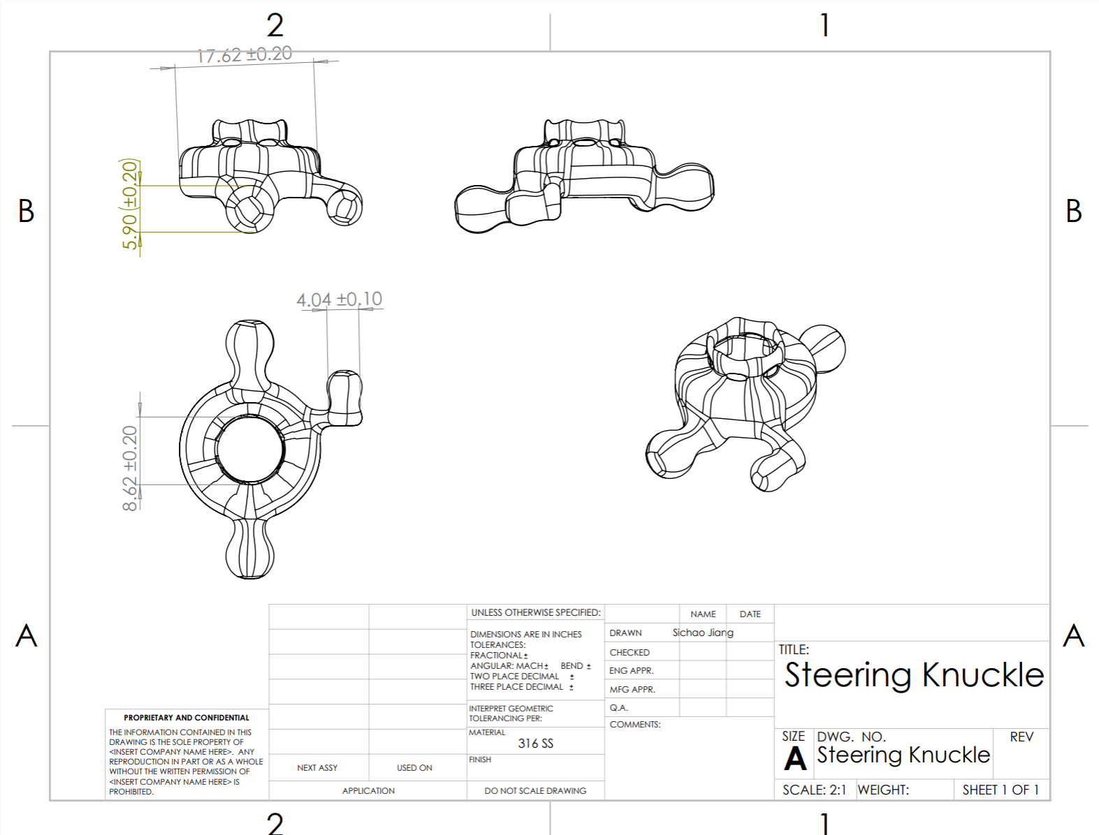
Figure 74: Steering Knuckle CAD Drawing

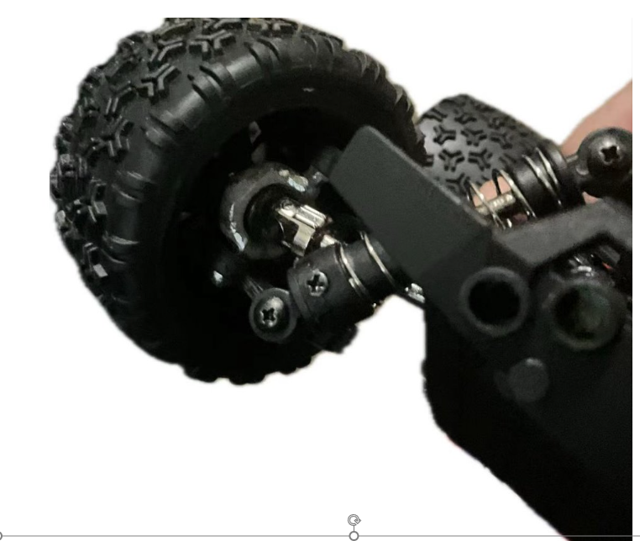
Figure 75: Steering Knuckle Final Physical Assembly

Hip Abduction Bracket
The hip abduction bracket connects the hip belt of the exoskeleton to the motor on each leg. This allows the degree of freedom for hip abduction during walking. The bracket is mounted to the hip belt using four M5 bolts through a custom thermoplastic part that allows the bracket to be placed at any point within the grid to allow some adjustability in the exoskeleton.
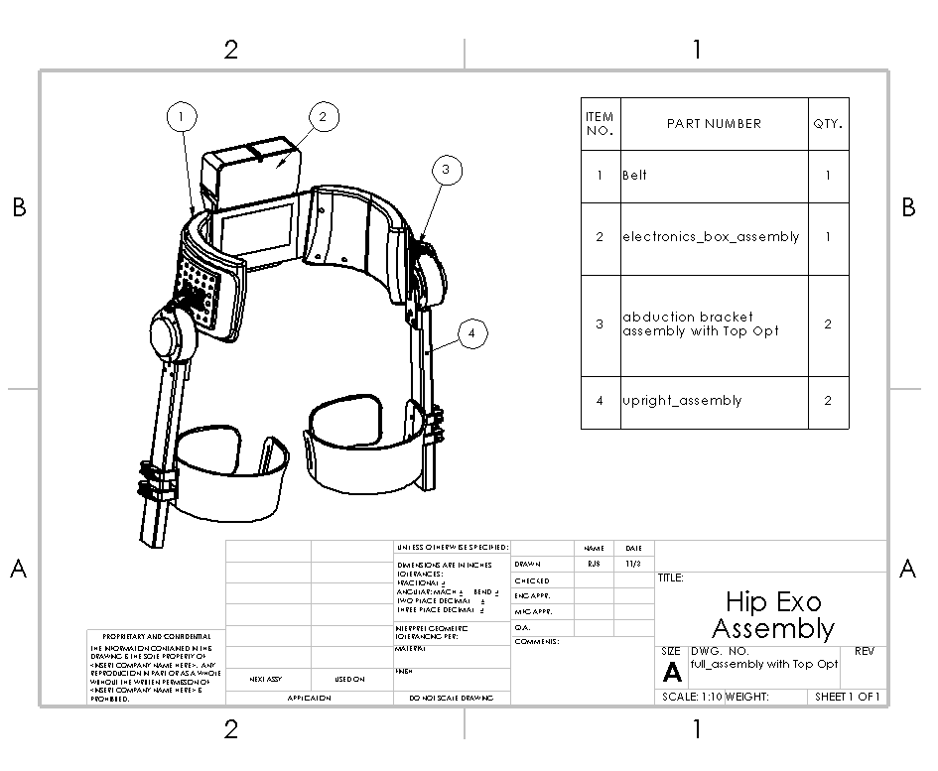
Figure 76: Hip Exoskeleton Final Assembly Drawing
The subassembly of the hinging bracket uses bearings and a shoulder bolt to allow smooth rotation. The bolt is capped with waster on each end to distribute the clamping force onto the inner bearing races.
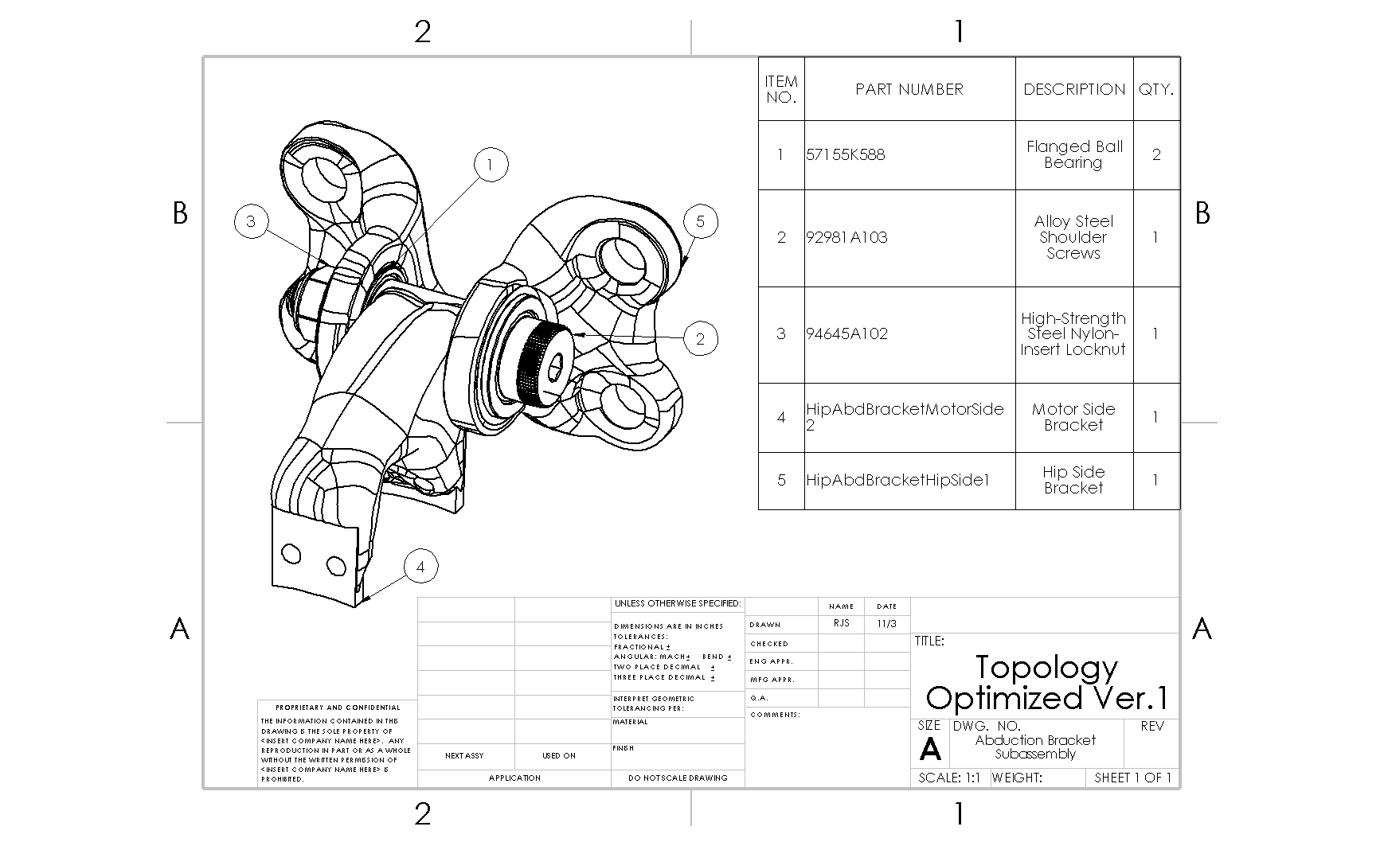
Figure 77: Hip Abduction Bracket Final Subassembly Drawing
The following figures show each of the topology optimized parts in detail with key dimensions shown.

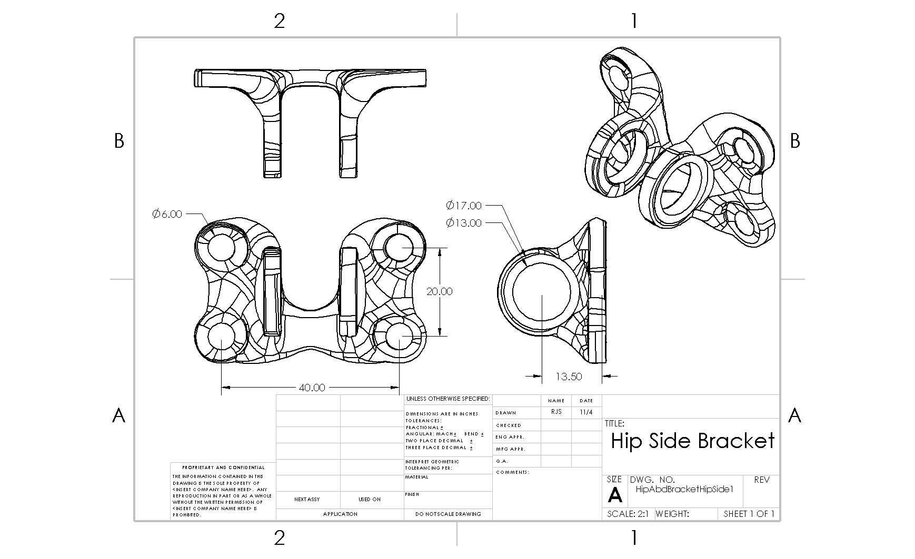
Figure 78: Topology Optimized Hip Side Bracket Drawing
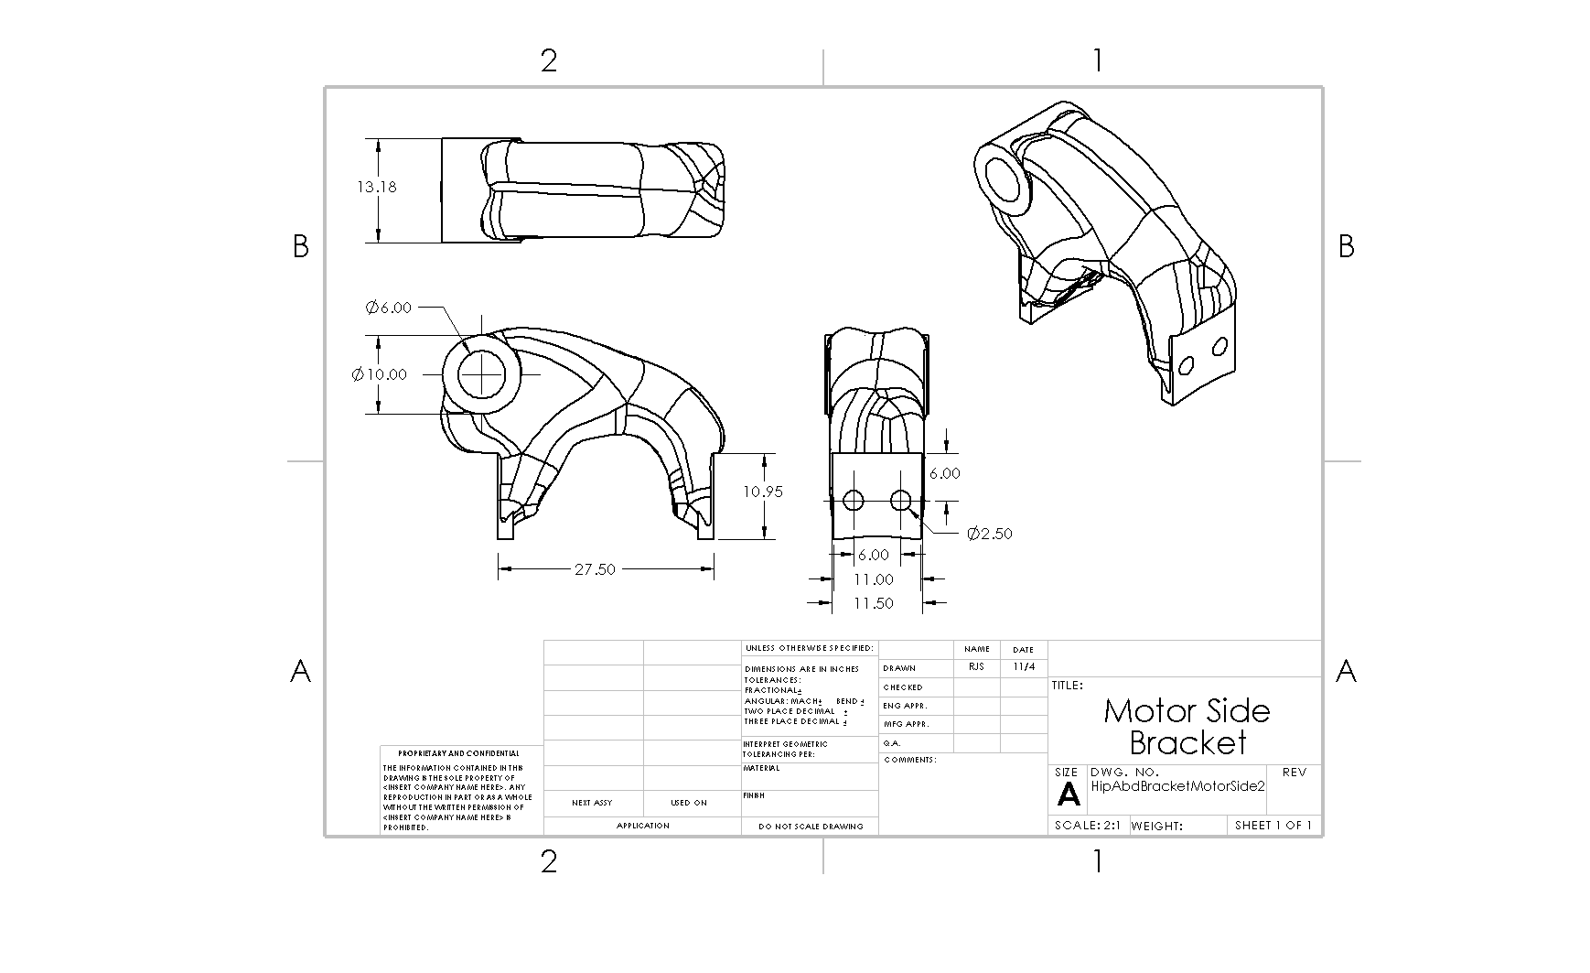
Figure 79: Topology Optimized Motor Side Bracket Drawing

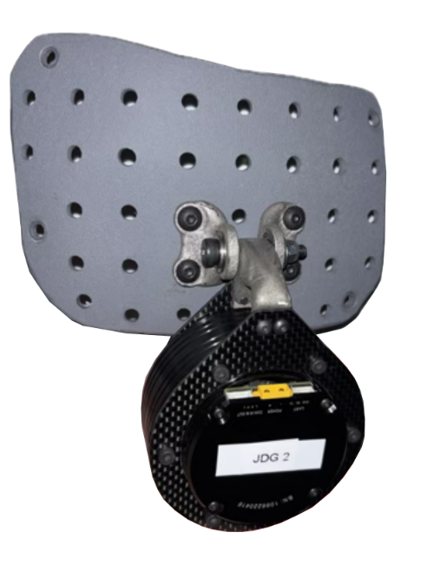
Figure 80: Hip Abduction Bracket Final Physical Hardware Close Up
The purpose of the figure above is to closely show how the bracket interfaces key parts on the hip exoskeleton assembly. This shows a clear image of the bracket within the hip exoskeleton.

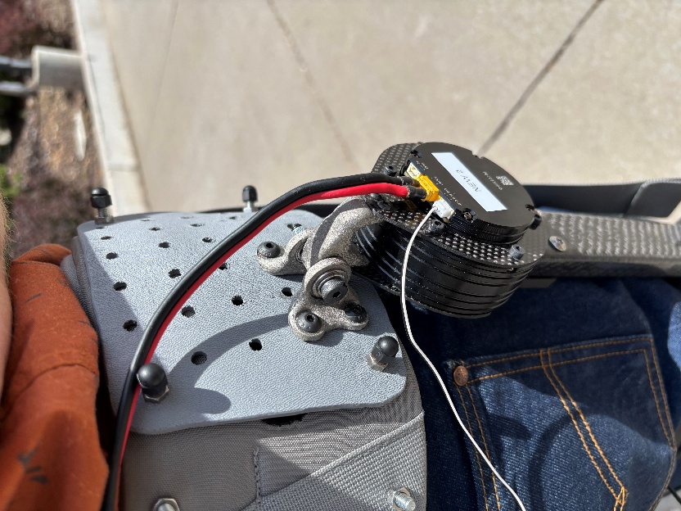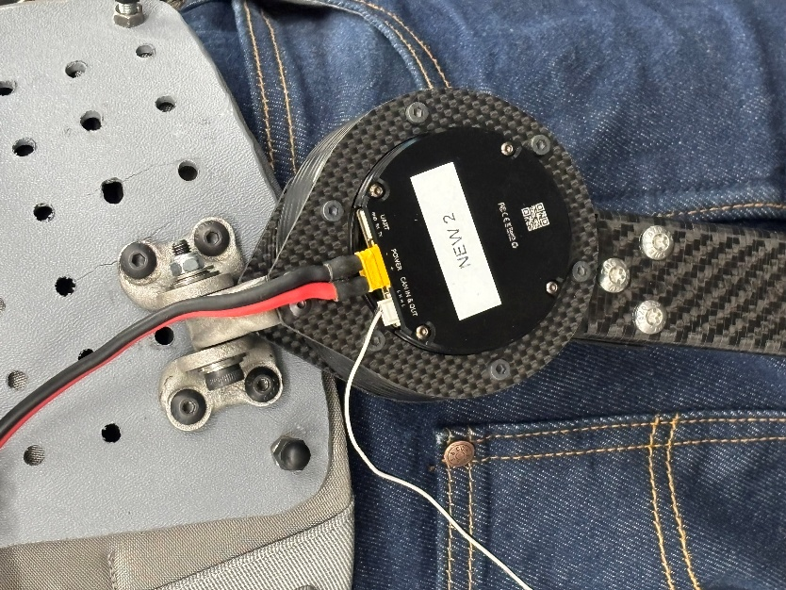
Figure 81: Hip Exoskeleton Final Physical Assembly
The figure above shows the hip abduction bracket installed on the hip exoskeleton during walking.

Service Requests

Active Rocket Control
The lower fin arm the team topology optimized and manufactured is shown in a drawing below. The assembly was not provided by the active rocket control capstone team, so only the drawing and final part will be shown.
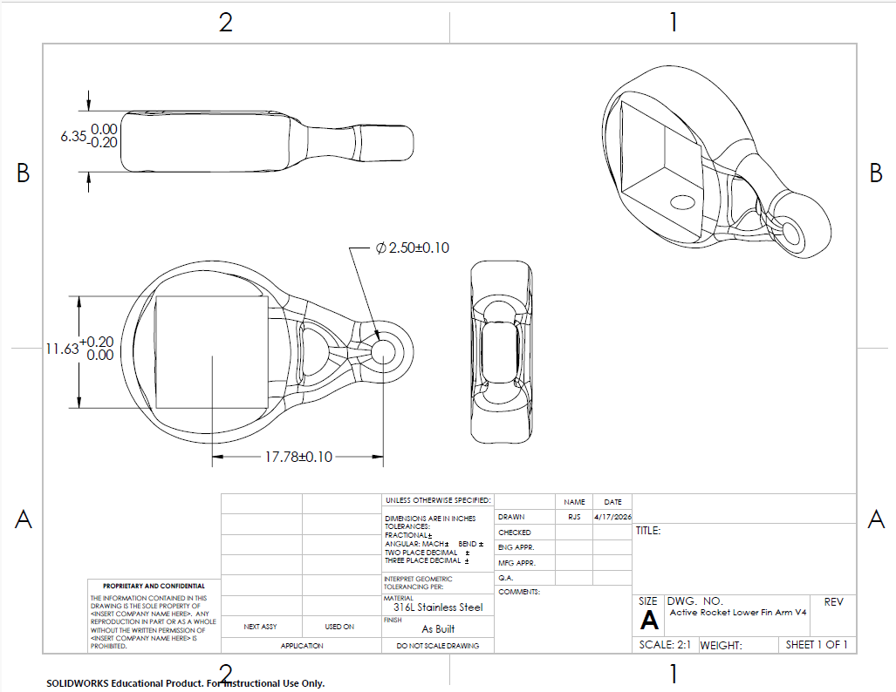
Figure 82: Topology Optimized Active Rocket Control Lower Fin Arm Drawing
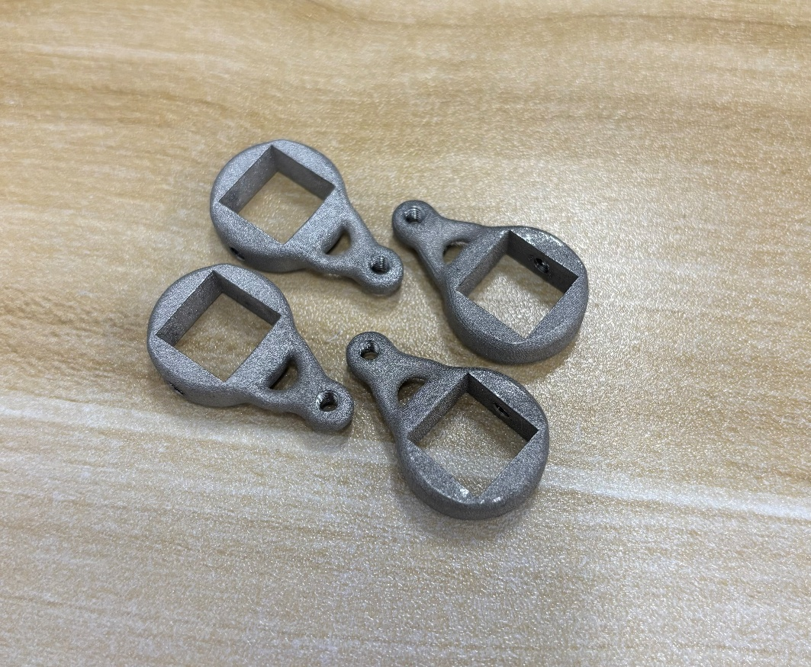
Figure 83: Active Rocket Control Service Final Hardware

Lerner Robotic Arm
The hinged bracket the team topology optimized and manufactured is shown in a drawing below. The assembly was not provided by the Lerner Robotic Arm capstone team, so only the drawings and final part will be shown.
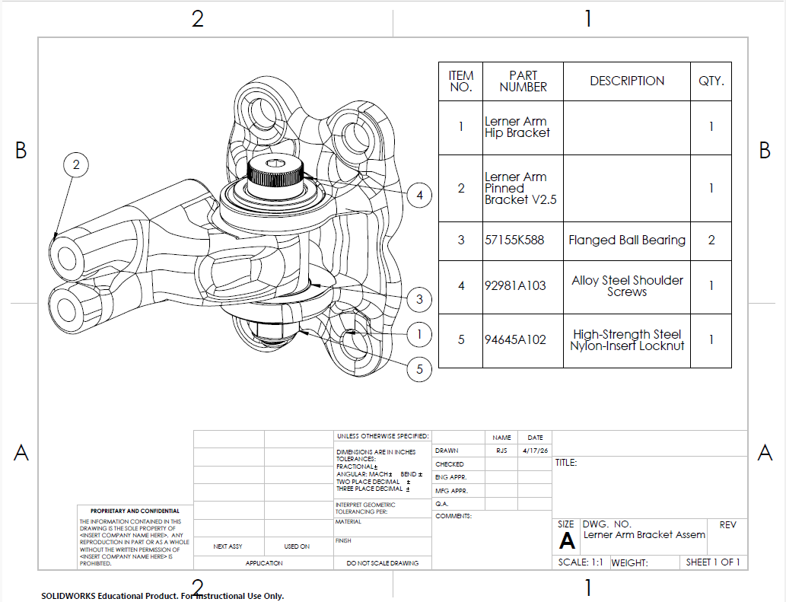
Figure 84: Topology Optimized Lerner Robotic Arm Hinge Assembly Drawing
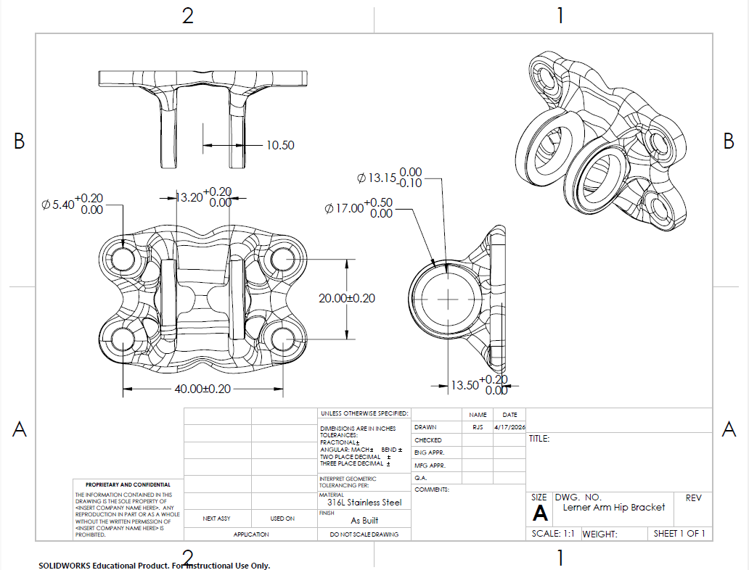
Figure 85: Topology Optimized Lerner Robotic Arm Hinge Hip Side Drawing
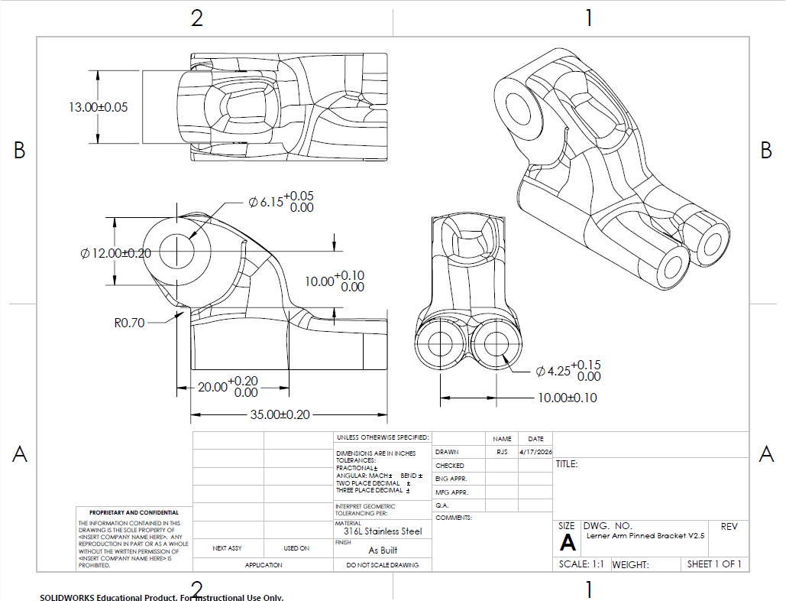
Figure 86: Topology Optimized Lerner Robotic Arm Hinge Motor Side Drawing
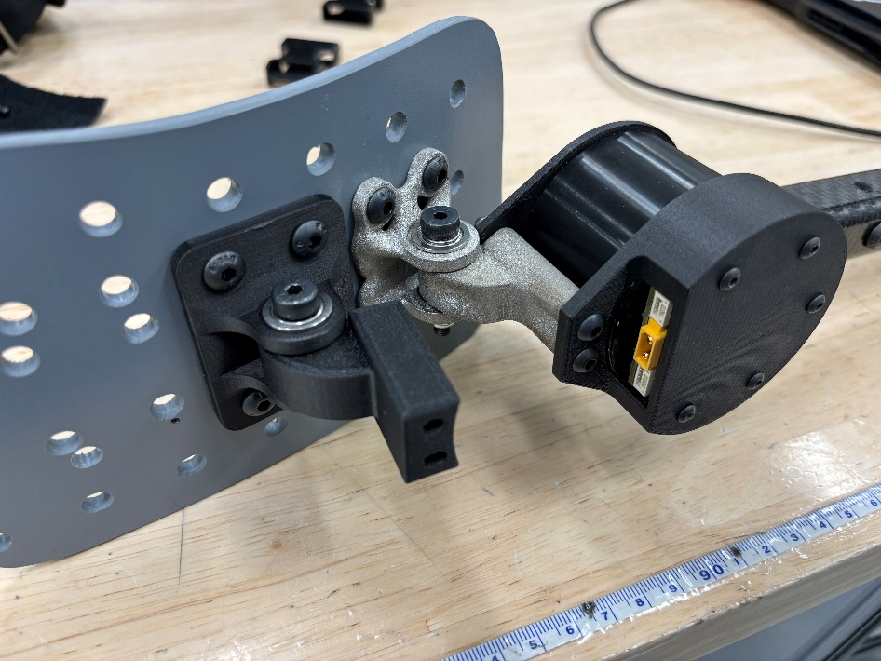
Figure 87: Topology Optimized Lerner Robotic Arm Hinge Final Hardware

Baja SAE
The SAE Baja hood ornament drawing and final part are shown below.
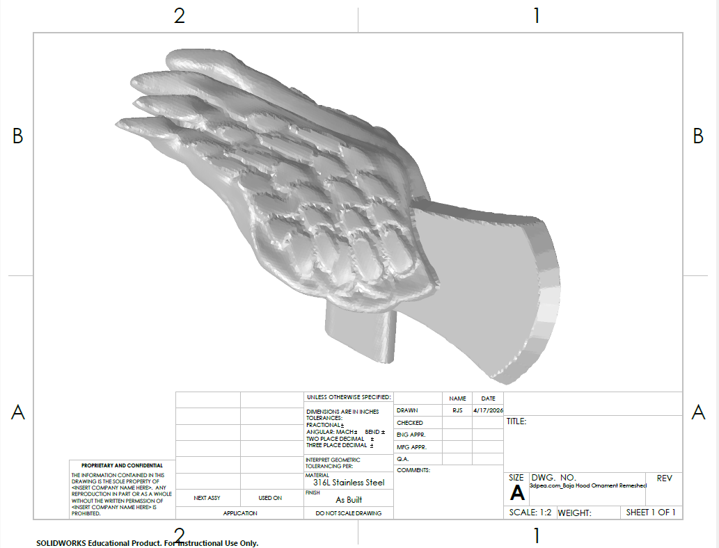
Figure 88: Baja Hood Ornament Drawing
Figure 89: Baja Hood Ornament Final Hardware

Formula SAE
The SAE Formula hood ornament drawing and final part are shown below.
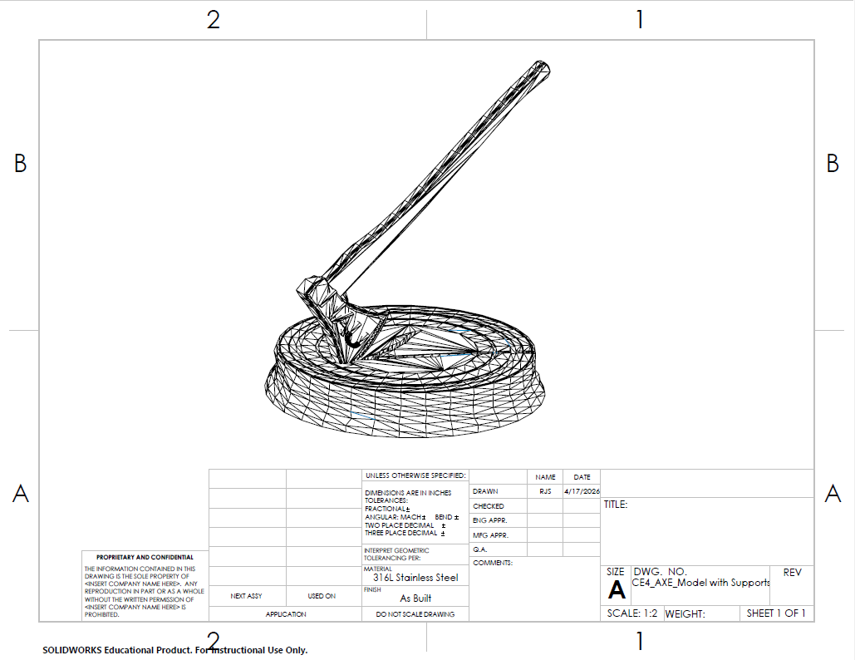
Figure 90: Formula Hood Ornament Drawing

Figure 91: Formula Hood Ornament Final Hardware

Final Testing

Top Level Testing Summary Tables

Erik
Experiment/Test | Relevant DRs | Testing Equipment | Other Resources
EXP1 – Comparison to Original | CR2 – Lightweight  ER2 – 10-20% weight reduction  ER5 – Range of Motion maintained | Scale  Dial Caliper | Original Arm  Optimized Arm
EXP 2 - Assembly | ER1 – Suitable fit  ER4 – Smooth Finish | Boom and Bucket attachments | Screwdriver
EXP 3 – Run Excavator | CR1 – Functional  CR4 – Safe for Use  ER3 – Maximum torque of 6.137x10^-4 Nm | Excavator and Controller | Batteries  Some material to scoop/dump
Table 7: Excavator Top Level Testing Summary Table

Sichao
Experiment / Test | Related Design Requirements (DRs) | Required Test Equipment | Other Resources
EXP1 – Mass Measurement Test | ER1 – Weight; CR1 – Lightweight | Gram scale | Final manufactured steering knuckle
EXP2 – Static Axial Load Test | ER4 – Stable Axial Load Capacity; CR2 – Durable; CR4 – Stable Under Load | Load fixture, force gauge | Mounted steering knuckle sample, test stand
EXP3 – Durability / Repeated Loading Test | ER2 – Lifetime; CR2 – Durable; CR4 – Stable Under Load | Assembled RC car, radio controller, battery, inspection tools | Flat test surface, completed steering system
EXP4 – Manufacturing Cost Evaluation | ER3 – Manufacturing Price; CR3 – Low Manufacturing Cost | Cost records, material pricing, manufacturing notes | Fabrication process documentation
Table 8: Steering Knuckle Top Level Testing Summary Table

Riley
Experiment/Test | Relevant DRs | Testing Equipment | Other Resources
EXP1- Mass Comparison | CR1-  Lightweight  ER1-  Weight Reduction of 15% | Electronic Balance | Use arbor press to remove bearings
EXP 2- Manufacturing Cost Analysis | CR3-  Manufacturing Cost  ER3-  Manufacturing Cost/Lead Time | Netfabb Slicer  Printing Documentation  Gas Consumption Documentation  MATLAB | Create cost equations for printing based on volume and height of build
EXP 3- Static Loading Analysis | CR2-  Durable  ER2-  Lifetime  CR4-  Stable in Use  ER4-  Axial Loading and Bending Moment | NTop  CubeMars AK60 Spec Sheet | Analysis of loading conditions in nTop by resumulating topology optimized model
EXP 4- Qualitative Walk Test | CR4-  Stable in Use  ER4-  Axial Loading and Bending Moment | Biomech Python GUI  OpenExo Hip Exoskelton  Laptop  Treadmill | Assemble topology optimized bracket and complete overground and treadmill walking
Table 9: Hip Abduction Bracket Top Level Testing Summary Table

Tensile Testing
Experiment/Test | Relevant DRs | Testing Equipment | Other Resources
EXP1 – Tensile Tests | CR1 – SS316  CR2 – In 718  ER1 – SS316 UTS ≥ 480-620MPa, E ≥ 190-205GPa  ER2 – In 718 UTS ≥ 965MPa, E ≥ 200GPa | 8802 Instron multiaxial testing machine | Lab Space  Excel Spreadsheet  ASTM E8/E8M Standards
Table 10: Tensile Testing Top Level Testing Summary Table

Detailed Testing Plan

Erik

Experiment 1- Comparison to Original

Summary
The goal of our individual design projects is to ‘optimize’ the original part using stainless steel 316. This test will determine whether improvement was made or not by comparing the size and weight of the original stick to the stainless steel one. This test in will specifically prove CR2: lightweight, ER2: 10-20% weight reduction, and ER5: 10% length increase.

Procedure
- Use a dial caliper to measure the length (cm) of the original stick
- Use a dial caliper to measure the length (cm) of the optimized stick
- Compare the lengths to one another
- Use a scale to measure the mass (g) of the original stick
- Use a scale to measure the mass (g) of the optimized stick
- Compare the lengths to one another

Results
The ideal result will be that the SS316 arm is longer and lighter than the original. Realistically, an acceptable result will be for both arms to have the same length, and while the optimized will be heavier, it will not negatively impact the function of the excavator.

Experiment 2- Assembly

Summary
This test is the most important of the bunch, as it proves whether optimization and metal printing was a waste of time and material. There are no calculations to be done here, as this test proves only that the excavator can be reassembled with the new part. In doing so, it will answer CR4: functionality and ER1: suitable fit.

Procedure
- Prepare all parts of the excavator for reassembly
- Fit both halves of the optimized stick to the boom connection
- Add all internal connectors to ensure the stick stays together
- Add bucket connection, and screw together
- Add bucket pins to connect the bucket’s hinge to the stick
- Check for excessive friction and adjust accordingly

Results
Based on all our prior testing of prototypes, the optimized model we are printing in SS316 should fit. There may be some additional friction due to the surface finish not being as smooth as the original plastic, but that can be handled with post processing.

Experiment 3- Run Excavator

Summary
The final test will be to run the excavator fully assembled with the optimized stick. While EXP2 demonstrates aesthetics, this experiment proves functionality. This specifically covers CR1: safe, CR3: durable, CR4: functional, and ER3: maximum load. The controlled variables will be the materials scooped and dumped, while the calculations will come from the weights of those loads converted into torque using the equation.

Procedure
- Fully charge the excavator’s battery, and ensure the controller has power
- Scoop a bucket-full of sand/dirt, and empty it 10x
- Estimate weight using density and bucket volume
- Scoop a bucket-full of rocks, and empty it 10x
- Measure weight using a scale
- Scoop and immoveable object to test for any sort of bending

Results
With the factor of safety for the optimized part being in the millions, there’s not even a slight risk of the stick breaking or bending. While technically testing the max load, this will more so prove the excavator's ability to function normally even with the new stick.

Excavator Arm Specification Sheet and Final Results
The following tables show the design requirements and whether or not the requirement is met through the experiments tested above. The tables show the target, tolerance, and measured or calculated value to support checks on the requirement being met.

Engineering Requirement | Target | Tolerance | Measured / Calculated Value | Requirement Met?  (✓ or X) | Customer Accepts? (✓ or X)
ER1 – Fit | Y | N/A | Y | ✓ | ✓
ER2 – Weight | 90% original | +/- 5g | 49.2g | X | ✓
ER3 – Max Load | 46g | + ∞ | > 46g | ✓ | ✓
ER4 – Surface | 6.3 μm | +/- 4 μm | > 6.3μm | X | ✓
ER5 – Range of Motion | 6.35cm | + ∞ | +0.05cm | ✓ | ✓
Table 11: Excavator Arm Engineering Specification Sheet

Customer Requirement | Requirement Met?  (✓ or X) | Customer Accepts? (✓ or X)
CR1 – Safe | ✓ | ✓
CR2 – Lightweight | ✓ | ✓
CR3 – Durable | ✓ | ✓
CR4 – Functional | ✓ | ✓
Table 12: Excavator Arm Customer Specification Sheet

Sicaho

Experiment 1- Mass Measurement Test

Summary
The purpose of this test is to verify that the redesigned RC car steering knuckle satisfies the weight requirement. This test is directly related to ER1 – Weight and CR1 – Lightweight. Since the steering knuckle contributes to the unsprung mass of the front suspension system, keeping the part lightweight is important for maintaining good steering response and overall vehicle handling. The question addressed by this test is whether the final manufactured steering knuckle has a total mass less than or equal to 100 g.
The required equipment for this test includes a digital scale with sufficient precision for small parts. The primary measured variable is the mass of the finished steering knuckle. No additional complex calculations are required other than comparing the measured mass to the engineering target.

Procedure
- Ensure that the digital scale is placed on a level surface.
- Turn on the scale and allow it to zero properly before use.
- Clean the steering knuckle to remove debris or excess support material that is not part of the final design.
- Place the finished steering knuckle on the scale.
- Record the measured mass in grams.
- Repeat the measurement three times to reduce random measurement error.
- Compute the average measured mass.
- Compare the average mass to the target requirement of 100 g.

Results
The average measured mass of the steering knuckle is expected to be less than or equal to 100 g. The evaluation can be expressed as:
m =（m1 +m2 +m3 ）/3
where m1 , m2 , and m3 are the three mass measurements.
The part satisfies the requirement if:
m ≤100 g
Since the design was developed with lightweight performance as a major objective, the final measured mass is expected to remain below the target limit.

Experiment 2- Static Axial Loading Test

Summary
The purpose of this test is to verify that the redesigned steering knuckle can safely withstand the required axial load without cracking, structural failure, or unacceptable deformation. This test is directly related to ER4 – Stable Axial Load Capacity, CR2 – Durable, and CR4 – Stable Under Load. The main question addressed by this test is whether the steering knuckle can resist an axial load of at least 60 N under a conservative loading condition.
The required equipment includes a load fixture, a force gauge or testing machine, and calipers or a displacement gauge to measure deformation if necessary. The primary measured variables are the applied load and any visible or measurable deformation in the steering knuckle. The calculated variable is whether the final deformation remains acceptable under the required load.

Procedure
- Mount the steering knuckle securely in a fixture that represents its support condition in the RC car assembly.
- Align the loading direction so that the applied force acts along the intended axial direction of the part.
- Set the force gauge or testing machine to zero.
- Apply the load gradually in increments until the total load reaches 60 N.
- At each load increment, observe the steering knuckle for visible deformation, cracking, or instability.
- If available, record displacement at the loading point using calipers or a displacement gauge.
- Hold the full load of 60 N for a short period, such as 10–30 seconds.
- Remove the load and inspect the part for permanent deformation, cracks, or damage.
- Record whether the part remained intact and functional after unloading.

Results
The steering knuckle is expected to withstand the full axial load of 60 N without fracture, yielding, or unacceptable deformation. The load condition for this test is based on the design verification load determined from the vehicle mass and an applied dynamic amplification factor.
The static front-wheel load was estimated as:
Fstatic =mg(0.6) /2
Using m=1 kg and g=9.81 m/s^2,
Fstatic =(1)(9.81)(0.6)/2 =2.94 N
To account for dynamic effects and safety margin:
Fdesign =Fstatic ×10×2
Fdesign =2.94×10×2=58.8 N≈60 N
Therefore, the steering knuckle satisfies the axial load requirement if it survives a load of 60 N without structural failure or unacceptable permanent deformation.

Experiment 3- Durability/Repeated Loading Test

Summary
The purpose of this test is to evaluate whether the redesigned steering knuckle can remain functional after repeated steering motion and short-duration vehicle use. This test is related to ER2 – Lifetime, CR2 – Durable, and CR4 – Stable Under Load. Since a dedicated cyclic loading machine is not available, this test will serve as a practical durability evaluation using the assembled RC car system. The main question addressed by this test is whether the steering knuckle can maintain structural integrity and functional performance after repeated steering operation under realistic prototype-level conditions.

The required equipment includes the assembled RC car, radio controller, battery, a stable test surface, and inspection tools such as calipers and visual observation. The primary measured variables are the number of completed steering repetitions, visible damage, looseness, cracking, and any loss of steering function. The test result is evaluated based on whether the steering knuckle remains intact and operational after the repeated-use test.

Procedure
- Install the steering knuckle into the complete front steering and suspension assembly of the RC car.
- Verify that the steering system operates normally before testing begins.
- Place the RC car on a flat test surface.
- Repeatedly steer the wheels from left lock to right lock and back to center under powered steering operation.
- Count each full left-to-right-to-left motion as one cycle, or record the total number of repeated steering actions in a defined test period.
- Perform the repeated steering test for a practical target such as 200 to 500 cycles, depending on available time and battery capacity.
- If desired, supplement the steering repetitions with short driving runs that include turning, stopping, and direction changes.
- After every 50 to 100 cycles, inspect the steering knuckle for visible cracks, looseness, interference, excessive wear, or permanent deformation.
- At the end of the test, perform a final inspection and verify that the steering system still functions properly.

Results
The steering knuckle is expected to remain intact and functional after repeated steering operation without visible cracking, permanent deformation, or significant loss of steering performance. Because no dedicated fatigue-testing apparatus is available, this test is intended as a practical functional durability assessment rather than a full laboratory fatigue-life verification.
The steering knuckle will be considered to pass this test if:
- no visible cracks are observed,
- no permanent deformation is detected,
- the steering linkage remains properly connected,
- wheel alignment is not obviously compromised, and
- steering motion remains smooth and functional after the repeated-use test.

Experiment 4- Manufacturing Cost Analysis

Summary
The purpose of this evaluation is to determine whether the steering knuckle can be manufactured at an acceptable cost. This evaluation is directly related to ER3 – Manufacturing Price and CR3 – Low Manufacturing Cost. The main question addressed is whether the total manufacturing cost per steering knuckle is less than or equal to $12.
The required information for this evaluation includes material price, machine usage cost if applicable, and post-processing or finishing cost. The measured variables are the individual cost contributions, and the calculated variable is the total manufacturing cost per part.

Procedure
- Record the amount and type of material used to manufacture one steering knuckle.
- Determine the material cost associated with that amount of material.
- Record any machine usage cost, printing cost, or fabrication cost associated with producing the part.
- Record any additional post-processing costs, such as support removal, machining, sanding, or finishing.
- Add all cost components together to determine the total manufacturing cost per part.
- Compare the total cost to the engineering requirement of $12.

Results
The total manufacturing cost is expected to remain less than or equal to $12 per part. The total cost can be calculated as:
Ctotal =Cmaterial +Cmanufacturing +Cpost−processing
The part satisfies the requirement if:
Ctotal ≤$12
Because the design was intended to remain practical for prototyping and small-scale manufacturing, the final cost should remain within the target value.

Steering Knuckle Specification Sheet and Final Results
The following tables show the design requirements and whether or not the requirement is met through the experiments tested above. The tables show the target, tolerance, and measured or calculated value to support checks on the requirement being met.

Engineering Requirement | Target | Tolerance | Measured / Calculated Value | Requirement Met? (✓ or X) | Customer Accepts? (✓ or X)
ER1 – Weight | ≤ 20 g | N/A | 12g | ✓ | ✓
ER2 – Lifetime / Repeated Use Durability | No visible damage after repeated functional steering test | N/A | No visible damage | ✓ | ✓
ER3 – Stable Axial Load Capacity | ≥ 60 N | N/A | No visible damage | ✓ | ✓
ER4 – Manufacturing Price | ≤ $80 | N/A | $61.75 | ✓ | ✓
Table 13: Steering Knuckle Engineering Specification Sheet

Customer Requirement | Requirement Met? (✓ or X) | Customer Accepts? (✓ or X)
CR1 – Lightweight | ✓ | ✓
CR2 – Durable | ✓ | ✓
CR3 – Stable Under Load | ✓ | ✓
CR4 – Low Manufacturing Cost | ✓ | ✓
Table 14: Steering Knuckle Customer Specification Sheet

Riley

Experiment 1- Mass Comparison

Summary
The purpose of the mass comparison test is to determine the difference in mass of the designs. The design requirements being tested are CR1 and ER1 which investigate whether the topology optimized geometry reduces the mass of the final design. The caveat is that the additively manufacture parts are made of 316L stainless steel, making them far denser than the original parts. The equipment needed for this test includes an electronic balance and a press. The isolated variables for this test include the mass of each of the individual parts. The calculations will include the percent difference of the original parts’ masses and the topology optimized parts’ masses.

Procedure
- Remove both the original 7075 T6 aluminum and topology optimized 316L stainless steel hip abduction brackets from the hip exoskeletons.
- Disassemble the brackets by removing the locknut on the end of the shoulder bolt and press the shoulder bolt out of the hinge.
- Separate the hip side parts from the motor side parts of both brackets.
- Press the bearings out for both brackets.
- Locate, turn on, and zero the electronic balance using grams for the measurement units.
- Take measurement of the mass for each of the parts and record the values in a spreadsheet.
- Perform calculations to determine the percentage difference between the original and topology optimized parts.

Results
The target results for this experiment entail a decrease in mass of a minimum of 15% when comparing the original parts to the topology optimized parts. Unfortunately, due to an inability to print in aluminum, this goal is likely unachievable. The density of 316L stainless steel is 8000 kg/m^3, and the density of 7075 T6 aluminum is 2810 kg.m^3. The mass results will be used to calculate the percentage difference of the masses using the following equation.
$$Percentage Difference=\left(\frac{\left|m_{original}-m_{topology optimized}\right|}{m_{original}}\right)×100\%$$

Based on the mass estimation provided using Solidworks, the topology optimized part will have a mass that is 100% greater for the pair of stainless steel printed components.

Experiment 2- Manufacturing Cost Analysis

Summary
The manufacturing cost analysis aims to determine the difference between the monetary costs of different manufacturing techniques, and the lead times involved with getting components made. The direct values will be compared from the moment the part models are finalized to the time of part delivery or completion. The cost analysis is based on an equation made using the gas consumption per hour predicted using the print height and the cost of metal powder. This test will evaluate the CR3 and ER3 design requirements which focus on the limitations of manufacturing methods for the given parts.

Procedure
- Record the time to print the parts.
- Record argon gas consumption for printing the parts.
- Record the height of the print in millimeters.
- Convert the height of the print to layers and calculate a time estimation based on the number of layers for the build.
- Record the volume of material printed using Netfabb Premium.
- Convert the volume of material to mass of the metal powder used for the base plate and part model.
- Complete calculations to estimate the cost of the materials based on the mass of printed material and print time for argon consumption.
- Record the time it takes to go from a part model to the final part in hand.
- Compare the cost and lead times for each manufacturing technique.

Results
The target results for this test include a reduction in material cost and lead time when comparing conventional manufacturing from additive manufacturing. The cost for additive manufacturing in materials should be below $1000, and the lead time should be below 14 days. The equation for cost estimation includes a term for the metal powder and the argon gas. This equation also includes a cost for hours of post processing at $60/hour based on machinist rates in Flagstaff on the low end.

$$C_{total}=C_{gram 316 SS}×m_{build}+C_{tank}×{Rate}_{argon}×t_{build}+{Wage}_{post proc}×t_{post proc}$$

Experiment 3- Static Loading Analysis

Summary
Due to limitations in testing methods and materials, the loading analysis is completed using FEA software per Professor Willy’s recommendation. The design requirements included in this test are CR2- durable, ER2- lifetime, CR4- stable in use, and ER4- axial loading and bending moment. Although the durability cannot directly be tested as there is no fatigue analysis in the software, the criteria will be based on the factor of safety being greater or equal to 10 for both parts. The isolated variables include the part model and the loading conditions of the parts. The calculations are completed using implicit modeling and a finite element analysis.

Procedure
- Import topology optimized model back into nTop.
- Mesh the model.
- Apply the 316L SS material model.
- Apply all boundary and loading conditions.
- Run the simulation.
- Read and report the maximum stresses.
- Calculate the factor of safety using the maximum stress of the result and the yield stress of the material.

Results
The expected results are based on the factors of safety that were calculated for the engineering calculations summary. The minimum factor of safety seen in the nTop analysis is 22.2, ensuring that the part will not fail in normal loading, and proving it is unlikely for the part to fail due to fatigue. While the exoskeletons are extensively tested and used in data collections, new designs are regularly being made. Based on the high factor of safety and turnover rate in projects, the part will be able to function as intended throughout its lifetime. The factors of safety were calculated using the following equation.
$$FOS=\frac{σ_{'max}}{σ_{yield}}$$

Experiment 4- Exoskeleton Walk Test

Summary
This is a qualitative test that will provide insight into the parts’ ability to withstand the expected loading conditions and a light number of cycles. The test will provide some qualitative metrics for the CR2, CR4, and ER4 design requirements. The purpose of this test is to ensure the component functions as expected on the hip exoskeleton for a period of walking. The part will be installed and tested on both overground and treadmill walking. The isolated variable is the brackets functionality over various walking conditions. As a qualitative test, not calculations will result, but observations will be recorded throughout the walking session.

Procedure
- Disassemble one side of the hip exoskeleton to remove the hip abduction bracket.
- Install the topology optimized hip abduction bracket on the exoskeleton.
- Power up the exoskeleton, complete calibration protocols, and set a torque setpoint of 9Nm.
- Complete walking overground throughout the LRC and outside on south campus of NAU.
- Complete treadmill walking at 1.25m/s.
- Record all observations throughout the walk test.

Results
The key results from this test include the verification of hinge function for multiple walking conditions. Observations should consist of stable operation of the topology optimized hinge, and it will be checked for any wear and deformation upon completion of the walk test.

Hip Abduction Bracket Specification Sheet and Final Results
The following tables show the design requirements and whether or not the requirement is met through the experiments tested above. The tables show the target, tolerance, and measured or calculated value to support checks on the requirement being met.

Engineering Requirement | Target | Tolerance | Measured / Calculated Value | Requirement Met? (✓ or X) | Customer Accepts? (✓ or X)
ER1 –Lightweight | -15% of original | +/- 5% | Original vs. Topology Optimized:  Al: -20%  316SS: -28.5%  Actual: +56.9% | X | X
ER2 – Durable | -10 minutes of walking | +/- 1 minute | 10:48 minutes | ✓ | ✓
ER3 –Manufacturing Cost and Lead Time | <$500  <14 days | +/- $50 | Cost: $290.38  Min Days: 3 | ✓ | ✓
ER4 – Axial Load and Bending Moment | Withstand <9Nm motor torque | +/-0.5 FOS | Min: 588.23 | ✓ | ✓
Table 15: Hip Exoskeleton Abduction Bracket Engineering Specification Sheet

Customer Requirement | Requirement Met? (✓ or X) | Customer Accepts? (✓ or X)
CR1 – Lightweight | X | X
CR2 – Durable | ✓ | ✓
R3 – Manufacturing Cost and Time | ✓ | ✓
CR4 – Stable in Use | ✓ | ✓
Table 16: Hip Exoskeleton Abduction Bracket Customer Specification Sheet

Tensile Testing

Experiment 1- Tensile Tests

Summary
As a requirement from Dr. Ciocanel and the commissioning of the Concept Laser MLab Cusing 100R Direct Metal Laser Melting 3D printer. The team has printed 16 test specimens for both 316L stainless steel and Inconel 718. The design requirements this experiment seeks to evaluate include CR1-validate 316 L SS, CR2- validate Inconel 718, CR3- evaluate heat treatments, ER1-316L SS material properties, ER2- Inconel 718 material properties, and ER3- untreated specimens. The team will test the specimens with Dr. Ciocanel in his lab using the 8802 Instron multiaxial testing machine. The isolated variable will be the displacement of the part to calculate the stress and strain of the tensile specimens to calculate the elastic modulus, yield stress, and ultimate tensile strength.

Procedure
- Prepare the tensile specimens by organizing and taking measurements of the gauge length and gauge diameter.
- Set up the machine with circular jaws to secure the specimens.
- Set the speed of the machine based on the material standard.
- Insert the specimen into the machine and clamp with the jaws.
- Complete appropriate zeroing and preloading procedures according to Dr. Ciocanel’s machine and ASTM standards.
- Conduct the tensile test by loading the part until part fracture.
- Repeat procedure for all 32 tensile test specimens.
- Record all displacement and force data in an Excell spreadsheet.
- Complete calculations to obtain stress and strain data.
- Plot the stress-strain curve.
- Calculate the Elastic Modulus.
- Use the 2% Offset method to determine the yield stress of the printed parts.
- Determine the maximum tensile stress.
- Report all results and compare to standard material properties.

Results
The results for this test include the stress-strain data for all the types iof tensile specimens with standard deviation, modulus of elasticity, yiled stress, and ultimate tensile stress. The expected material properties for 316L SS are a tensile strength between 480-620 MPa and a Young’s Modulus between 190-205GPa. The expected material properties for Inconel 718 are a tensile strength of 965 MPa and a Young’s Modulus between 200GPa. The annealed 316L SS specimens are unlikely to see any increase in strength due to its inability to be hardened. The Inconel 718 specimens that are HIPed should provide higher strength due to increased density and heat treatment. The equations used for the calculations are as follows.
$$σ=\frac{F}{A}$$

$$ε=\frac{∆l}{l_{o}}$$

$$E=\frac{σ}{ε}$$

Tensile Test Specification Sheet and Final Results
The following tables show the design requirements and whether or not the requirement is met through the experiments tested above. The tables show the target, tolerance, and measured or calculated value to support checks on the requirement being met.
Engineering Requirement | Target | Tolerance | Measured / Calculated Value | Requirement Met? (✓ or X) | Customer Accepts? (✓ or X)
ER1 – SS316 | UTS ≥ 480-620MPa  E ≥ 190-205GPa | +/-0.5MPa  +/-0.5GPa | 648.4MPa  56.GPa | ✓  X | ✓
ER2 – Inconel 718 | UTS ≥ 965MPa  E ≥ 200GPa | +/-0.5MPa  +/-0.5GPa | 1022 MPa  54.9 GPa | ✓  X | ✓
Table 17: Tensile Testing Engineering Specification Sheet

Customer Requirement | Requirement Met? (✓ or X) | Customer Accepts? (✓ or X)
CR1 – Print 316L SS | ✓ | ✓
CR2 – Print Inconel 718 | ✓ | ✓
Table 18: Tensile Testing Customer Specification Sheet

Future Work
The future work for this project falls into two categories: commissioning and design projects.

The commissioning future work includes improving laser parameters, building a partition for the IDEA Lab, and printing in titanium (Ti-6AL-4V). The laser parameters used throughout the project excluded upskin and downskin parameters. This would expand the capabilities of the printer by improving the surface finish of inclined and declined surfaces. Additionally, further tuning of laser parameters for the machine may be able to ensure fewer print defects and better surface finish. Netfabb slicer also provides the ability to implement custom support material scripts. This could improve the current process where support materials are designed into the model manually.
The partition was ultimately cancelled from the project because due to issues getting approval, and EHS and the building manager deeming the addition is too complex for the capstone team to carry out. The IDEA Lab would benefit greatly with the addition of a partition because it would separate the metal powder and machines from the rest of the space. With the addition of the partition, the facility would improve overall safety and be able to print titanium.
The team purchased the materials to manufacture build plates and print in titanium, but due to the cancellation of the partition and a back up in the machine shop, the team was unable to print in titanium. The addition of titanium printing would greatly expand the capabilities of the IDEA Lab and NAU in general.
The future work possible for the design projects include further developing the topology optimizations for the hip exoskeleton abduction bracket, the Lerner Robotic Arm hinged bracket, and the Active Rocket Control lower fin arm. The abduction bracket would benefit revisions for a lower factor of safety and overall volume. This would allow for further mass reduction to reach a target lower than the original conventionally manufactured design. The team did not have time to complete another topology optimization and reprint the part.

CONCLUSIONS
The goal of this project can be broken into three sections: provide NAU with a safe and functional metal 3D printer setup, topologically optimize and print individual designs with engineering applications, and lastly service other capstone teams by optimizing their parts and providing them with topology optimized components to replace in their projects. As the project progressed, the team was also tasked with designing and building a safe room to contain the printer and its add-on machines.
The group decided that the individual designs would be an RC Excavator Arm, an RC Car Steering Knuckle, and a Hip Abduction Bracket.
Regarding the partition, it was determined by EHS and the building manager that the project was too complicated to simply be an add-on to a pre-existing capstone. As such, the project has been put on an indefinite hold. Following this, the team will not go forward with printing in titanium (Ti6Al4V).
The team has been able to assess and restore the printer to be functional. Module 3 has been fully repaired and validated with several prints, while modules 2 and 4 are functional albeit with some deformations in their resulting prints.

Commissioning Report

Printer Operation and Safety Guides
Up to this point, the biggest portion of the team’s efforts has gone into commissioning the printer and its corresponding machines. Dr. Ciocanel informed the team that he had tried to operate the sieve but was asked for a password that he did not know. When the team operated the sieve, we encountered no such password restriction. Using the online manual, the team managed to get all the way through the sieve process up until starting the sieve. Metal powder was found inside the sieve, so the team didn’t feel it was safe to fully operate it until it was cleaned.
To clean the sieve, a wet separator must be used. The team was provided with one, but the previous year’s capstone team left water in it which has sat idle for several months. We have reached out to waste disposal personnel around NAU for the sake of finding a safe way to clean the separator to then be able to clean the sieve.
For the metal printer, the team has conducted a couple of diagnostic prints to test its capabilities. These include a few cubes based on the Gao Block [27] as well as a hollow, spherical mesh. The team has found that while the printer is functional, the vertical surfaces it produces are wavy. The cause of this defect is currently being investigated.

Initial Printed Parts- Diagnostics and Results
The team has completed two initial diagnostic prints with the machine. All parts have been printed out of 316L stainless steel. The purpose of the initial test prints is to get the team familiar and confident in printer operation and handling procedures. The parts designed for printing are based on the Gao Block [28], a diagnostic part developed for additive manufacturing. This model features different geometries to understand the printers capabilities regarding overhang sensitivities, dimensional accuracy, surface roughness, and more. The first test print focused only on printing a single diagnostic block that measures 20mm x 20mm x 20mm in volume. The following figure shows the geometries of the block in the slicer software. The purple body underneath the block is a baseplate the part is printed on as recommended by the previous capstone team.
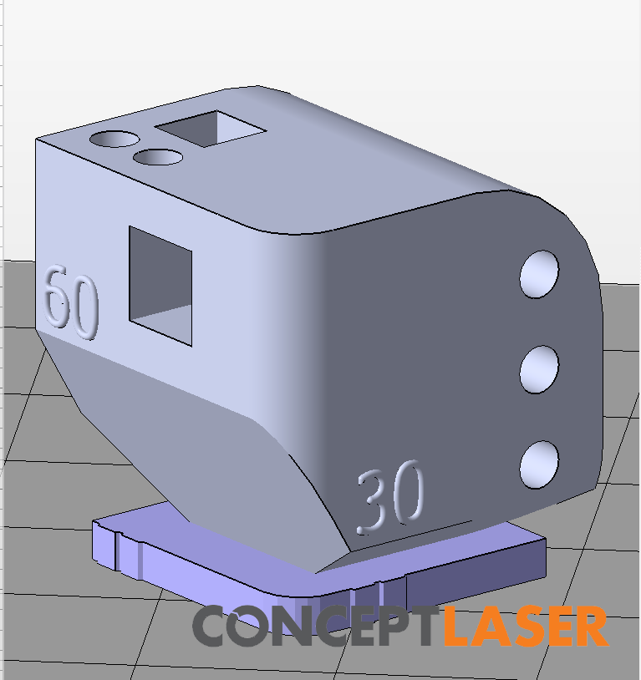
Figure 92: First Diagnostic Block
The first test print was completed without significant challenges. The final part, however, has some issues with the print quality which the team suspects is caused by user error. There are visible waves on the vertical surfaces that should be flat, which the team believed was caused by the poor quality of the build plate.
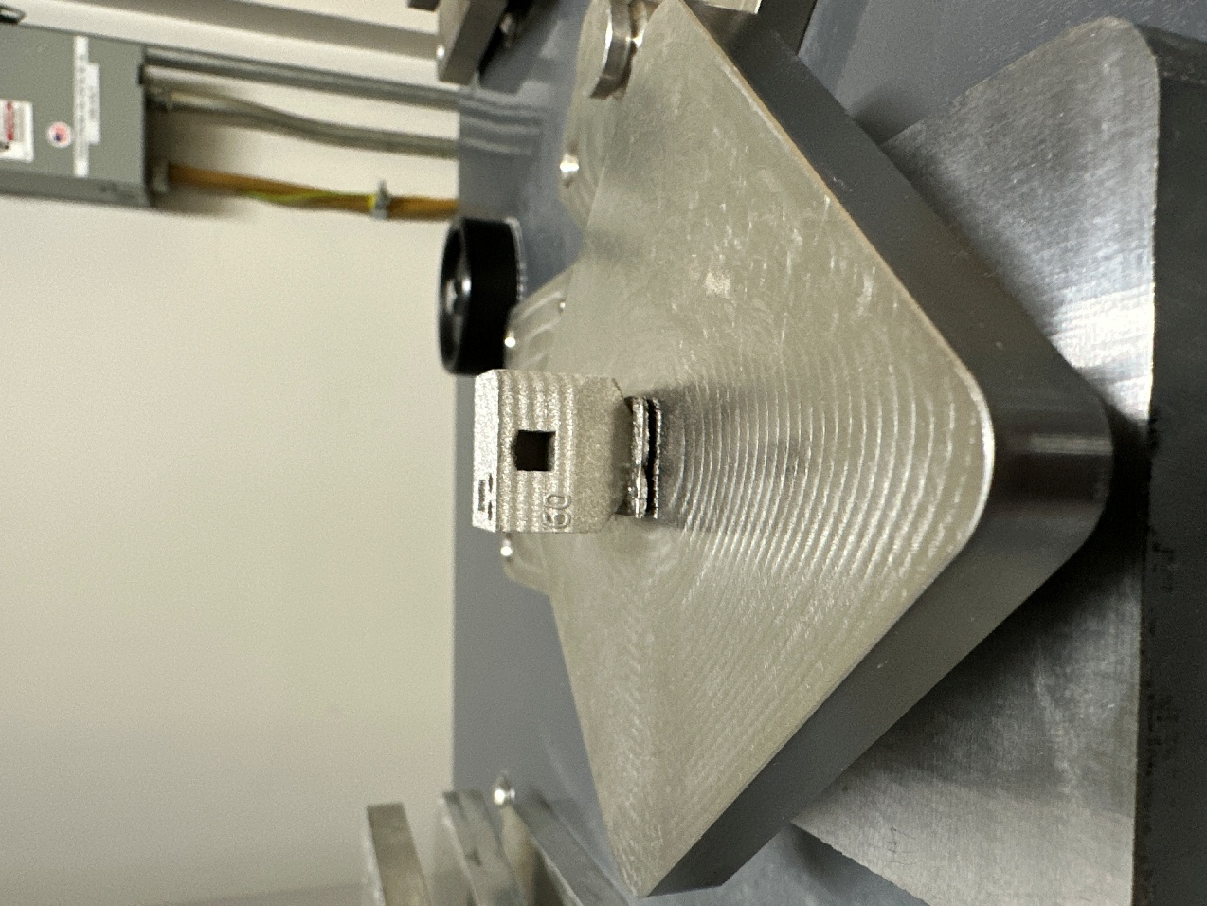
Figure 93: Initial Test Print Results
The second test print included two smaller diagnostic blocks and a lattice sphere. The purpose of the smaller blocks is to see if the team can determine the cause of the reduced print quality and test the differences between using a generated support and a baseplate. The decision to print a lattice sphere was based on wanting to provide the Idea Lab with an interesting part to show at an upcoming event. The part was designed to highlight the capabilities of additive manufacturing and the new ability for the Idea Lab to manufacture very complex geometries using metal.
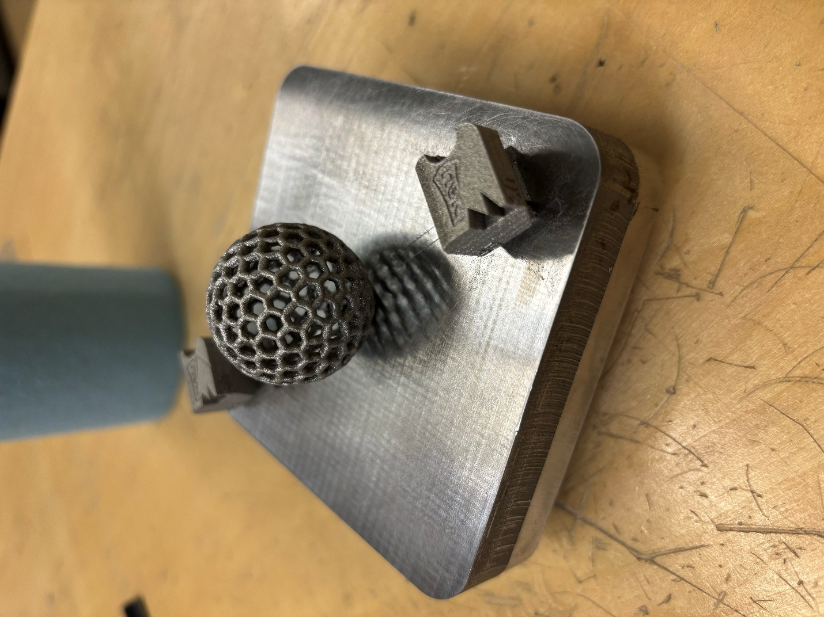
Figure 94: 2nd Test Print Results

Idea Lab Printer Partition
Lastly, there is the design and building of a safe room. Presently, the bordering walls have been designed through 80/20, and research is being conducted into how to approach the building of the roof. This includes finding potential filter fans to use [12] and reviewing a previous capstone team’s creation of a clean room [11].

Additional Printed Parts
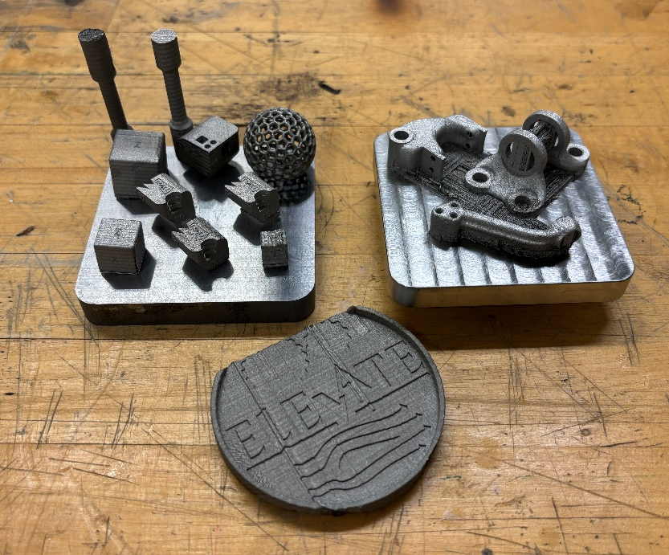
Figure 95: All Printed Parts to Date (11/26)
The team has been working hard to make sure the printer is operating properly. The only module that was functional (module 3) produced parts with print defects (wavy vertical surfaces). These print defects took time and effort to diagnose, and the team had to find a solution to ensure the printer can print reasonable parts. After determining that the ball screw for the build chamber was damaged, the team disassembled module 1, which was not functional due to a broken ball screw nut, and used some components to repair module 2. After completing this, the team was able to produce its first acceptable parts. There were no structural or cosmetic print defects that could be found. This allows the team to move forward and print the topology optimized designs for the hip bracket and RC car steering knuckle. These components will be used in the team’s 2nd prototype presentation.
The part on the bottom of the above figure is a coaster printed for Dr. Ciocanel. The printer was still having issues with the print quality, and it is obvious. The team did not have enough material to print the entire part, so the coaster was unfinished. Dr. Ciocanel was very disappointed and frustrated with the team. This instigated the change to update him weekly and suggest alternative rather than doing as he says, no questions asked. The geometries of the coaster are not optimized for any print orientation, leading to significant issues in the printing process. For the future the team will be vocal about these concerns instead of exclusively pushing to meet deadlines and requirements.
On the left build plate, many diagnostic parts are shown as the team printed several builds attempting to diagnose the issues with print quality. Now that the printer has been fixed and validated, the team will be capable of printing parts as the initial topology optimized designs have been printed.
After several prints and much research, the team was able to fully validate module 3, as well as repair modules 2 and 4 to the point that they function. Module 3 has since been used to print in SS316L and has produced several parts without defects.
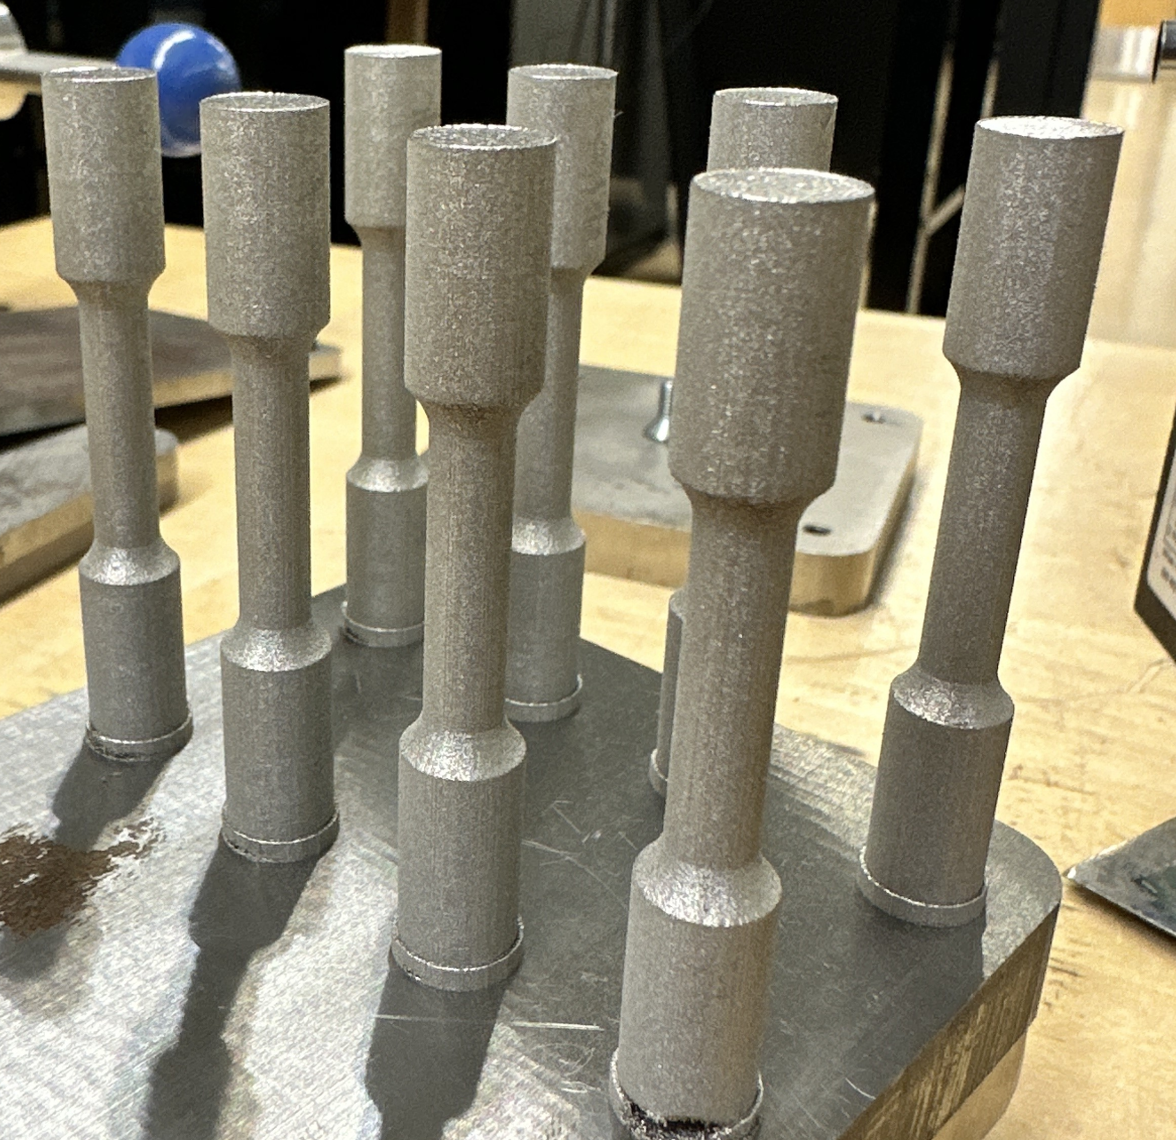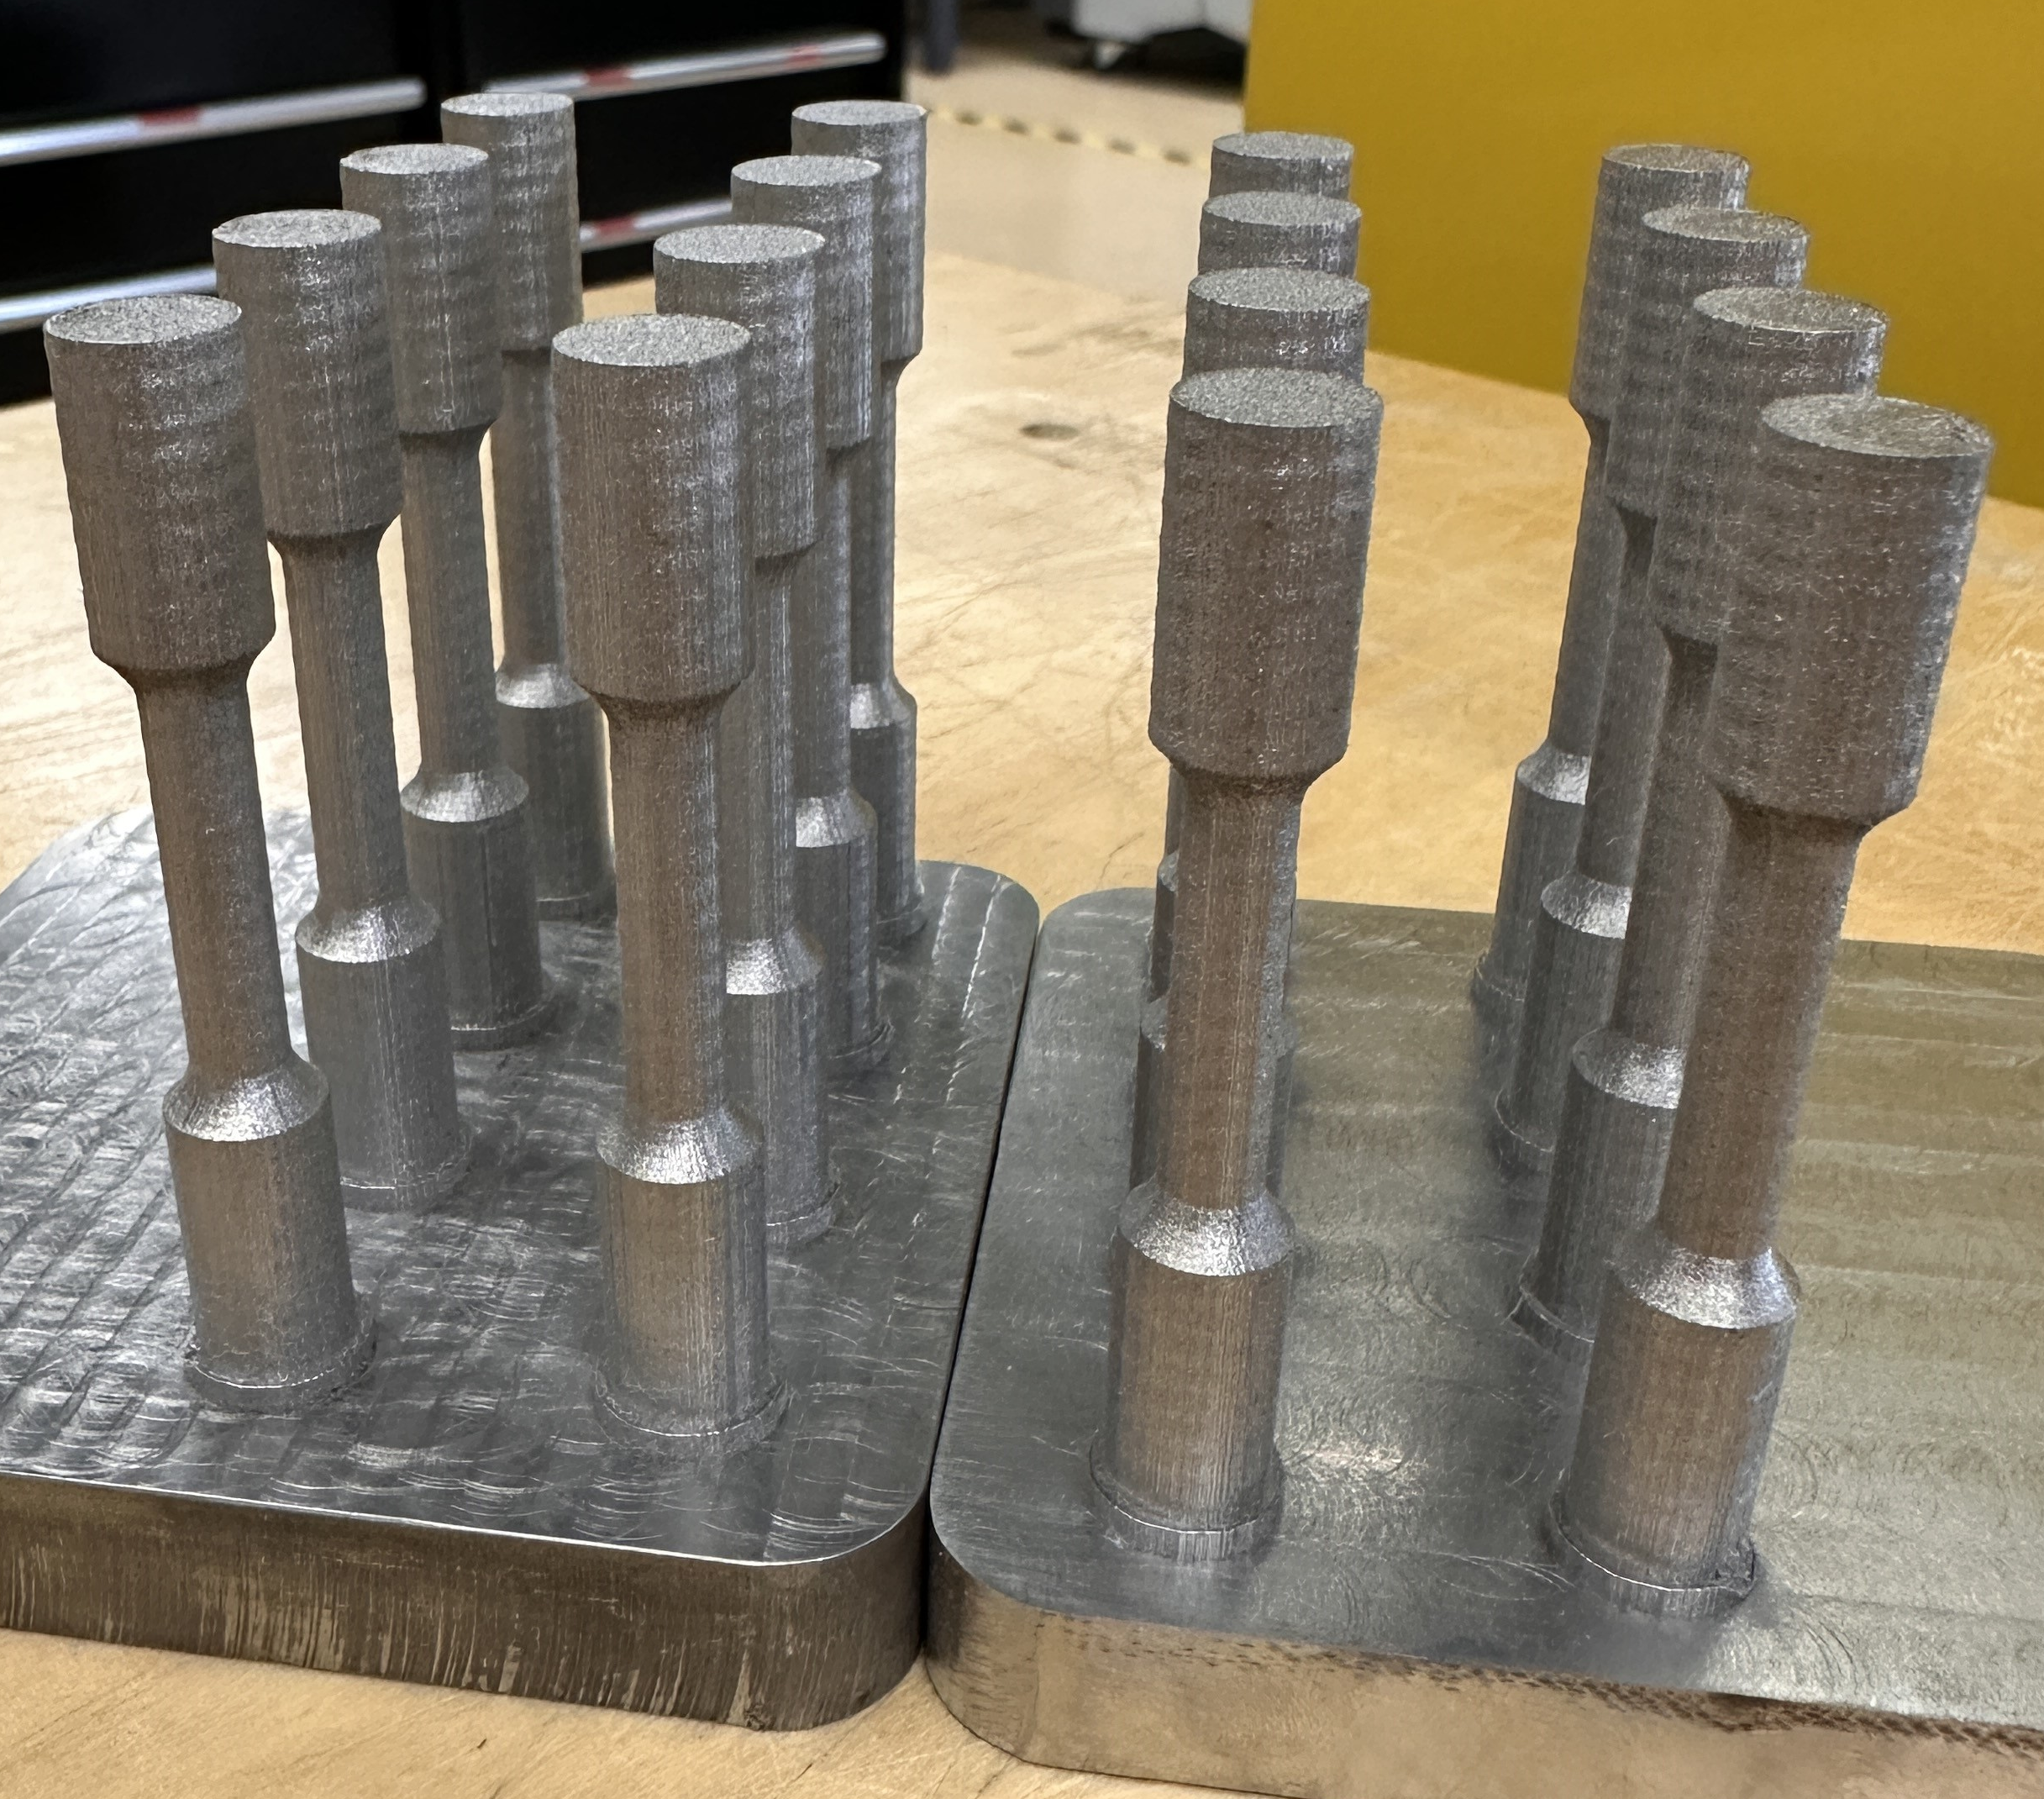
Figure 96: Satisfactory SS316L Tensile Specimens Figure 97: Inconel 718 Tensile Specimens
As shown in figure 96, module 3 was able to produce stainless steel parts without the waves that had been present in prior prints. Modules 2 and 4 were used to print in Inconel 718. While the laser parameters were narrowed down to produce parts with smoother surface finishes, there was a prevalent binding error in the build chamber's elevator shaft that caused waves again as shown in figure 97. Although not as severe as the initial waves, this defect will still negatively impact the physical properties of these prints.

REFERENCES
- O. Okorie, A. Perveen, D. Talamona, and K. Kostas, “Topology Optimization of an Aerospace Bracket: Numerical and Experimental Investigation,” Applied Sciences, vol. 13, no. 24, p. 13218, Jan. 2023, doi: https://doi.org/10.3390/app132413218.
- Nebojsa Raicevic, Aleksandar Grbović, Gordana Kastratović, Nenad Vidanović, and A. Sedmak, “Fatigue Life Prediction of Topologically Optimized Torque Link Adjusted for Additive Manufacturing,” International Journal of Fatigue, pp. 107907–107907, Aug. 2023, doi: https://doi.org/10.1016/j.ijfatigue.2023.107907.
- “Next-Gen Engineering Design Software: nTop (formerly nTopology),” nTop. https://www.ntop.com/
- Mlab cusing R: Translation of Operating Manual, v1.0.15, CONCEPT Laser GmbH, 2013, S1 pp.10-141
- Instruction Manual: Wet Separator, v1.0.15, CONCEPT Laser GmbH, June 2014, S3 pp.7-39
- Mlab cusing: Concept Laser Software 1.2.4, v1.0.15, CONCEPT Laser GmbH, 2013, S4 pp.7-39
- QM Powder: Automatic Sieving Station Operation Manual, v1.0.15, CONCEPT Laser GmbH, July 12, 2016. Accessed Sept. 16, 2025. [Online] Available: https://www.prestigeequipment.com/pix/29314.pdf
- nTop, “How to get the most out of topology optimization,” nTop, Mar. 19, 2020. https://www.ntop.com/resources/blog/how-to-get-the-most-out-of-topology-optimization/
- The Engineering Toolbox, “Young’s Modulus - Tensile and Yield Strength for common Materials,” Engineeringtoolbox.com, 2003. https://www.engineeringtoolbox.com/young-modulus-d_417.html
- R. M. Dhawale and S. R. Wagh, “FINITE ELEMENT ANALYSIS OF COMPONENTS OF EXCAVATOR ARM—A REVIEW,” Jan. 2014. https://www.ijmerr.com/v3n2/ijmerr_v3n2_40.pdf
- “Cleanroom,” Nau.edu, 2024. https://www.ceias.nau.edu/capstone/projects/ME/2024/F23toSp24_CleanRoom/
- “Fan Filter Unit (FFU),” Terrauniversal.com, 2025. https://www.terrauniversal.com/fan-filter-units.php (accessed Oct. 21, 2025).
- Specification for HEPA Filters Used by DOE Contractors. Washington, D.C. 20585: U.S. Department of Energy, 2005.
- T. H. Lee, J. Park, and S. Lee, “Lightweight design of steering knuckle using topology optimization and additive manufacturing,” Journal of Mechanical Science and Technology, vol. 34, no. 11, pp. 4425–4435, Nov. 2020. doi: 10.1007/s12206-020-0955-7.
- C. Wang, Y. Zhang, and H. Li, “Structural analysis and optimization of RC car steering knuckle under extreme cornering load,” International Journal of Vehicle Structures & Systems, vol. 12, no. 3, pp. 216–222, 2020.
- Traxxas, Slash 2WD Exploded View & OEM Parts Manual, 2023. [Online]. Available: https://traxxas.com
- Integy RC, 6061-T6 Aluminum Steering Knuckle for Slash 2WD Product Sheet, 2023. [Online]. Available: https://www.integy.com
- S. K. Moon and Y. H. Kim, “Additive manufacturing of lightweight components for small-scale vehicles: steering system applications,” Rapid Prototyping Journal, vol. 28, no. 1, pp. 33–45, Jan. 2022.
- J. Thompson and R. D. Brandt, “Topology optimization for additive manufacturing using nTop Platform,” Additive Manufacturing Letters, vol. 3, pp. 100–108, 2021.
- nTop, nTop Platform Documentation and Tutorials, 2023. [Online]. Available: https://www.ntop.com
- ANSYS Inc., ANSYS Mechanical User’s Guide, 2023. [Online]. Available: https://www.ansys.com
- H. Zhang, Y. Sun, and K. Wang, “Mechanical Performance Optimization of Aluminum Suspension Components Using Additive Manufacturing,” Journal of Manufacturing Processes, vol. 85, pp. 1021–1032, 2023.
- A. Reeves and M. Patel, “Finite Element Analysis of RC Car Steering Knuckle Under Braking and Cornering Loads,” in Proc. Int. Conf. Vehicle Dynamics and Mobility, 2022, pp. 411–418.
- S. Müller, D. Koch, and T. Berg, “Design Verification of Additively Manufactured Ti-6Al-4V Components for Small Mechanical Assemblies,” Materials Today: Proceedings, vol. 72, pp. 554–562, 2024.
- P. Maggiore, S. Brischetto, and C. Ferro, Additive Manufacturing Technologies and Applications. 2017.
- D. Jankovics, H. Gohari, M. Tayefeh, and A. Barari, “Developing Topology Optimization with Additive Manufacturing Constraints in ANSYS®,” IFAC-PapersOnLine, vol. 51, no. 11, pp. 1359–1364, Jan. 2018, doi: https://doi.org/10.1016/j.ifacol.2018.08.340.
- “Design for Metal Additive Manufacturing Part 2: Topology Optimization and Build Preparation,” Ansys.com, 2023. https://www.ansys.com/academic/educators/education-resources/am-case-study-part-2 (accessed Sep. 15, 2025).
- “Safety management in metal Additive Manufacturing,” Metal Additive Manufacturing, Mar. 01, 2019. https://www.metal-am.com/articles/safety-management-in-metal-3d-printing/
- “Specification for Additive Manufacturing Stainless Steel Alloy (UNS S31603) with Powder Bed Fusion,” Sep. 2016, doi: https://doi.org/10.1520/f3184-16.
- “Test Methods for Tension Testing of Metallic Materials,” doi: https://doi.org/10.1520/e0008_e0008m-13a.
- E. Maleki, B. Salehnasab, M. Paul, S. Shao, and N. Shamsaei, “Dimensional accuracy of fabricated geometries through powder bed fusion: An overview and a new benchmark artifact proposal,” Materials & Design, vol. 257, p. 114361, Jul. 2025, doi: https://doi.org/10.1016/j.matdes.2025.114361.
- Georgi Genov, “REVISITING THE RULE-OF-THUMB DEPENDENCIES OF THE SHEAR STRENGTH AND THEHARDNESS ON THE YIELD AND THE ULTIMATE STRENGTHS,” Nov. 17, 2020.https://www.researchgate.net/publication/355208819_REVISITING_THE_RULE-OF-THUMB_DEPENDENCIES_OF_THE_SHEAR_STRENGTH_AND_THE_HARDNESS_ON_THE_YIELD_AND_THE_ULTIMATE_STRENGTHS
- “Metallurgy & Process Development – Castheon,” Castheon.com, 2025. https://www.castheon.com/process-material/metallurgy-and-print-parameter-development/ (accessed Oct. 08, 2025).​
- J. R. Williams et al., “OpenExo: An open-source modular exoskeleton to augment human function,” Science Robotics, vol. 10, no. 103, Jun. 2025, doi: https://doi.org/10.1126/scirobotics.adt1591.
- “AISI 316 Stainless Steel Properties, SS 316 Grade Density, Composition, Yield Strength, Thermal Conductivity,” World Material. https://www.theworldmaterial.com/316-stainless-steel/
- ISO 17296-2:2015, Additive manufacturing: General principles—Part 2: Overview of process categories and feedstock, ISO, Geneva, Switzerland, 2015.
- ISO/ASTM 52902:2023, Additive manufacturing: Test artifacts—Geometric capability assessment of additive manufacturing systems, ASTM International, West Conshohocken, PA, USA, 2023.
- ISO/ASTM 52907:2019, Additive manufacturing: Feedstock materials—Methods to characterize metal powders, ASTM International, West Conshohocken, PA, USA, 2019.
- ASME Y14.41-2019, Digital Product Definition Data Practices, ASME, New York, NY, USA, 2019. ASME Y14.5-2018, Dimensioning and Tolerancing, ASME, New York, NY, USA, 2018.
- ISO/ASTM 52900:2021, Additive manufacturing: General principles, Terminology, ASTM International, West Conshohocken, PA, USA, 2021.
- ISO/ASTM 52901:2017, Additive manufacturing: General principles, Requirements for purchased AM parts, ASTM International, West Conshohocken, PA, USA, 2017.
- ISO/ASTM 52910:2018, Additive manufacturing: Design, Requirements, guidelines and recommendations, ASTM International, West Conshohocken, PA, USA, 2018.

APPENDICES

Appendix A: Bill of Materials
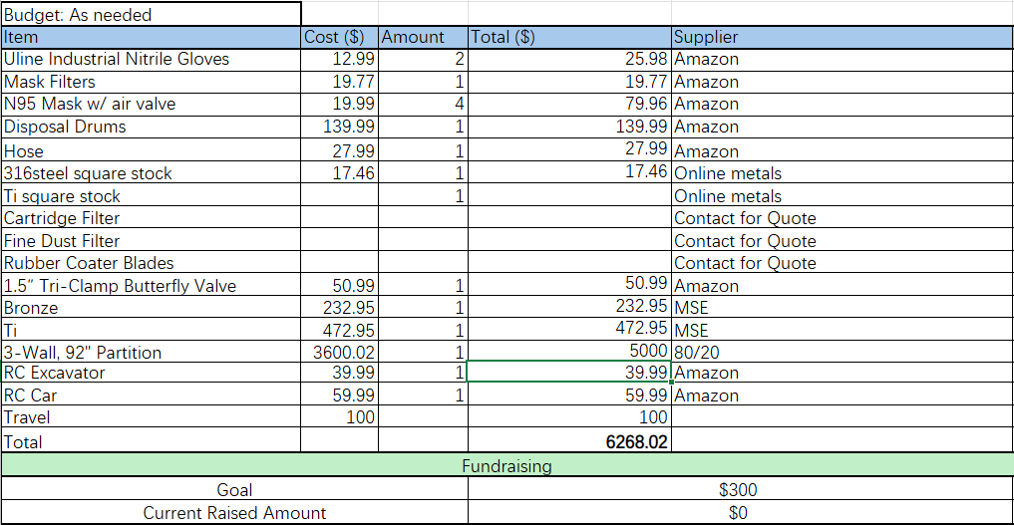

Appendix B: Hip Abduction Bracket Force, Shear, and Moment Matlab Script for Initial Calculations
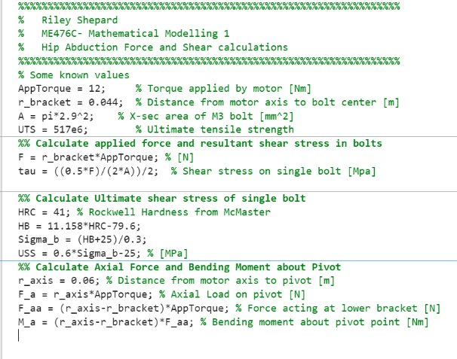

Appendix C: RC Excavator Torque and Moment Calculations
